Annex
Questionnaire on the development of an Integrated CITES
capacity-building framework
Contact Details
For Parties:
Name of country
Ministry/Department
Are you… | Management Authority Scientific Authority Enforcement focal point
For other entities:
Name of organization
For all respondents:
Contact person
Email

Consideration for an integrated CITES capacity building framework
Q1. Do you think an integrated framework for CITES capacity building would help you better plan, prioritize, and coordinate capacity-building efforts?  (If you answered “No”, please jump to Q13.) | YES | NO

Q2. If Yes, what should be included in an integrated framework for CITES capacity building?
(You can choose more than one)
- A common “language” – e.g. specifications for system requirements, terminology, methodology
- An approach to capacity needs assessment
- A “concept model” that maps the necessary elements for any Party to implement CITES
- A monitoring and evaluation tool that helps identify gaps preventing a Party from meeting CITES compliance and implementation
- Performance indicators associated with goals and objectives from the CITES Strategic Vision
- A resource tracking tool to track resource inputs including donor activities
- Potential capacity building strategies and key activities that can be employed
- Other (please specify):

Needs Assessments
Q3. Who should conduct the CITES capacity needs assessments? (You can choose more than one)
- Parties (self-assessment)
- Other Parties (peer review)
- Secretariat
- Third party, or other (please specify):
Q4. What data should be used to conduct the needs assessments? (You can choose more than one)
- CITES implementation reports
- Party status under CITES compliance mechanisms
- Direct expression of interest by Parties
- Other (please specify):

A Concept model for CITES Capacity Building (refer CoP18 Doc. 21.3 Annex 3)
Q5. Please provide examples of capacity building efforts in your country that may inform the development of a concept model for integrated CITES capacity building. Please include how the need was identified, participating parties/stakeholders, the specific activity undertaken and measurable results of the activity.
Q6. Please provide any recommendations or comments on the draft Conceptual Framework for CITES Capacity Building presented in document CoP18 Doc. 21.3 Annex 3 (attached to this questionnaire).

Management of Resource Tracking Tools and Indicators (refer CoP18 Doc. 21.3 Annex 4)
Q7. Do you think a resource tracking tool is necessary?  (If you answered “No”, please jump to Q13.) | YES | NO

Q8. If yes, what would you like to use the tracking tool for? (You can choose more than one)
 | - Tracking the donors’ capacity-building support activities
 | - Tracking the progress of recipient Parties’ capacity building activities
 | - Tracking the progress of Parties’ capacity building efforts towards certain objectives/activities using resources provided
 | - Co-ordinating activities
 | - Preventing duplication
 | - Other (please specify):
Q9. What kind of indicators would be useful when tracking resources? (You can choose more than one)
 | - indicators associated with objectives of CITES Strategic Vision
 | - indicators associated with the Sustainable Development Goals (SDGs)
 | - indicators associated with the post-2020 Global Biodiversity Framework
 | - indicators associated with other Multilateral Environmental Agreements
 | - indicators shown in the document CoP18 Doc. 21.3 Annex 4 (attached to this questionnaire)
 | - Other (please specify):
Q10. How should development and management of the tracking tool be funded?
 | - CITES Core budget
 | - CITES Extrabudgetary resources
 | - Third party (to be funded outside of CITES)
Q11. Who should have access to the data? (You can choose more than one)
 | - Recipient Parties |  | - All Parties
 | - Donor Parties |  | - Everyone (publicly available)
 | - Secretariat |  | - Different versions for the Parties/Secretariat and the public
Q12. Please provide any other recommendations or comments on the draft integrated CITES capacity building framework “Resource Priority Tracking Tool” presented in document CoP18 Doc. 21.3 Annex 4 (attached to this questionnaire).

General capacity building information
Q13. Please provide any other concise information, examples, and experiences, including case studies, that can inform the development of a comprehensive capacity-building framework.
Q14. Please provide any other ideas, comments or observations in as concise form as possible.
This is the end of the questionnaire. Thank you very much for your cooperation.

CoP18 Doc. 21.3
Annex 3
(English only/Seulement en anglais/Únicamente en inglés)
CONCEPTUAL FRAMEWORK FOR CITES CAPACITY BUILDING
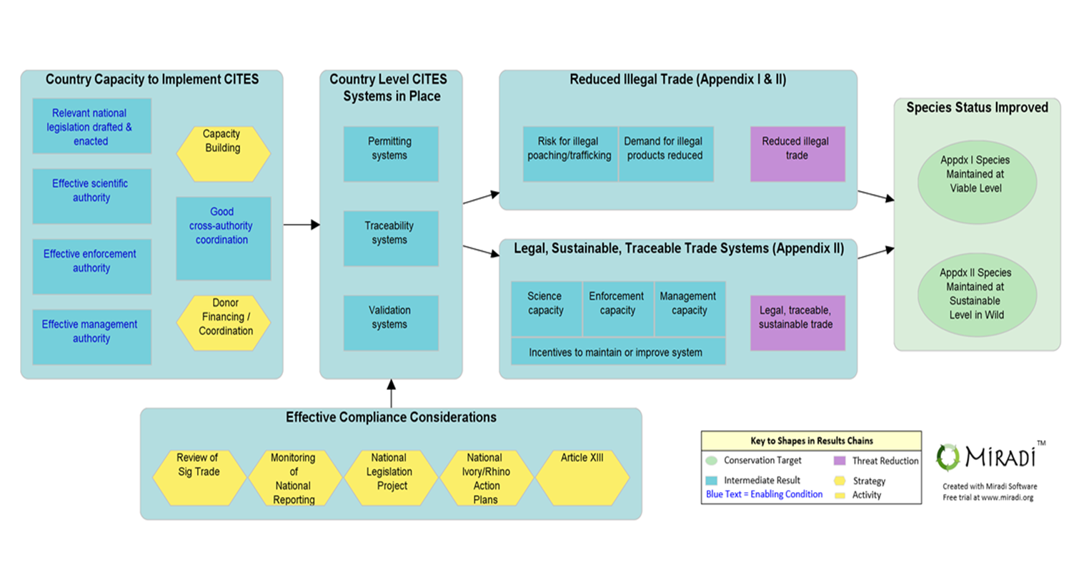
CoP18 Doc. 21.3
Annex 4
(English only/Seulement en anglais/Únicamente en inglés)
Example of a Resource Priority Tracking Tool
