# **MODULE 9: NDFs for REPTILES**

1. **What is in this module?**

This Module provides additional guidance to Parties on some of the key considerations when undertaking NDFs for reptiles. Where possible, the preparation of NDFs should be relatively simple, not onerous. It is clear that in many cases for reptiles there is no evidence a shipment is detrimental and a very simple, or basic, NDF should suffice. As such, this Module on reptiles offers guidance for simple NDFs and includes a template-based framework for simple NDFs. The data requirements for making an NDF should also be proportionate to the vulnerability of the species concerned (Res. Conf. 10.16). Many instances of trade in reptiles involve species that are susceptible to over-exploitation, are considered uncommon, or under pressure from multiple conservation threats. Cases like this would naturally require more complex NDFs. As such, the Module has included guidance about the kinds and quality of data that would be typically required in a NDF. Regardless of whether the NDF will be basic or complex, the aim of this Appendix is to help preparators of NDFs for reptiles understand what may be required, why it is required, and the basic steps for getting the information.

The number of reptile species subject to commercial trade varies over time. Recent studies recorded around 1250-1532 reptile species in current international trade, while the composition of species is assumed to differ on a spatial and temporal scale (Altherr et al. 2020; Scheffers et al. 2019). Not all species in international trade are listed in the CITES Appendices. The overall volume of trade, number of shipments, and number of specimens per shipment is highly variable across species of reptiles in trade. In many cases, small shipments consist of dozens or a few hundred specimens of generalist species that are widespread. Many other cases concern reptile species that have been used for commercial purposes continuously for decades, such as American Alligators, several species of crocodiles, tegu lizards, several species of pythons, and several species of monitor lizards. In other cases, a shipment may be the first ever to be regulated by CITES authorities. Trade in a species may be sporadic, or there may requests to trade in species that are faced with multiple conservation challenges. Many reptile specimens in trade are sourced from the wild, others from captive or ranched sources, and species that are caught from the wild sometimes transition to being produced almost entirely in captivity for the trade. Unfortunately, it is a fact that some reptile species, most notably turtles, have been severely over-exploited to the point they are now considered endangered. It is important that general guidelines for NDFs are applicable to this spectrum of scenarios.

1. **Guiding principles: Life history traits, range and distribution, trade volume**

CITES considers the extant Reptilia to include the crocodilians, turtles, tuatara, and squamates (snakes and lizards). As of July 2023, there are 12,000+ species of reptiles (The Reptile Database <http://www.reptile-database.org/>), about 10% of which are listed in the CITES Appendices. Though not all of these species are listed under CITES, more than 10% of the described reptile species have been recently recorded in the international wildlife trade. Most of these species are only poorly studied in the wild. It would be impossible to study the exact distribution, ecology, and population biology of all reptiles that may end up in trade as prerequisite for an NDF, even if such studies could be funded. Yet, as soon as a CITES-listed species appears in international trade for the first time, a NDF will be required. It would be rather impossible to expect biologists to conduct long-term studies at multiple locations of all the reptile species in their countries that are internationally traded as natural resources. Therefore, this working group aims to provide guidance on the kinds of data and parameters most crucial for inclusion in an NDF.

A NDF should consider aspects of a species’ biology at the appropriate scales. Short-term population studies carried out at one or several sites are helpful, while taking into account that extrapolating from one study site to broad geographic areas may not be applicable in many cases. Population sizes of reptiles are prone to fluctuate over time in response to local conditions like availability of food, drought and so forth. Conditions also vary inconsistently across a species’ range; some populations may be thriving at the same time others are declining. Therefore, in almost all cases of trade in reptiles, it is necessary to be able to formulate NDFs on the best existing data, historical data, expert opinion, common sense, and understanding of how wildlife populations respond to harvest and management. The degree of details needed for an NDFs should be proportionate to the harvest volume and vulnerability of the species concerned and be adapted to take into account changes in degree of exploitation, population status, habitat availability, domestic use, and conservation threats.

* 1. **Life History Traits and Populations of Reptiles**

Although recovery from harvesting is influenced by more than just a species’ life history (e.g., density-dependence), in general a species that takes a long time to reach maturity, breeds infrequently and produces only a small number of offspring, will take a long time to recover. Conversely, a species that grows and matures rapidly and has many offspring every year is likely to recover more quickly. Further, the mode of reproduction such as being oviparous vs. (ovo)viviparous or the ability of parthenogenesis may affect the reproductive potential. In viviparous species, one vulnerable live stage is missing (risk of eggs may not hatch due to unfavourable conditions or losses due to predation). For example, *Shinisaurus crocodilurus* is an ovoviviparous species that matures with 3-4 years in the wild, giving birth to a medium size of up to 14 offspring (mean 7) per year. Its life history could therefore be estimated as “medium” along the life history gradients in Figure 2. Tegu lizards in the genus *Salvator*, were the most exploited reptile species in the world by numbers during the 1980s. How could their populations endure harvest of millions of these large lizards every year? Understanding how their life history is relatively fast helps explain how. These species mature within 3 years, most females breed annually and lay clutch of about 20 eggs on average, and have a relatively long life span of at least 10 years.

**2.1.1. Geographic and Exploitation Gradients**

Species are not distributed evenly across continents, regions, and countries and their populations may be scattered among suitable habitat patches. At the extremes, some species may be ecological generalists that occur almost everywhere, and others may be micro-endemics that can only be found in very specific patches of habitat. Similarly, patterns of exploitation of species for trade and hunting pressures are not even throughout a country. Thus, knowledge of where species occur in concert with some idea of where hunting occurs is important information for determining if a trade is likely to be detrimental.

We can break down the spectrum over which species in trade occur across broad landscapes into geographic gradients. Geographic range refers to the overall area where a species may occur. Is this range small and fragmented or is it large? Populations and suitable habitat are not distributed evenly, and habitat quality varies across a species range (i.e., spatial variation in population density and habitat heterogeneity) Therefore, it is important to have some idea in which part of their ranges the species actually occurs.

The combination of knowledge about the range and distribution for species is important for evaluating how hunting and trade may affect a species in a country. Geographic Distribution refers to the pattern of occurrence of populations across a species’ entire range. Knowledge of geographic distribution relies on accumulation of locations and known areas where the species is found. This information accumulates as surveys are conducted, local knowledge is transferred, and other studies document presence of the species. The geographic distribution within the species’ range in a country can be estimated for many reptile species based on available information and availability of habitat, while recognizing that working out fine-scale distributions of species is often a work-in-progress for most species of reptiles.

The IUCN Redlisting effort uses standard methodology based on species’ presence at the scale of 4km2 to obtain metrics of geographic distribution referred to as Area of Occupancy (AOO). If AOO has been reported for a species in the Redlist or elsewhere it is useful to include it in a NDF. However, NDFs are not required to employ the AOO methodology used in redlisting.

Across many species, the geographic distributions fall along a gradient spanning from species with populations across their entire geographic range to those that may occur only in scattered patches of habitat, though these patches may together cover a large range. In some cases, the distribution and range within a country can be almost identical, but in others it is not. For example, the Boa Constrictor (*Boa constrictor*) has a large distribution in South and Central America, but almost an equally large area of occupancy as a result of its ability to thrive in human modified-environments. Conversely, the Emerald Tree Boa (*Corallus caninus*) has a large distribution within South America, but a smaller area of occupancy owing to its reliance on rainforest habitat and an inability to thrive in human-modified environments. Likewise, the Crocodile lizard (*Shinisaurus crocodilurus*) is distributed from southern China to northern Vietnam. However, the species is associated to specific densely vegetated forest streams with backwater pools. Therefore, its geographic distribution is much smaller than its entire range (Box 2). In practice, a NDF would consider the geographic distribution at a national level for the country of export only (and use standard metrics of AOO if available).

**2.1.2. Considerations of Life Stage on Effects of Harvest**

Among the reptiles, removal of different stages (eggs, juveniles, sub-adults, and adults) can result in very different impacts on populations. In very general terms, for long-live species (often large-bodied) the effect of offtake of eggs and hatchlings is less detrimental than that of adults. Adults reproduce many times during their long lives and removing adults has a disproportionate impact on population size over time. Because species with these traits have high hatchling mortality, the offtake of eggs and hatchlings, within reasonable limits, is indistinguishable from natural mortality for the hatchlings. Because of their life history, which for most species is characterized by very delayed times to maturity, small brood sizes, high hatchling mortality, and unpredictable reproductive success turtles and tortoises provide the clearest examples why consideration of life stage is important (AC28 Doc.15 Annex 2: Non-Detriment Findings and Trade Management for Tortoises and Freshwater Turtles - a guide for CITES Scientific and Management Authorities). There are exceptions these broad generalizations, such as when entire cohorts of eggs and hatchlings can be targeted over long time periods, like what happened in the past with sea turtles. However, it was the double-whammy of unsustainable removal of adults and eggs together that led to the decimation of sea turtles. In contrast, protection of adults allows harvests of eggs to be managed sustainably. For example, a shipment of hundreds of hatchling pond turtles may have little impact on the turtle species’ population at the national or regional level, but a harvest of hundreds of adults of the same species may cause a long-lasting decline in the same population. In one study of Common Snapping Turtles, it was shown that it would take 30 years for a population to recover from removal of half the reproducing females, without immigration. We also know that local populations of crocodilians can be overexploited by taking too many adults, and that these populations recover much faster when adults move in from outlying areas. Consideration of life stage is also more important when populations are isolated from each other, especially when the species’ dispersal is dependent on a particular life stage. Depending on the species, it may be hatchlings that disperse to sustain regional populations, or it could be the movements of sub-adults. For these reasons, a NDF should specify what life stage is being used and how it is predicted to impact the population. For species that have not been studied, a good starting point is to consider similar related species as surrogates. Life spans, modes of dispersal, and which life stages have highest rates of mortality are roughly similar across the major groups of reptiles.

**2.1.3. Assessing Impacts of Trade Volume and Harvest Level on Reptile Populations**

Non-detriment findings need to address the volume of trade in the species and provide an assessment of the potential effect of the volume of trade on the species’ population in the exporting country. The quantity of specimens in trade can be judged as Low, Medium or High, large or small, significant, or not significant. Dozens or a few hundred specimens in a shipment and few shipments per year may be considered a low trade volume, whereas a number in the tens or hundreds of thousands of specimens may appear shockingly large. The problem is that the *trade volume* by itself does not account for the *level of harvest* in relation to the population size. Then, ecological studies of population size are notoriously difficult to carry out for reptiles, and doing so requires years of study at only one location.

Faced with this conundrum, how can resource managers and CITES authorities include defensible assessments of trade volume in NDFs? Fortunately, for most reptile species coarse and very precautionary estimates of population density of the species based on all available data (both quantitative and qualitative) can be used to put the volume of trade into perspective. Once the geographic distribution is described, a precautionary population density can be extrapolated across the distribution to provide a country-wide population size as a starting point. Over time, both the AOO and average population density values can be updated and incorporated via adaptive management protocols.

The next step in assessing trade volume, especially in cases where the simple NDF template does not suffice, is to determine the harvest level in relation to the precautionary population size, also taking into account the species’ life history (Figure 2, Box 1). Using the example in Box 1, *Simalia amethistina* (scrub python) has an estimated geographic distribution amounting to 176,750 km2. Suppose the population density is 2 individuals per km2, which would be a surprisingly low population density, an annual harvest rate of 5% in this scenario would amount to precautionary population size of 353,500 with an annual off-take of 17,675 individuals per year. The life history of this species falls toward the fast end of the slow-fast continuum, and hunting takes place in a very small proportion of the distribution. The ecological role of the species as predator and prey would not be compromised. The best available data shows it occurs throughout the island of New Guinea, in diverse habitats, both natural and degraded, and has an annually harvest of only 400 individuals from less than 5% of the species’ AOO. The species has clearly not been extirpated from the areas in which it is harvested, has life-history traits that allow it to recover from harvesting, and a total wild population that is likely to comprise millions of individuals. There is no reasonable probability that such a scenario could cause species extinction and thus a complex and detailed NDF would not be required before exports take place. This case is also illustrative of the need for adaptability in the NDF because CITES may recognize taxonomic changes in *Simalia* over time, as well as anecdotal information on population declines in specific areas.

**BOX 1.**

**Example geographic distribution**

Here we will examine the area of occupancy for *Simalia amethistina* in Indonesia, a species of python inhabiting the island of New Guinea. Small numbers are harvested from Indonesian New Guinea each year to supply the pet trade.

* *Simalia amethistina* is found in Indonesia, which has a land area of 1,904,569 km2 (Fig. A)
* However, *S. amethistina* is known to occur only in the Indonesian provinces of Papua and West Papua. The area of these provinces is 416,129 km2
* Furthermore, *S. amethistina* only occur in rainforest habitats, which do not occur some parts of the highlands, or in some parts of southern Papua.
* Based on this information, an estimate for the distribution area of *S. amethistina* in Indonesia **176,750 km2** – i.e., the extent of lowland tropical rainforest in Papua and West Papua (Fig. B).

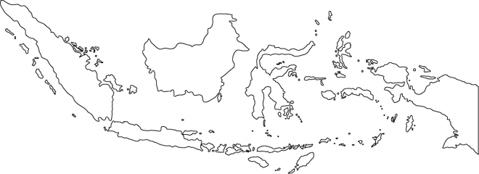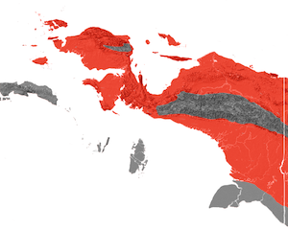

**Fig. 1.** The area of Indonesia

**Fig. 2**. *Simalia amethisina* occurs in the lowland rainforest areas of Papua (red), but not in woodlands or the highlands (grey).

**BOX 2.**

**Example geographic distribution**

Here we will examine the area of occupancy for *Shinisaurus crocodilurus* in Vietnam, a semi-aquatic lizard species inhabiting rocky streams in evergreen forests of China and Vietnam. Collection for international trade contributed to the species decline in both countries.

* *S. crocodilurus* is recorded from fragmented sites in northern Vietnamand southern China. According to the latest IUCN Red List assessment, the species’ range, or **global extent of occurrence (EOO)** (China and Vietnam together) is estimated at **1500 km²**.
* In Vietnam, *S. crocodilurus* is known from the provinces of Bac Giang and Quang Ninh. The area of these provinces covers 10,027.91 km2 in total (Fig. A), while the species only occurs at few sites.
* Estimated suitable habitats of the species in Vietnam are small and fragmented (Fig. B).
* Within suitable habitats, *S. crocodilurus* occurs along vegetated and remote rocky streams only (Fig. C). During extensive annual field research between 2013 and 2016, the species has been recorded along a total of **nine streams** in Vietnam, while its presence in some of these streams could not be re-confirmed during more recent surveys.
* Based on this information, the geographic distribution for *S. crocodilurus* in Vietnam is estimated to be **smaller than the threshold of 2.500 km² and therefore categorized as “small”**.

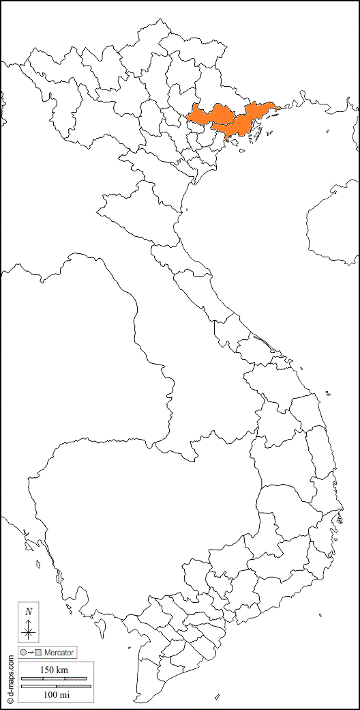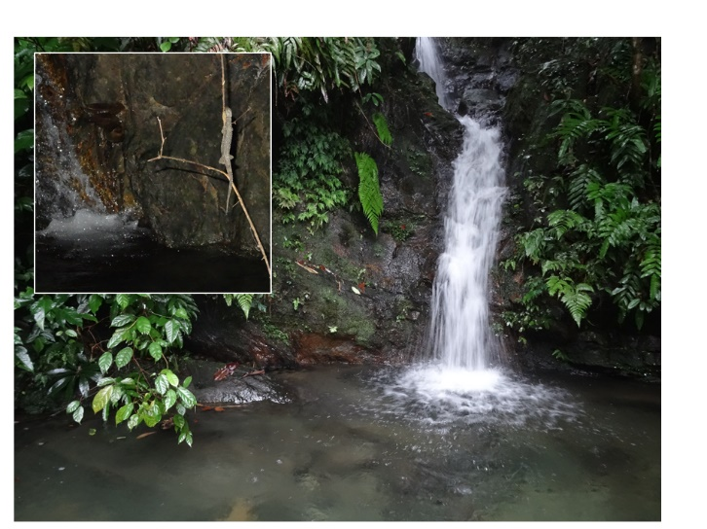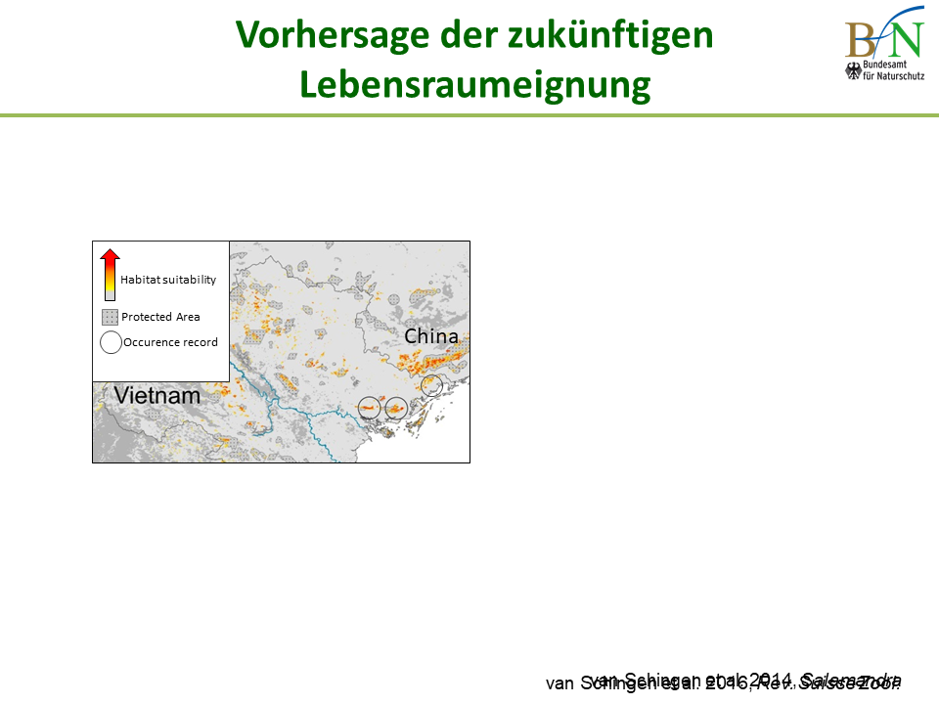

Fig. 5. Microhabitat of *S. crocodilurus* in Vietnam.

Fig 4. Occurrence records of *S. crocodilurus* (circles) and estimated suitable habitats in Vietnam (red).

Fig. 3. Area of Vietnam.

*S. crocodilurus* occurs in Bac Giang and Quang Ninh (orange)

1. **Guidance on completing Simple NDFs for reptiles**

Table 1 provides thresholds for the four criteria in the Simple NDF Template, which were developed by the CITES NDF Working Group on Reptiles. Although these figures are specific, even coarse data on life history, AOO, and harvest pressures can be used to create a robust basis for determining the likelihood a reptile species has attributes that make its populations relatively easy or difficult to sustain harvest. Reptiles, like all species, possess co-evolved suites of life history traits that are directly linked to population growth and persistence. Life history traits, taken together, influence the ability of a population to recover from decline, and endure harvesting. We can estimate species’ time to maturity, brood size, and frequency of reproduction with published data, local knowledge, samples from harvested specimens, and comparison with closely related species without expensive and time-consuming field-based studies carried out by ecologists. Going further, we can take into account the AOO of a species as well as the area over which most harvest occurs. Qualitative and quantitative data can be used to create defensible scenarios of harvest level in relation to trade volume. The Simple NDF Template is a tool for translating the framework for creating simple NDFs for any species of reptile. Importantly, all aspects of the framework and template are scientifically defensible and can be updated with more precise measures over time.

For specific information on how to score each of the criteria in the Simple NDF Template see Module 2.

|  |  |  |  |  |
| --- | --- | --- | --- | --- |
|  | **Number of points** | | | **Score** |
| **Criteria** | **1** | **2** | **3** |
| **Annual Harvest level** | Low (<500) | Medium (500 - 5,000) | High (>5,000) |  |
| **Area of occupancy** | Large (>20,000km2) | Medium (2,500 – 20,000km2) | Small (<2,500km2) |  |
| **Life-history** | Fast | Medium | Slow |  |
| **Illegal trade and IUCN Threat status** | If levels of illegal trade are known, they should be included under “Annual harvest level”. If unknown, and suspected to be detrimental, give a **maximum score of 1 point. Similarly, if the status of the species is** listed as VU, EN or CR in the IUCN Red List Of Threatened Species, or in national lists, give a **max score of 1 point** | | |  |

**Table 1.** Scoring criteria for the four variables of interest in the Simple NDF Template.

1. **When more complex NDFs for reptiles are needed** 
   1. **Data and evidence needs**

The framework using life history, geographic, and exploitation gradients provides a strong foundation for any NDF for reptiles. Use of the template described above is also a good starting point for any NDF. When the template indicates a more complex NDF is needed, it makes sense to begin by asking, “What additional information is needed for NDF?” It is useful to categorize the quality and quantity of information that is likely to be helpful in a more detailed NDF. Information on population size and structure, harvest level in relation to population size, more precise geographic distribution, and data on harvest levels, harvest locations, number of areas harvested, frequency of harvests, and measures of hunter effort may be requested. Evidence that ongoing conservation and management efforts are working may be necessary to include. It is easy to visualize that a rigorous monitoring and management program would be aimed at providing these kinds of data. Table 2 indicates some of these types of data needed for complex NDFs.

A vast scientific literature can be consulted to evaluate the effects of harvest on animal populations, ranging from highly mathematical to practical examples (e.g., Getz and Haight 1989. Population Harvesting: Demographic Models of Fish, Forest, and Animal Resources. Princeton University Press (Monographs in Population Biology 27.).



* 1. **Population Size, Structure, and Abundance**

Resource managers, CITES authorities, and conservation scientists are ultimately concerned whether populations are persisting across the geographic distribution, and if they are growing, declining, or stable. This is why NDFs require defensible assessments of the status of populations. Considering the difficulties in measuring the populations of many reptile species, what approach should be taken when making a NDF that is required to contain a high level of substantiated information? The published volume McDiarmid, et al. 2012, “Measuring and Monitoring Biological Diversity: Standard Methods for Reptiles” is a good starting point for designing studies to measure and monitor reptile populations.

**4.1.1. Population Size and Growth**

If we could reliably estimate population size (the number of individuals alive in a defined population; N) and structure every year for every population in every ecological setting, biologists could construct life tables and apply simple models of the effect of offtake on every population’s size and growth. The truth is, accurate and precise measures of population size and growth are probably the most desired, most difficult to obtain, most unreliable, and least utilized data in management of many commercially traded reptile species. Even at a single study site, measuring a population’s size can be a Sysiphaen task; once it’s measured it has already changed and must be measured again at great cost. Extrapolating those population numbers to other sites only creates the illusion of knowing the regional population size because of natural local population fluctuations, source-sink phenomena, and the correlations between population dynamics and habitat quality. Yet, wildlife and fisheries management plods along without these measures, with thousands of cases of successful sustainable use management programs, some demonstrating remarkable population recovery and some ongoing for a century or more (and some tragic failures). At the same time, the fundamental interaction between offtake and population-level processes is undeniable—populations subject to harvest are affected at some level. Monitoring programs are designed to provide data needed to assess trends in population abundance and structure over time, and managers use these inputs to develop strategies that ultimately affect population size and structure.

**4.1.2. Population Abundance**

Many resource managers and authorities are probably interested in scientifically defensible assessments of population abundance, or how common the reptile is within its habitat. Abundance is a much looser term than population size. Assessments of population abundance may not be based on the intensive sampling needed to obtain population birth and death rates and actual measures of population density. In Box 1 and Box 2 above and in many examples in Annex B, the true population size would be almost impossible to estimate, but it is clear that even very conservative measures of abundance are sufficient to evaluate if the harvest level may be non-detrimental or unsustainable. Abundance can be assessed through a number of field-based methods that are best suited to the taxon being studied (Table 3). Using comparable methods, measures of abundance can be used as an indicator of whether the population is growing or declining or stable. Naturally, implementation of any of these methods is time-consuming and can be expensive. These methods are used in ongoing management and monitoring programs, which feed data into creation of NDFs.

**4.1.3. Population Structure**

Population structure refers to the sex ratio and distribution of age or size classes in a population. Knowledge of population structure is very important for assessing impact of harvest on a population and many methods have been developed to use information on population structure to evaluate population trends and sustainability. For reptiles, it is usually best to consider the size distribution or distribution of life-stages rather than age because it is very challenging to know the ages of sub-adult and adult reptiles. This is especially true in crocodylians, turtles, and large-bodied lizards and snakes. Moreover, sexual maturity and fecundity are more associated with size than with age in reptiles. Incidentally, because populations of reptiles are structured by size, this helps explain why consideration of the life-stage that is harvested is important. Population structure can be obtained through ecological studies and through harvest monitoring. However, most field methods do not sample all life stages with equal probability, so analyses need to be carried out to account for bias. Harvest monitoring can also be biased against inclusion of some life stages, and also require careful analyses to determine the underlying population structure. Through harvest monitoring, the life stages most targeted will be identified and analytical methods can be used to infer the underlying population structure.

Table 3. Common field-based approaches to measure population abundance and population structure of reptiles. Also refer to McDiarmid et al. (2012).

|  |  |  |  |  |
| --- | --- | --- | --- | --- |
| **Order** | **Family** | **Habitat** | **Abundance estimate method** | **Examples of technique in application** |
| Squamates | Snakes | Forest | * Transect surveys * Pitfall trapping | Natusch and Natusch (2011) |
|  |  | Desert | * Pitfall trapping |  |
|  |  | Aquatic | * Draining of waterbodies to reveal snakes * Fyke nets submerged within lagoons | Kusrini et al. (2022)  Houston & Shine (1994) |
|  | Varanids | Forest | * Active capture of lizards using baited snares | Khadiejah et al., (2019) |
|  |  | Desert | * Techniques explained |  |
|  |  | Semi-aquatic | * Techniques explained |  |
|  | Agamidae | Semi-aquatic | Hand-capture, mark-recapture (colour) | Nguyen et al. (2018); Gewiss et al. (2020) |
|  | Scincidae |  | * Pitfall trapping |  |
|  | Gekkonidae |  | * Visual surveys, trapping |  |
|  |  | Forest caves/ karst asscociated | * Hand capture, mark-recapture (colour) | Ngo et al. (2016); Ngo et al. (2019) |
|  | Iguanidae |  | * Visual surveys, trapping |  |
|  | Shinisauridae | Semi-aquatic | * Hand capture, mark-recapture (tansponder) | Van-Schingen et al. (2014); van Schingen et al. (2016) |
|  |  |  | * eDNA monitoring (shows presence only) | Reinhardt et al. (2018) |
| Crocodylia | Crocodiles | Forest and swamp dwelling | * Distance transects coupled with spotlight or nest surveys in terrestrial or inundated habitats * Nocturnal spotlight surveys in navigable, forested waterbodies * Burrow surveys and occupancy * Traditional ecological knowledge surveys |  |
|  |  | Navigable waterbody dwelling (i.e., lakes, rivers, some marshes) | * Nocturnal spotlight (e.g., eyeshine) surveys * Aerial surveys of basking individuals and/or nests * Nest surveys * Traditional ecological knowledge surveys | Fukuda et al. (2012) |
| Testudines | Fresh water turtles | Marsh, Ponds, Rivers | * Hoopnets (baited), Fyke nets, Basking traps | Harless & Morlock (1979) |
|  | Tortoises | Desert | * Hand capture, burrow surveys | Harless & Morlock (1979) |

1. **References**

Getz and Haight 1989. Population Harvesting: Demographic Models of Fish, Forest, and Animal Resources. Princeton University Press (Monographs in Population Biology 27.

Gewiss, L., Ngo, H.N., van Schingen-Khan, M., Bernardes, M., Rauhaus, A., Pham, C.T., Nguyen, T.Q. & Ziegler, T. (2020). Population assessment and impact of trade on the Asian Water Dragon (*Physignathus cocincinus* Cuvier, 1829) in Vietnam. – Global Ecology and Conservation 23 (2020) e01193.

Ngo, H. N., Nguyen, T. Q., Nguyen, T. V., Barsch, F. & T. Ziegler, van Schingen, M. (2016). First population assessment of the endemic insular Psychedelic Rock Gecko (*Cnemaspis psychedelica*) in southern Vietnam with implications for conservation. Amphibian and Reptile Conservation, 10(2): 18-26.

Ngo, H. N., Nguyen, T. Q., Phan, T. Q., van Schingen, M. & Ziegler, T. (2019). A case study on trade in threatened Tiger Geckos (*Goniurosaurus*) in Vietnam including updated information on the abundance of the Endangered G. catbaensis. – Nature Conservation 33: 1-19.

Nguyen, T. Q., Ngo, H. H., Pham, C. T., Ngo, C. D., van Schingen, M. & Ziegler, T. (2018). First population assessment of the Asian Water Dragon (*Physignathus cocincinus* Cuvier, 1829) in Thua Thien Hue Province, Vietnam. – Nature Conservation 26: 1-14.

Reinhardt, T., van Schingen, M., Windisch, H. S., Nguyen, T. Q., Ziegler, T. & Fink, P. (2018): Monitoring the loss: Detection of the semi-aquatic crocodile lizard (*Shinisaurus crocodilurus*) in inaccessible habitats via environmental DNA. – Aquatic Conservation 29 (3): 353-360.

van Schingen, M., Pham, C.T., Thi, H.A., Bernardes, M., Hecht, V.L., Nguyen, T.Q., Bonkowski, M. and Ziegler, T. (2014). Current status of the Crocodile Lizard *Shinisaurus crocodilurus* Ahl, 1930 in Vietnam with implications for conservation measures. *Revue Suisse de Zoologie.* 121(3): 1-15.

van Schingen, M., Ha, Q.Q., Pham, C.T., H.Q., Le, T.Q., Nguyen, Q.T., Bonkowski, M. and Ziegler, T. (2016). Discovery of a new crocodile lizard population in Vietnam: Population trends, future prognoses and identification of key habitats for conservation. *Revue Suisse de Zoologie*. 123(2): 241-251.

van Schingen, M., C.T. Pham, H.A. Thi, T.Q.Nguyen, M.Bernardes, M. Bonkowski and T. Ziegler, T. (2015). First ecological assessment on the endangered Crocodile Lizard *Shinisaurus crocodilurus* Ahl, 1930 in Vietnam: Microhabitat characterization and habitat selection. *Herpetological Conservation and Biology*. 10(3): 948-958.

van Schingen, M., Schepp, U., Pham, C.T., Nguyen, T.Q. and Ziegler, T. (2015). Last chance to see? Threats to and use of the Crocodile Lizard. *Traffic Bulletin*. 27: 19-26.

van Schingen, M., Ihlow, F., Nguyen, T.Q., Ziegler, T., Bonkowski, M., Wu, Z. and Rödder, D. (2014). Potential distribution and effectiveness of the protected area network for the Crocodile Lizard *Shinisaurus crocodilurus* AHL, 1930 (Reptilia: Squamata). *Salamandra* 50(2): 71-76.

Guidelines for making NDFs for turtles (2015) AC28 Doc. 15 Annex 2

<https://cites.org/eng/virtual-college/ndf?search_api_fulltext=turtles&sort_by=field_date_of_submission>

Reptile & Amph Final Report from Cancun NDF WS 2008

http://www.conabio.gob.mx/institucion/cooperacion_internacional/TallerNDF/Links-Documentos/WG-CS/WG7-ReptilesandAmphibians/WG7-FR.pdf

TTWG Checklist and Atlas v9 2021

<https://iucn-tftsg.org/wp-content/uploads/crm.8.checklist.atlas_.v9.2021.e3.pdf>

Conservation Biology of Freshwater Turtles and Tortoises:

A Compilation Project of the IUCN/SSC Tortoise and Freshwater Turtle Specialist Group

https://iucn-tftsg.org/cbftt/

CITES, 2016, CoP17 Doc. 73 TORTOISES AND FRESHWATER TURTLES (TESTUDINES SPP.),

Annex Table 2, page 63.

On the Trail Quarterly information and analysis bulletin on animal poaching and smuggling

<https://robindesbois.org/en/a-la-trace-bulletin-dinformation-et-danalyses-sur-le-braconnage-et-la-contrebande/>

Note: Current Redlist Assessments for Turtles have a lot of good information for making NDFs

R.W. McDiarmid, M. S. Foster, C. Guyer, J. W. Gibbons, and N. Chernoff (eds.) 2012. Measuring and Monitoring Biological Diversity: Standard Methods for Reptiles. University of California Press, Berkeley, California.

Fitzgerald, L.A. 2012. Studying and Monitoring Exploited Species. Pp.323-331. In R.W. McDiarmid, M. S. Foster, C. Guyer, J. W. Gibbons, and N. Chernoff (eds.), Measuring and Monitoring Biological Diversity: Standard Methods for Reptiles. University of California Press, Berkeley, California.

Fitzgerald, L.A. 2012. Finding And Capturing Reptiles. Pp.77-88. In R.W. McDiarmid, M. S. Foster, C. Guyer, J. W. Gibbons, and N. Chernoff (eds.), Measuring and Monitoring Biological Diversity: Standard Methods for Reptiles. University of California Press, Berkeley, California.

Smolensky, N. and L.A. Fitzgerald. 2010. Distance sampling underestimates population densities of dune-dwelling lizards. *Journal of Herpetology* 44:372-381.

Subalusky, A., L.A. Fitzgerald, L.L. Smith. 2009. Ontogenetic niche shifts in American Alligators establish functional connectivity between aquatic systems. *Biological Conservation* 142:1507-1514.

Subalusky, A. L.L. Smith, L.A. Fitzgerald. 2009. Detection of American Alligators in Isolated, Seasonal Wetlands. *Applied Herpetology* 6(3):199-210.

Mieres, M.M. and L.A. Fitzgerald. 2006. Managing and monitoring the tegu trade in Paraguay. *Journal of Wildlife Management* 70(6): 1723-1734.

Fitzgerald, L.A., C.W. Painter, A. Reuter, and C. Hoover. 2004. *Harvest and trade in reptiles of the Chihuahuan Desert Ecoregion*. TRAFFIC North America, World Wildlife Fund. ISBN # 0-89164-170-X. 112 pages.

Fitzgerald, L.A. and C.W. Painter. 2000. Rattlesnake commercialization: long-term trends, issues, and implications for conservation. *Wildlife Society Bulletin* 28 (1):235-253.

Fitzgerald, L.A. 1994. The interplay between life history and environmental stochasticity: Implications for management of exploited lizard populations. *American Zoologist* 34: 371-381.

Fitzgerald, L.A. 1994. *Tupinambis* lizards and people: a sustainable use approach to conservation and development. *Conservation Biology* 8(1): 12-15.

Fitzgerald, L.A., G. Porini, and V. Lichtschein 1994. El manejo de *Tupinambis* en Argentina: historia, estado actual, y perspectivas futuras. *Interciencia* 19(4):166-170.

Fitzgerald. L.A., F.B. Cruz, and M.G. Perotti. 1993. The reproductive cycle and size at maturity of *Tupinambis rufescens* (Sauria: Teiidae) in the dry chaco of Argentina. *Journal of Herpetology* 27(1):70-78.

Fitzgerald, L.A., J.M. Chani, and O.E. Donadio. 1991. *Tupinambis* lizards in Argentina: Implementing management of a traditionally exploited resource. Pages 303-316 In John G. Robinson and Kent H. Redford (eds.) Neotropical Wildlife Use and Conservation. University of Chicago Press.