MODULE 8: NON-DETRIMENT FINDINGS FOR BIRDS

- What is in this module?
This Module provides additional guidance to parties on some of the key considerations for undertaking NDFs for birds. At the time of writing, CITES lists 156 species of birds on Appendix I, 1,294 species on Appendix II and 60 species on Appendix III. CITES coverage of birds on the Appendices is most complete for Falconiformes (Birds of Prey), Strigiformes (Owls), Psittaciformes (Parrots) and Apodiformes (including Hummingbirds, Swifts and Tree Swallows) with between 75-100% of the total known species included. Birds are primarily traded live, though there is also large-scale trade in feathers, specimens, and derivatives. Most trade in live birds (2011-2022) was in species of Psittaciformes (Parrots). The greater part of this trade was in captive-bred individuals, though there remains a considerable trade in wild-caught Psittaciformes (c.10% of live birds). In the live trade, the second most-traded order was Falconiformes (Birds of prey). Much of this trade is also in captive bred individuals, with wild-caught individuals accounting for 8.5% of the trade.
The commercial trade in birds largely concerns Appendix II listed species, though both trade in Appendices I and III species is also recorded to a lesser degree. The trade in Appendix I species largely relates to trade in scientific specimens, though some trade in wild-caught live birds is recorded in the CITES trade database. For Appendix III, the live trade is predominantly in Galliformes (incl. pheasants and peacocks).
- Application of the NDF Framework for Birds
  - Pre-NDF Checks
Module 2 sets out a series of Pre-NDF checks relating to:
- Identification of the specimen
- Checking the Appendices for the species and specimen under consideration
- Assessing whether an NDF is required using the source code
- Evaluating National Legislation with relevance to understanding detriment and extinction risk.

2.1.1. Identification
Critical to completing the NDF process is ensuring i) the correct identification of the specimen(s), ii) checking the listing under the CITES appendices and confirming the relevant source code, and iii) verifying the legal acquisition of the specimen(s), without confirmation of which the export should not proceed. This is the role of the Management Authority.

2.1.2. Birds
Within the CITES trade database (2011-2022) there is a concerning number of bird specimens not identified to the species level, with 1072 records of trade in specimens marked as spp. (the qualifier used to indicate where identification to species was not recorded). The majority are identified to the Family level only though this also includes cases for which the identification is at the Order level (i.e. Passeriformes). The failure to identify species to at least the genus level will impact the robustness of the NDF.
Whilst identification is largely undertaken at the point of the application for export/import, with the onus on the applicant to provide the correct scientific name according to CITES standard nomenclature, there are methods available to Scientific Authorities to aid the identification of species. This is particularly relevant in cases where there is a higher risk of misidentification. This can occur as a result of i) recent nomenclatural changes not recognized in the standard taxonomic references adopted by the Conference of the Parties, ii) the existence of look-alike species, iii) a deliberate effort to conceal illegal trade. These methods include:
- Cross-referencing the information received from the Management Authority with:
  - national/ regional field guides or where these are unavailable the Illustrated checklist of birds of the world, which includes species-level illustrations by genus, or the online Birds of the World website which is a searchable media archive including photographs.
  - Checking the standard nomenclature against the taxonomic notes contained in the Red List factsheet or the Birds of the World website.
  - the species distribution to ensure the species occurs within the harvest area indicated using the relevant field guide, Red List factsheet or BirdLife DataZone.
- Asking for photographs of the specimens concerned if they cannot be examined directly, noting the possibility of deliberate substitutions.
- Requiring an inspection or engaging an expert consultant to make the identification.
The CITES Identification Manual for Aves provides general notes on species listed under the Appendices, their characteristics, distribution, population, and, for a limited number of species, details on intraspecific variation and similar species. Information complemented by that available on the Birds of the World website and the BirdLife DataZone.

2.1.3. Dealing with look-alike species
The degree to which there are morphological similarities (their physical characteristics) among bird species is widely acknowledged. This can complicate identification to the species level, especially for eggs and juvenal stages, and adds complexity when species with strong similarities are listed in different Appendices. The Psittaciform genus Amazona is one such group of hard to identify species listed across both Appendices I and II. One such identification guide has been produced in the case of the Cape Parrot (Poicephalus robustus) and Grey-headed parrot (Poicephalus fusicollis suahelicus (BOX 1).

BOX 1: Identification of the Cape Parrot and the Grey-headed Parrot
Morphological similarities between the Cape Parrot (Poicephalus robustus) and the Grey-headed Parrot (Poicephalus fuscicollis suahelicus) make distinguishing the two species challenging. The similarities are such that the Cape Parrot was previously considered a subspecies of P. fuscicollis. Whilst both species are Appendix II listed, the Cape Parrot is endemic to South Africa and considered Vulnerable, whereas P. fusicollis spp. are distributed across a much wider range and are classified as Least Concern by IUCN. This has clear implications for the preparation of an NDF.
To support correct identification, the South African National Biodiversity Institute (SANBI) has compiled the ‘Cape Parrot Identification Guide’ on behalf of the Scientific Authority of South Africa. This includes,
1. A brief description of the two species,
2. Tables listing the main ecological, morphological and biological differences between the two species,
3. Photographs of both sexes annotated to show the colour differences between the two species, and.
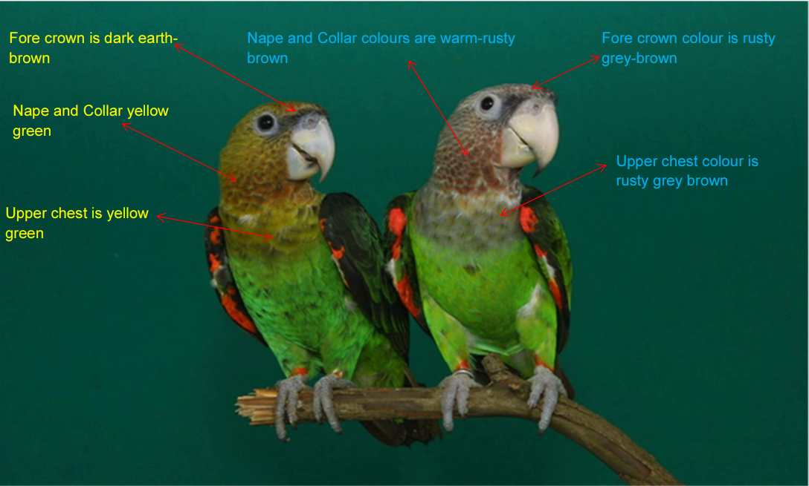
4. A colour palette to assist in recognising the various colours described.
Male Cape parrot (P. robustus)(left) and male grey-headed parrot (P. fusicollis suahelicus)((right)

2.1.4. Identification of parts and derivatives
Resolution Conf.9.6 (Rev. CoP19) provides guidance on the identification of readily recognizable parts and derivatives.

For birds, the identification of derivatives (any processed part of an animal or plant), which may include carvings, feathers and claws, to the species level can be challenging. Whilst these do not constitute the major part of the international trade in birds, the proportion is significant, particularly in specimens for medicinal purposes. Identification must therefore rely on the accompanying documentation, packaging, mark or label as outlined in Conf. 9.6 (Rev. CoP 19), although such information should not necessarily be taken at face value.

Conducting a Simple NDF

This section concerns the application of the Simple NDF evaluation approach to birds. The following sections provide more detail on how to address common issues associated with making Bird NDFs, alongside the rationale for the scoring criteria outlined in Table 2. It has been arranged to follow the compilation of information according to the NDF process outlined in the Module 2.

As a general rule all three criteria can be considered as sitting across a gradient, as follows:

Life history trait gradients
“K-selected” ‘Slow’ | Slow-to-fast Continuum | “r-selected” ‘Fast’
Delayed | Time to maturity | Rapid
Small | Brood size | Large
Infrequent &  unpredictable | Frequency of reproduction | Frequent
Geographic and exploitation gradients
Easier to overexploit |  | Easier to sustain
Small, fragmented | Geographic range | Large
Small, scattered | Area of Occupancy | Large, contiguous
High, constant,  everywhere | Pressure to Exploit and Area of Harvest | Low and infrequent

2.2.1. Life History traits
This concerns the intrinsic vulnerability of a species or population based on life history traits (including reproductive capacity) and biological characteristics (i.e., niche breadth). The biological attributes or life history traits of an organism determine in part to what extent it can sustain a level of wild-take or harvest. Understanding the basic biology of a species, and its vulnerability to harvest, helps you to assess the degree of risk.
Generation time as a proxy for life-history traits in birds
Bird et al. (2020) systematically estimated generation lengths of birds based on published life-history and trait data for all species, using linear models to estimate generation lengths where life-history data was unavailable. Generation length ranges from 1.42 to 27.87 years, with most bird species having generation lengths of <3.33 years (61% of all birds). For CITES-listed birds, generation length ranges between c.1.5 years to c.27 years, with a median generation length of c.4.2 years. There is a lot of interspecific variation at the Family level. For example within the listed Cacatuidae (Cockatoos) the range in generation length c.6.8 years (Callocephalon fimibriatum) to 27.2 years (Cacatua galerita).
To score the criteria ‘life history’ for the primary evaluation consult the publicly available generation lengths (GenLength, supplementary table 4 (Bird et al 2022)) The following table uses this rationale to determine whether the life-history is considered ‘fast’, ‘medium’ or ‘slow’ based on the IUCN Red List Criterion A relating to population size reduction. Using this interpretation would categorise species with generation lengths of under 3.33 years as having ‘fast’ life histories based on the period of 3 generations <10 years (Bird et al 2020). This includes the Trochilidae (Hummingbirds) and several Families of the Passeriformes (Songbirds).
Qualifier | Fast | Medium | Slow
Generation Length | <3.33 years | 3.33 | > 33.33 years
Period of 3 generations | <10 years | 10 years> | >100
Primary Evaluation score | 1 | 2 | 3

2.2.2. Area of Occupancy
Area of occupancy estimates for birds are rare and where information is available this is regionally biased and is largely only available for well-studied species. Where these are available for bird species these should be prioritised as the primary source of information for assessment. The robustness of an Area of occupancy estimate is impacted by the following factors, the quality of the data, method of derivation, and year of estimate, each of these should be noted and considered as part of the assessment. Global-scale Area of Habitat maps have been produced for c.95% of bird species, both non-migratory and migratory. The repository for the Area of Habitat data tables (including estimates in km²⁻) and maps, can be downloaded from the Dryad Open Access Repository To note, these estimates can also be clipped to the national level (see National area of occupancy). Further, for migratory species a series of sub-maps have been created for breeding, non-breeding, resident and uncertain areas of occupancy. An R script is available to combine these to create one AOH map and area in km² (reference).

2.2.3. Additional Risk Factors
To note, if the species being assessed qualifies under either factor under consideration within this section apply a maximum score of ‘1’.

Global Conservation Status
Global conservation status for birds is comprehensively assessed and recorded in the IUCN Red List of Threatened Species. Of the 10,994 recognised extant species of bird, 13.5% (N=1,481 species) are currently threatened by extinction. The greatest proportion of threatened birds belong to the parrots (Psittaciformes), and extinction risk is correlated with greater body size, longer generation times, and lower fecundity.
To score this criterion, check the threat status of the species under consideration on the IUCN Red List website, for any species classified as Vulnerable, Endangered or Critically endangered score the species ‘1’.

Sharp increase in trade
Consideration of data on recent trends in harvest level can also be relevant here. In particular if there is any evidence to suggest there has been a sharp increase in either global and/or national trade. If a sharp increase is detected in either, this should be considered as indicating an uptick in demand, and scored as an additional risk factor.
To score this criterion, where evidence of a sharp increase is found this should be scored ‘1’.

Illegal Trade
Illegal wildlife trade can have a significant impact on species persistence. This can be assessed using a qualitative approach – firstly by looking for evidence to determine whether illegal trade exists and, secondly, by estimating the suspected magnitude of illegal trade in general terms (e.g., low, medium, high).
If there is any evidence at the national level that illegal trade is occurring, even where evidence is patchy or the trade is considered minimal, this factor should be accounted for in the Non-Detriment Finding process. If national data is not available, datasets which record seizures of illegally traded wildlife include i) The TRAFFIC International Wildlife Trade Portal (open access) and ii) LEMIS, the Law Enforcement Management Information System, from the United States Fish and Wildlife Services) (closed, accessed by FOI). A static database listing taxa involved in wildlife seizures along with their intended use-type (collated between January 1,2010 to December 31,2019) has been made available by Stringham et al 2021 , and can be interrogated using R programming language.
To score this criterion, where evidence of illegal trade is found this should be scored ‘1’.

2.2.4. Assessing detriment for captive-bred Birds: Source codes ‘C’, ‘D’ and ‘F’
For some bird species, international trade in birds involves a significant proportion of captive bred specimens. For assessing non-detriment in captive bred species, performing an NDF of the initial breeding stock should be sufficient in closed-loop systems, with additional NDFs only required when additional wild-caught individuals are harvested to maintain production. Considerations on the definition and treatment of captive bred specimens are outlined in CITES Res. Conf. 10.16 (Rev. CoP19) . BOX 2 is included to support assessment of detriment relating to captive breeding.

BOX 2: Completing a Simple NDF for Sulphur-crested Cockatoo (Cactua galerita)
This illustrative example walks through the application of the Simple NDF Template using the Sulphur crested cockatoo, a large white cockatoo found in wooded habitats in Australia, New Guinea, and some of the islands of Indonesia.
- Annual harvest level: There has been a ban on international trade in live wild-caught birds in Australia since 1959. International trade in live birds exported from Australia involves low numbers of captive-bred live individuals. There is also low-level international trade in derivatives, including feathers, specimens, skeletons and skulls sourced from both wild and captive bred populations. With 8 export permits granted for trade in wild-collected derivatives (2015-2019) and 13 instances of permits granted for trade in captive-bred individual and derivatives concerning 3 permits for live individuals (N=14) and 10 permits for trade in derivatives.
- Area of occupancy (AOO): Estimates of Area of occupancy are not available for this species. The Area of Habitat for this species, equivalent to the upper bound of the species AOO is estimated at 1,781,968 sq km². As this is above >20,000km² this would be considered ‘large’ under the scoring system and be scored ‘1’.
- Life-history: Using generation length as a proxy, this species would be considered to have ‘slow’ life history traits, with a generation length of 27.2 years, and as such would score ‘3’ .
- Additional risk factors: The species conservation status is Least concern, however, there is evidence that illegal trade is occurring, to reflect this concern the score applied is ‘1’.See Section 5 of Module 1 on how to score Simple NDFs.
 | Number of points |  |  | Score
Criteria | 1 | 2 | 3
Annual Harvest level | Low (<500) | Medium (500 - 5,000) | High (>5,000) | 1
Area of occupancy | Large (>20,000km²) | Medium (2,500 – 20,000km²) | Small (<2,500km²) | 1
Life-history | Fast  (<3.33 yrs) | Medium  (>3.33yrs-15 yrs) | Slow  (15 yrs>33.33) | 3
Illegal trade and IUCN status | If levels of illegal trade are known, they should be included under “Annual harvest level”. If unknown, and suspected to be detrimental, give a maximum score of 1 point. Similarly, if the status of the species is is listed as VU, EN or CR in the IUCN Red List Of Threatened Species, give a maximum score of 1 point |  |  | 1

Conducting a Complex NDF

General approach - criteria and evaluation
In the instances where having completed a first evaluation against the criteria for the simple NDF non-detriment cannot easily be established (i.e., score= 5>), then a further more detailed evaluation should be completed. The following guidance considers factors relevant to birds and seeks to provide solutions to address issues associated with data scarcity.
In the case of birds, the criteria concerning mean body size, minimum body size at maturity and catch-per unit effort are considered less effective in supporting a conclusion for non-detriment, and so detail on their assessment has not been included. In the case of mean body size, unlike other taxa, for many birds there is no direct correlation between mean body size and the species vulnerability based on life history.
There is an optimum harvest level, where exceeding this will cause the population to go into decline and harvest becomes unsustainable. For birds, evidence suggests that for some species there is a fine line between capture volumes being sustainable and dramatically unsustainable.
There is not a robust method to assess optimum harvest levels and infer the potential trade impact for birds. Further, in reality market demand often sits well below this. Therefore, assessors must weigh the evidence available on annual harvest level data in relation to the population abundance, and the species life history traits (i.e., the intrinsic rate of increase). With the focus placed on achieving non-detriment through continuous monitoring of the impact of harvesting and other management interventions.

Biological characteristics and life history traits

Population abundance
Population abundance refers to the number of individuals in a given area. When populations are harvested, at levels higher than the rate of replacement abundance declines.
Information on population abundance for the national population and the sub-population where harvest occurs based on direct observation would be considered the gold standard for assessing the impact of trade. However, this data is often scarce, and can be resource intensive to collect. In circumstances where such data is not available, abundance could be estimated, inferred or projected using indirect methods.

Population abundance monitoring data
Birds are by far the most monitored taxon globally. There are a growing number of records being contributed by citizen scientists, with the data being increasingly integrated into population analyses,. If estimates are available this data should be prioritised. Population abundance data may be available in the form of national institution monitoring records, in published datasets, academic journals, and as part of civil society data holdings. More detail on the assessment of monitoring methods and their robustness is included in Section 3.2.
- The Living Planet Index Database of Population Abundance
However, in the absence of national monitoring records, referenced data on population abundances have been compiled by the Living Planet Index for 17,576 populations (national and/or subnational populations) for 1,802 bird species. Ranked by region, the greatest degree of abundance data is available from studies in Oceania (n=7,260), Europe (n=2,050), North America (N=2,769) and Latin America and Caribbean (n=1,051). Of these [x] are CITES-listed. This data can be downloaded at https://www.livingplanetindex.org/data_portal. The data recorded includes a time series of population abundance (1950-2020, with entries by year for which data is available), country, location (in country), unit (i.e. individuals), method, whether the species is migratory, and citation for the original study.

Using Global abundance estimates as a proxy
In the absence of data at the individual population or national level for abundance, assessments of trends in global populations have been made for many species in order to evaluate species for IUCN Red List categories and threat and these assessments may help inform the preparations of NDFs. Though caution should be taken to ensure the data within the assessment is robust or caveated appropriately.
In the NDF report, record the species population abundance at the sub-population and/ or national level (where available) or in the absence of this global abundance data. Where this data points to a species abundance being below carrying capacity increasing the populations vulnerability to stochastic changes, then a precautionary approach should be taken when considering harvest levels. With further consideration needed on the likely impact of harvest and the requirement for management interventions (see Section 3.1).

Number of locations or subpopulations
As a general rule, species which are dispersed across several locations are less vulnerable to extinction, while those species with a low number of locations (typically five or fewer) are more prone to effects of human activities or stochastic events. Similarly, severely fragmented species with geographically isolated subpopulations are more vulnerable due to a lack of immigrants and genetic exchange as well as greater vulnerability of small, isolated populations to overexploitation and to habitat degradation and loss.
The CITES Glossary defines subpopulations as: ‘A geographically or otherwise distinct group which has little exchange with other groups in the population.’
For birds there are many species with subpopulations and recognised subspecies. In the absence of information on monitored locations, the Area of Occupancy or Area of Habitat maps could support understanding the pattern of distribution and the potential number of locations or subpopulations.
Although subspecies are not generally listed on the Appendices understanding whether the harvest targets a subpopulation/ subspecies can be an important part of assessing risk of trade impact. All recognised subspecies are listed in the Handbook of the Birds of the World and BirdLife Checklist.
In the NDF report, record the number of locations (and whether this is 5 or fewer) and/ or existing subpopulations and whether any of these are considered to represent subspecies, and the location of the harvest impact. Where any of these is the case further consideration is needed on the likely impact of harvest and the requirement for management interventions.

Number of mature individuals
Population estimates for birds (based on mature individuals) span six orders of magnitude (from below 10 to over 47 million individuals), with 73% of threatened birds (1,088 species) estimated to have fewer than 10,000 individuals.
Red List assessments at the national, regional and global level can be a useful resource containing estimates of mature individuals. National Red List processes can be accessed on the National Red List website, though these have only been carried out in a few countries globally. Where estimates for national populations are unavailable the IUCN Red list for Birds provides global estimates of species populations size measured as the number of mature individuals.
Applying IUCN Red List criterion C can support assessment of trade impact and potential detriment based on the number of mature individuals. IUCN criterion C states that population sizes <10,000 mature individuals globally or nationally, would indicate the species could be threatened and would trigger further considerations.
In the NDF report, record the number of mature individuals (at global and national levels where available) and note whether the estimate is <10,000 mature individuals. Below this figure further consideration is needed on the likely impact of harvest and the requirement for management interventions.

Applying management interventions where detriment is considered
If detriment is suspected management interventions should be put into action. If a need has been identified for the implementation or revision of management procedures, but these are yet to enacted, Parties should describe planned monitoring actions and management interventions, and how related results will be interpreted in the context of non-detriment in the Non-Detriment Finding Report (Step 4.). This approach can be taken to make positive NDFs, and allow some trade, even where information or data are limited or of poor quality; the conditions imposed may provide safeguards against the risk of over-exploitation. See the Section 9 of Module 1 for advice on adaptive management and conditional NDFs, including on pros and cons relating to different types of conditional NDFs.
For a comprehensive assessment of the types and effects of different interventions on bird conservation see ‘Bird Conservation - evidence for the effects of interventions’. Section 8, ‘On Biological Resource Use’ in this publication examines management interventions designed to address the impact of exploitation. Boxes 3 and 4 provide examples of species management that relates to adaptive management.

BOX 3: Preventing illegal take, killing and trade of Helmeted Hornbill
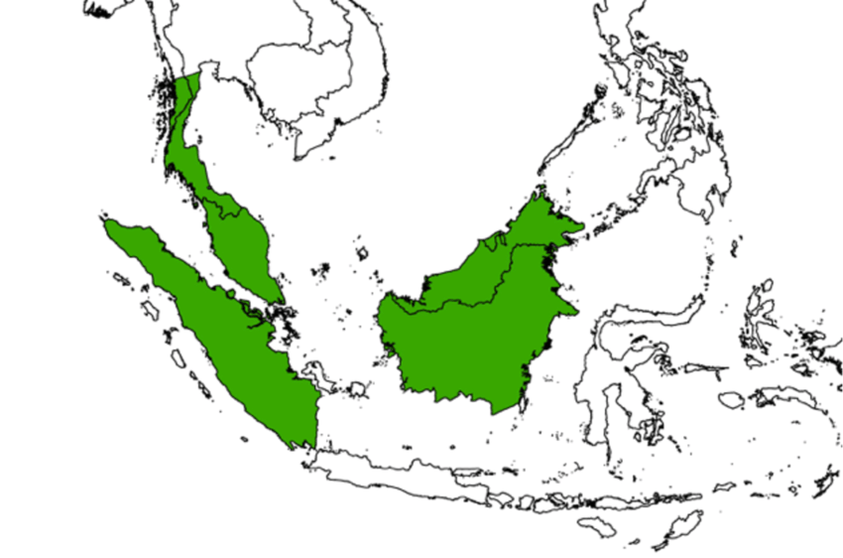 | 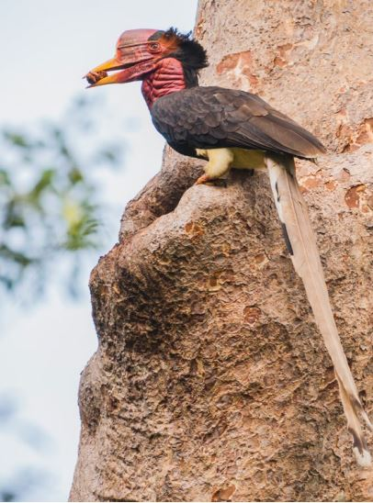
Helmeted Hornbill (Rhinoplax vigil), a species restricted to South-East Asia, is hunted throughout its range for its unique solid casque, which is used to make ornamental carvings. International trade in parts, products or specimens of this species for primarily commercial purposes has been illegal under CITES since 1975, while national legislation prohibits hunting and trade in most range states. However, high demand continues to drive unsustainable illegal take, killing and trade. A surge in trade resulted in the species being re-classified in 2015 as Critically Endangered on the IUCN Red list. In response, BirdLife and others developed a Range-wide conservation Strategy and Action Plan for conservation of the species. The plan has been widely adopted across the range and many actions are already underway. These include: monitoring of hornbill populations and poaching activity; identification of the most important sites of hornbills; public engagement and awareness raising; disruption of trade routes with seizures at transit points; improved law enforcement at poaching sites; and working with indigenous peoples and local communities to appointment them as guardians for their local hornbill populations. This approach has been successful in securing several high priority sites across Indonesia, Malaysia, Myanmar and Thailand, with these countries’ sites are acting as ‘safe havens’ where the hornbills breed and are shielded from illegal take.

BOX 4: Local self-regulation can be more effective at ensuring sustainable resource use than an outright ban
An outright ban, though at times necessary, is not always the most effective or desirable mechanism for dealing with unsustainable levels of hunting. For example, at Lake Chilwa Important Bird Area (IBA) in Malawi—where wildfowl hunting is an important part of local livelihoods—hunting clubs have successfully implemented measures to control hunting. They have also created a framework of fines that are enforced locally and contribute to community projects. This system of self-regulation is working well and, crucially, is respected by the local community. | 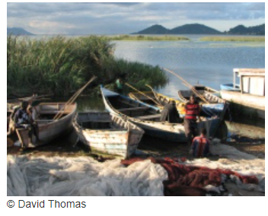
Lake Chilwa Important Bird Area (IBA), a shallow lake of about 700 km² bordered by swamps and seasonally flooded grassland, is very rich in fish and supports the livelihoods of about 60,000 people. It meets IBA criteria mainly because of its large congregations of waterfowl. Hunting these birds has long been part of local livelihoods, but large-scale commercial exploitation started in 1996, when the lake dried up and the fishery collapsed. This ability to shift between resources is an important dimension of the resilience of people dependent on natural resources and living in an uncertain environment. But a survey in 1998/99 estimated that over a million waterfowl had been taken following the drying of the lake, a level that appeared unsustainable.
The response of BirdLife Partner the Wildlife and Environmental Society of Malawi (WESM) was not, as might have been expected, to seek a ban on bird hunting, but to find a way to give communities the responsibility and capacity to manage their resource sustainably. A revision of Malawi’s Wildlife Act allows Community Conserved Areas to be established. Under the management of WESM’s Zomba branch, 20 hunting clubs have been created around the lake, with representatives elected to an umbrella body. WESM worked with the clubs and local government to reach an agreement on measures such as a closed season, no-hunting zones, and licensing and bag-limits. These have been written into a by-law, with a framework of fines and measures for dealing with infractions. Importantly, the whole process operates at the local level—offenders are dealt with by traditional chiefs, and fines contribute to community projects like repairing bore-holes and improving school buildings.
So far, the system is working well, and the regulations seem to be respected. The hunting clubs are now looking at ways of diversifying their livelihoods. They are earning extra income by guiding tourists and, with WESM’s help, have developed a tourism business plan. The hunters also carry out bird censuses four times a year, in January, April, July and October.

3.3. Monitoring approaches for birds
Population monitoring for birds should be carried out periodically to capture population patterns and trends in order to accurately inform conservation efforts and sustainable harvest levels. The approach taken largely depends on the objectives of the survey/ monitoring regime.
Types of estimates of population include,
- Abundance, derived from birds identified and counted in the field
- Relative abundance, derived from the frequency with which birds were detected and how common or rare a species is relative to other species in a given location or community.
- Density, based on the number of birds of a given species counted in a specified distance/ per unit area.
Table 1. Survey methods for field monitoring of birds. Adapted from Irham (2018)
Method | Description | Suitable ecosystems | Complexity
Area search | Records a list of species observed in a given area/ or distance taken to record a pre-specified number of observations. It can be used to estimate species richness and relative abundance. This method can be used to inform more systematic quantitative monitoring (i.e., point count or distance methods) | All | Simple to conduct, provides a baseline assessment only.
Point count | Records birds species and their number at a specified observation area. The observation area is determined as the radius around a specified point (i.e., 25m-50m). Records birds observed (detected) in a specified time period and place. These detections can be grouped by type of observation i.e., primary, supplemental, flyover etc.  It can be used to estimate the actual population figure, relative abundance, population trend (if carried out periodically by time/ season).  This can be combined with vegetation plots to determine its structure and composition. This information is useful in ecological modelling of bird communities/ habitat associations. | Suitable for high vegetation cover ecosystems i.e. forest/ uneven ground | This can be performed randomly or systematically i.e. according to a pre-determined system. Error rate can be higher than other methods given the potential for double-counting and errors in estimating distance.
Line transect Distance sampling/ Point count distance sampling | Line surveys are conducted by walking continuously along a predetermined route recording species observed (seen/ heard) either side of the path.  It is used to estimate abundance and density of birds in a location. | Limited to ecosystems in which a relatively accessible pathway can be established, so is less suitable for dense vegetation/ undulating landscapes. | It is a relatively fast method for covering a survey area, and has a lower error rate than a point survey. Drawbacks include, difficulties in assessing distance between the observer and bird, which is important for estimating density, and potential for birds to take flight on the observers approach.
Trade monitoring survey | Based on the circulation of birds in the trade, population values are measured on the number of birds harvested from the wild and available for sale.  If birds are frequently recorded in the surveys then the assumption is the species population is still within its carrying capacity, if supply declines then it can be inferred the population is in decline in the wild. Though there a number of factors which can effect | Markets | As an indirect method it is less accurate than direct observation methods because it relies on trade dynamics (i.e. value and trapper effort)

To note, in the CITES nomenclature these species are listed under the Apodiformes, though have recently been reclassified taxonomically as the Caprimulgiformes.
CITES trade database
The source codes which are exempt are, ‘I’ which refers to specimens confiscated or seized, and, ‘O’ which refers to pre-convention specimens. For further detail on source codes see Module 2 on NDFs by source code).
Cites trade database ref
Checklist reference
Birds of the World (https://birdsoftheworld.org/).
Noting that there may be differences in the nomenclature used across these resources.
BirdLife datazone reference
Checklist of CITES species – CITES Identification Manual. CITES Secretariat, Geneva, Switzerland, and UNEPWCMC, Cambridge, United Kingdom. Accessed on [Date].
See ¹⁵.
See ¹⁷
CITES Conf. 9.6 (Rev. CoP19)* Trade in readily recognizable parts and derivatives, including providing the definition ‘m ‘readily recognizable part or derivative’, as used in the Convention, shall be interpreted to include any specimen which appears from an accompanying document, the packaging or a mark or label, or from any other circumstances, to be a part or derivative of an animal or plant of a species included in the Appendices, unless such part or derivative is specifically exempted from the provisions of the Convention.’
Bird et al generation lengths of the world’s birds and their implications for extinction risk PAPER
Bird et al (2022) Supplementary material – generation lengths dataset cobi13486-sup-0004-TableS4.xlsx (this dataset is open-access)https://conbio.onlinelibrary.wiley.com/action/downloadSupplement?doi=10.1111%2Fcobi.13486&file=cobi13486-sup-0004-TableS4.xlsx
IUCN Red List categories and criteria, version 3.1, second edition https://portals.iucn.org/library/node/10315
Lumbierres et al (2022) Area of Habitat maps for the world’s terrestrial birds and mammals
Lumbierres, Maria et al. (2022), Area of Habitat maps for the world's terrestrial birds and mammals, Dryad, Dataset, https://doi.org/10.5061/dryad.02v6wwq48
iucnredlist.org
. Bird JP, Martin R, Akçakaya HR, Gilroy J, Burfield IJ. 2020. Generation lengths of the world’s birds and their implications for extinction risk. Conserv. Biol. 34:1252–61
iucnredlist.org
Adapted from the definition provided under the Review of Significant Trade (AC32. Doc.14.2), as follows, ‘Sharp increase (global): Taxa met this criterion if the volume of direct exports in [the last year of trade] at the global level across all accepted terms was more than three times the average trade volume of the preceding five years. A minimum trade threshold [should be applied]; [with] taxa excluded if they were traded in very low volumes, defined as (a) totalling less than 100 units over the [preceding] 10 year period or (b) average trade of less than 1 unit/year (if the taxon is CR, EN) or 20 units/year (any other IUCN classification or not assessed) in the most recent three years) Sharp Increase (Country): Taxon/country combinations met this criterion if the volume of direct exports across all accepted terms (see Table 2) in 2021 was more than three times the average trade volume of the preceding five years (2016-2020). A minimum trade threshold was applied; taxa were excluded if exports of that taxon/country combination occurred in very low volumes, defined as (a) totalling less than 100 units over the 10 year period 2012-2021 or (b) average trade of less than 1 unit/year (if the taxon is CR, EN) or 20 units/year (any other IUCN classification or not assessed) in the most recent three years (2019-2021)). It should be noted that, in cases where specimens are taken from marine areas beyond national jurisdiction (ABNJ; the ‘high seas’) in a ‘one-state transaction’ (see Figure 3), the high seas is treated as the exporter. A sharp increase in trade in one-state transactions from the high seas is therefore not attributed to any single country, but information on the major one-state transaction importers of specimens from ABNJ is shown alongside these cases for clarity. AC32 Doc. 14.02
Snakes guidance
Stringham et al 2021 Dataset of seize wildlife and their intended uses
Stringham et al dataset download https://figshare.com/articles/dataset/Dataset_of_seized_wildlife_and_their_intended_uses/14914773
Conf Res https://cites.org/sites/default/files/document/E-Res-10-16-R11_0.pdf
https://www.publish.csiro.au/mu/MU13094_CO check for details re: evidence of potential smuggling of native Australian parrots
Valle, Collar, Harris, Marsden (2018) Trapping method and quota observance are pivotal to population stability in a harvested parrot
Moussy et al (2021) A quantitative global review of species population monitoring https://conbio.onlinelibrary.wiley.com/doi/10.1111/cobi.13721
Fraisl et al (2022) Citizen science in environmental and ecological sciences https://www.nature.com/articles/s43586-022-00144-4
Sun et al Citizen Science Data Collection for Integrated Wildlife Population Analyses https://www.frontiersin.org/articles/10.3389/fevo.2021.682124/full
Bianchini & Tozer (2023)
The Living Planet Index (LPI) is a measure of the state of the world’s biological diversity based on population trends of vertebrate species from terrestrial, freshwater and marine habitats. It is based on trends of thousands of population time series collected from monitored sites around the world. https://www.livingplanetindex.org/
statistics https://www.livingplanetindex.org/stats
The carrying capacity of an environment is the maximum population size of a biological species that can be sustained by that specific environment.
Red list criteria
HBW and BirdLife Taxonomic Checklist v.7 http://datazone.birdlife.org/userfiles/file/Species/Taxonomy/HBW-BirdLife_Checklist_v7_Dec22.zip
REFERENCE BLI SOWB
https://www.nationalredlist.org/
BirdLife International. 2020. IUCN Red List for birds. BirdLife International. http://www.birdlife.org
Red list criterion
Williams, D.R., Pople, R.G., Showler, D.A., Dicks, L.V., Child, M.F., zu Ermgassen, E.K.H.J. and Sutherland, W.J. (2012) Bird Conservation: Global evidence for the effects of interventions. Exeter, Pelagic Publishing (https://www.researchgate.net/publication/268214226_Bird_Conservation_-_evidence_for_the_effects_of_interventions)
Adapted from the State of the Worlds Birds 2022
IUCN SSC Hornbill Specialist Group Helmeted Hornbill (Rhinoplax vigil): Status review, range-wide conservation strategy and action plan (2018-2027) https://iucnhornbills.org/wp-content/uploads/2018/09/HelmetedHornbill_actionplan_final_LR.pdf
BirdLife International (2011) Local self-regulation can be more effective at ensuring sustainable resource use than outright ban. Downloaded from http://www.birdlife.org on 25/07/2023
Irham (2018) Book IX: Survey and monitoring methods bird population ( LIPI Survey method series and animal population monitoring)
Harris et al (2015) Using market data and expert opinion to identify overexploited species in the wild bird trade. Biological Conservation. 187:51-60

