MODULE 5: MARINE AND AQUATIC SPECIES

- What is in this module?
This Module provides additional details to support the making of NDFs for aquatic species, for which there have been increasing number of species listed in the CITES Appendices over the last three decades. Ensuring harvest and associated trade in aquatic species is legal, sustainable, and traceable can pose unique challenges for Parties based on life-histories, modes of trade and storage, and the fact that many people that rely on these species for their livelihoods often have limited resources.

- Lack of capacity and technical resources to carry out NDFs for aquatic species

A lack of capacity and resources is consistently being raised as a barrier to producing NDFs, and directly links to limited data situations as discussed in the previous Section. Indeed, addressing this was a key recommendation to CoP15 after the 2008 workshop in Cancun. There has been general progress in building NDF capacity across Parties but in the report of the “Implementing CITES for seahorses – Asia region workshop”, held in March 2023, the importance of building synergies was raised as fundamental for strengthening the assessment process. It was stated:

Authorities can partner with other government agencies and/or external stakeholders (academia, NGOs, etc.) to collect and analyse information, then collaborate on NDF assessments.

Authorities should seek synergies with their CITES responsibilities for marine species, using research programs and management measures to improve knowledge and action for several CITES taxa at once.

National NDF workshops could help [with NDFs] for several CITES listed taxa.

For example, Scientific Authorities elsewhere in a region may have already prepared NDFs for the same species/stock and/or can collaborate in developing assessments to be shared and adapted to reflect each Party’s specific situation.

  - CITES NDF website/database

Since the first NDF workshop in 2008, a great deal of work has been carried out to establish the dedicated NDF page and associated database on the CITES website. This has over 50 documents relating to NDFs for aquatic species from case studies submitted by Parties, guidance documents and workshop reports. This provides a very useful starting point for Parties looking to carry out NDFs, and where possible sharing of case studies is strongly encouraged.

  - eNDF platform

In order to simplify and automate elements of the NDF process, Blue Resources Trust (BRT) have been working for a number of years to develop a tool – eNDF – using sharks and rays as model species. The aim of the tool is to provide a stepwise risk analysis approach to making a NDF. The process provides an estimated impact level on the shark stock by making inferences on populations status and management risk of the species. Its steps are based on 2014 the NDF guidance for Sharks.
This endeavour has been supported by the German government in recent years to develop it into an online platform which is now open for Parties to use. Where appropriate, input is through drop-down menus and selection of pre-populated information from external resources, making the process much less labour intensive. Further, there are help sections that can advise at each step.

Access to the platform can be requested here and the user manual can be found here. It is possible that the platform could be modified for use with other species.

More recently, BRT have been working with The Pacific Community (SPC) to adapt the process for use with sea cucumbers. It is possible that it could further be adapted for other species.

  - Simplified guidance documents

The aforementioned regional workshop to improve CITES implementation for seahorses included “Easier advice for making seahorse CITES non-detriment findings (NDFs)” developed by Project Seahorse.

Their approach maps answers to five questions (5Q) in overlapping layers and these could be tailored for us with other species:

- where has the species been found?

Then, for those areas:

- What pressures do the species face?
- What measures are in place to manage the pressures?
- How well are the management measures implemented?
- What is happening to seahorse populations?

By following this process, it was stated:

Answering the first four questions allows for a rough inference of possible population trends – and the capacity to make interim NDFs – even while monitoring is being developed to answer the fifth. Answering “what is happening to the seahorse populations” will provide new or strengthened information with which to revisit the first four questions, in an adaptive management framework.

The workshop report summarises comments from participating CITES Authorities with respect to the guidance. In particular they noted that:
- working through the 5Q framework (and Figure 1) is very helpful, especially when people are new to making NDFs, or in data poor situations;
- that the 5Q approach provided a way to categorize information needed for an NDF, offers a means of identifying gaps in information needed for the NDFs, and helps highlight next steps; and
- that making NDFs does not have to be a one size fits all situation. Authorities may use more sophisticated approaches in regions where they know more, but should be able to do a first pass of the easier 5Q approach in most places, even with limited data.

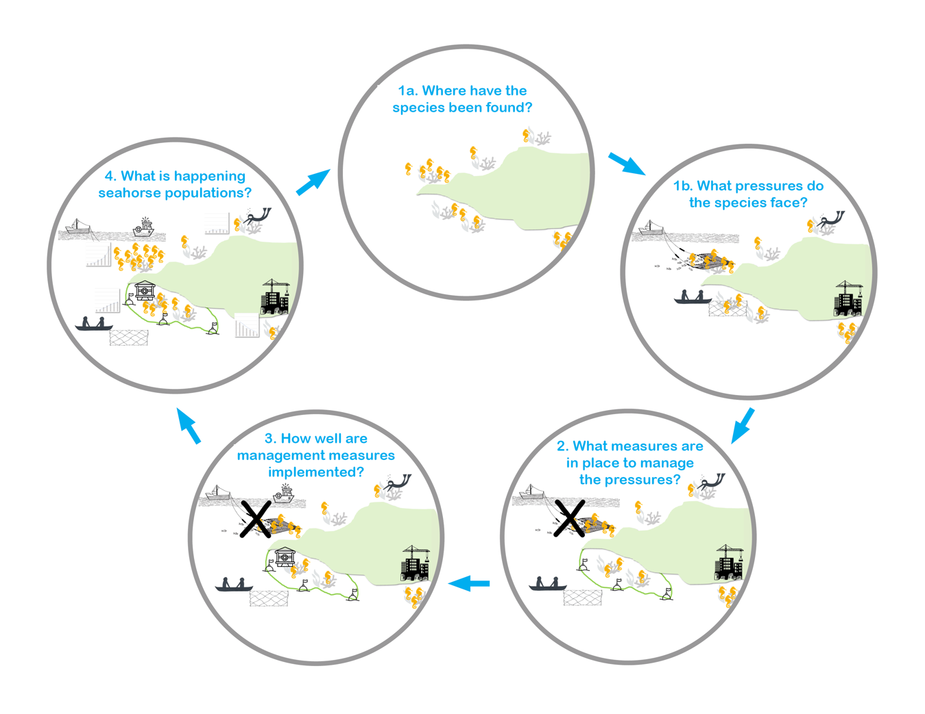

Figure 1. A framework for making easier NDFs for seahorses.

- How to address low/poor data situations
Limited data has long been recognised as prohibitive in the production of NDFs. For example, this may be an absence of harvest data, temporal and/or spatial patchiness, or challenges relating to utilising available data for making NDFs. Further, most, but not all, CITES-listed aquatic species are not the primary target of fisheries and data on bycatch, in particular historical data, is often non-existent, unreliable and/or has low taxonomic resolution. There has been good progress in recent years with regard to addressing these challenges and Module 1 specifically focuses on these, This Module focuses on resources that relate specifically to aquatic species.

In the absence of harvest-dependent catch data to make a NDF, there may already be relevant actors and/or frameworks in place that can be used with limited time and resources to yield information to inform NDFs. For example, while data specifically related to fisheries is valuable in the making of NDFs there may be opportunities elsewhere in the supply/traceability chain that could supply relevant data. Carrying out a mapping exercise of relevant actors within these chains could help to identify points of entry for data collection. One example that was highlighted was that issuance of licences/permits within the supply/traceability chain provide opportunity to have conditions relating to data submission that could inform NDFs. This could apply to fishers, but also consolidators, dealers and/or traders. As a condition of the hammerhead (Sphyrna spp.) NDF for trade from the Atlantic Ocean and Gulf of Mexico fishery in the US, both fishers and dealers are required to report catches and purchases respectively. Traders were interviewed in a 2019 study that aimed to understand the scale of illegal trade in dried seahorses in Hong Kong Special Administrative Region (hereafter Hong Kong SAR). It was highlighted that subjects such as this could put interviewees at risk and that appropriate confidentiality mechanisms should be put in place to ensure anonymity.

It was raised that, where possible, it would be a useful exercise to characterise minimum data requirements – this is referenced in operative paragraph 4 of Resolution Conf. 12.6 (Rev. CoP18) on Conservation and Management of Sharks.

Low data situations have also been considered in the development of simplified guidelines for making NDFs for aquatic species (see Section 2.3, above).

  - Use of risk assessments as the starting point of NDFs

Some Parties have utilised methods that implement a risk assessment approach as a starting point for NDFs of aquatic species. There are a number of these that can be applied in the context of aquatic species e.g. Productivity Susceptibility Assessment (PSA) and Ecological Risk Assessment (ERA). These assessments are intended to be rapid, semi-quantitative tools that utilise life history data to characterise the relative productivity and associated susceptibility of species to fishing pressure. They do not provide information on the current status of a stock or a sustainable management reference point but can help to identify which species / locations / fisheries are more or less resilient than others. Possible data inputs can be seen in Table 1:

Table 1 – Potential data inputs for risk assessment analyses

Productivity Attributes | Susceptibility Attributes
• Population growth rate  • Max age  • Max size  • Growth rate  • Natural mortality  • Breeding and reproductive strategy  • Recruitment  • Age at maturity  • Trophic level | • Geographical overlap of fisheries  • Geographic concentration of fisheries  • Vertical overlap of fisheries  • Seasonal migrations  • Schooling behaviour  • Morphology  • Desirability (Value)  • Management strategy  • Fishing rate  • Spawning biomass  • Survival after capture  • Impact on habitat

Examples from the US and Mexico provide useful case studies of how PSA has been applied to sharks.

Below is a proposed framework provided by Mexico on how data is assessed as part of the risk assessment process:

When making NDFs two main processes are deployed as envisaged in Resolution Conf. 16.7 (Rev. CoP17) on NDFs: I. Acquisition and assessment of information on species biology and II. Set a sustainable harvest rate. Both processes are linked such that better species data (including threats), will reduce the risk associated with management decisions and strengthen NDFs. These two processes ultimately work on a spectrum and depend on the available baseline data (Figures 2 and 3):
- The quality of the species population data depends on the collection methodology and associated analysis. Figure 2 aims to categorise the state of knowledge to assess baseline data. When you move from informal or anecdotal information to using standardised sampling of the population, the analysis becomes more robust.

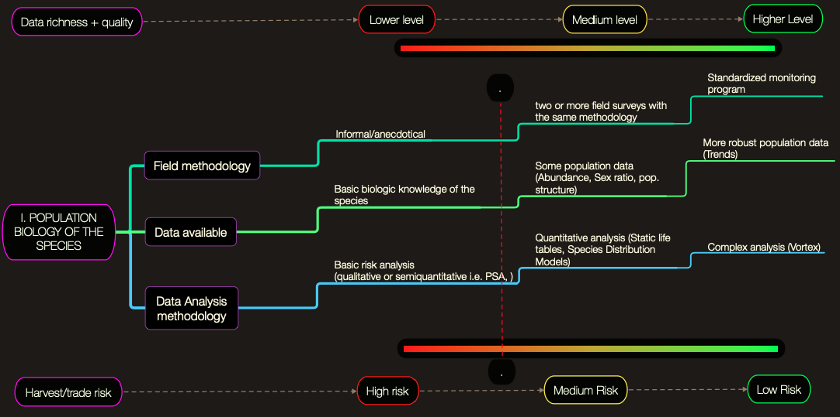

Figure 2. The relationship between species data quality and harvest risk.

- If data is limited, the harvest rate may have to be set by expert opinion and which comes with greater uncertainty. This can be refined through adaptive management, but the initial risk is higher. With better data, you can define more robust harvest rates and reference points. Figure 3 aims to categorise the risk of harvest rates. Better data quality and analysis reduces the risk associated with a harvest rate.

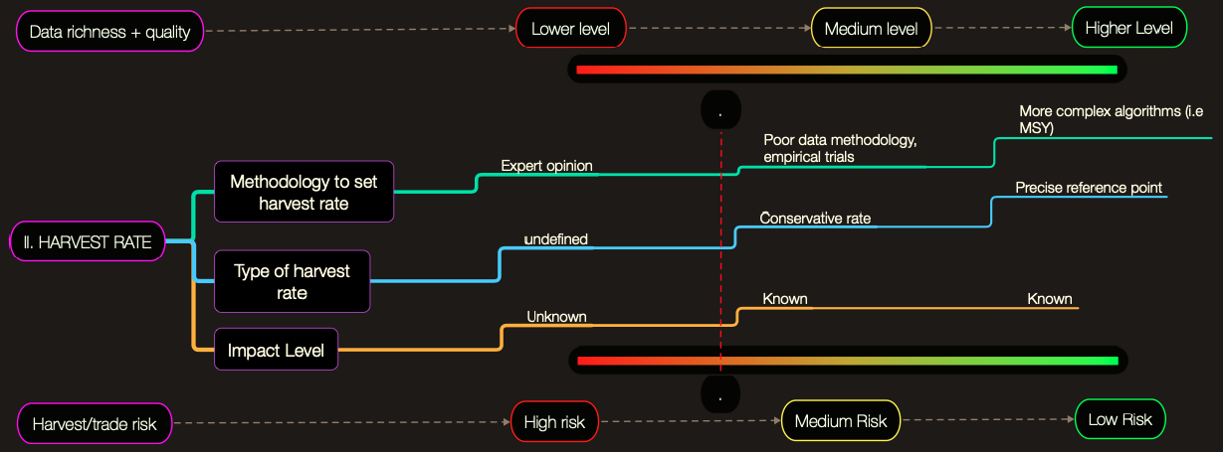
Figure 3. Harvest rate based on associated risk and data quality.

Once you have defined your population biology and harvest rate, you can identify relevant tools strengthen the data and reduce risk associated with NDFs. An example of the application of this self-diagnostic tool is shown in the case study of the NDFs for sharks of Mexico in Section 4.2.4.1.

The work carried out by TRAFFIC supported by the UK Government to develop the M Risk (1, 2, 3) framework also used sharks as a model taxa. This is a more complex process and based around three elements – stock status, species-specific management, and generic fisheries management. In 2023, 56 carcharhinid shark species sharks - were analysed using the M Risk framework. This could provide a useful starting point for Parties wishing to carry out NDFs for these species – these analyses can be accessed using the links above.

Conditional NDFs

Some Parties have approached uncertainties, risks and/or data gaps in the context of producing NDFs by applying associated conditions to trade. In so doing, they have allowed for precautionary levels of harvest and associated exports while risks are reduced, gaps in management are addressed, or quality of information is improved. This pragmatic approach offers the opportunity to identify and implement effective management measures, rather than deferring to zero quotas or trade suspensions/bans, though there are circumstances when such stricter measures are needed. Conditional NDFs are discussed in more detail in Module 1 on NDF Principles.

The US government shared materials that they had developed to consider conditional NDFs for sharks based on case studies from other species. These possible conditions could include providing data for management through mandatory species-specific reporting requirements linked to licences/permits, harvest season and/or gear restrictions, and size restrictions for whole sharks and/or fins. The US also proposed that SAs work with relevant domestic and international fisheries organisations in developing the conditions for positive NDFs. The need for such collaborations is addressed elsewhere in the document (see Section 3.1.2.).

Several of the NDFs for sharks and rays that have been shared via the CITES database have come with certain conditions. For example, India recognised that more information was needed in relation to the status of Mobula birostris and M. alfredi in their waters and proposed the following time-bound NDF in 2017:

From the information available on the fishery and stock status of manta rays in Indian waters, ICAR-CMFRI has found that at present the extent of threat posed to the stock cannot be clearly assessed. Collection and analysis of data on fishery and trade of this species must be continued for three more years. The NDF study can be taken up after three years, during which time international trade in this ray and its by-products can be done with CITES certification, subject to existing regulatory laws on elasmobranch trade implemented by the Government of India. Since the species is characterised by high biological vulnerability, a precautionary approach is recommended, which includes intensive awareness generation among stakeholders.

These conditions were also applied to India’s NDF for Silky shark (Carcharhinus falciformis) between 2019-2022 – note that this NDF assessment was carried out using the eNDF tool (see Section 2.2):

This silky shark (Carcharhinus falciformis) NDF for India is “positive with conditions” to enable trade (of non-fin commodities) to continue for this newly-listed species while improvements are made to existing fisheries and trade management and monitoring frameworks, and while additional research activities and management measures are adopted... This NDF will be re-evaluated after 3 years, to gauge progress against the recommendations … and update it with newly acquired data, before agreeing to a new NDF for 2023-2026.

Costa Rica similarly used time-bound NDFs for Thresher sharks (Alopias spp.) in 2020 in relation to compliance:

For its part, the Board of Directors of Incopesca must adopt this agreement within a period of no more than 6 months from the date of presentation of this NDF to the CITES Management Authority for species of fishery and aquaculture interest. For its part, the CAC-CITES shall meet before the expiration of this NDF, in a working session in which the only topic to be discussed will be the compliance of this recommendation. If positive, then the NDF term will be extended for an additional year. (Translated from the original Spanish).

While conditions are normally associated with a positive NDF, there are negative NDFs that outline key areas that need attention before trade would be permitted. For example, Indonesia produced a negative NDF for mako sharks (Isurus spp.) and had a number of conditions that would need to be met before harvest and trade would be permitted, e.g., improving data collection and catch monitoring, strengthening implementation of management measures and developing appropriate policy. Indeed in the report of the Asia regional workshop for seahorses, it was stated:

Authorities should consider working through the NDF framework even when they know the NDF will be negative. It helps in communicating the MAs decision to stakeholders. It also helps Authorities and stakeholders understand what is needed to move toward sustainable exports in the future, informing an action plan.

    - Strategies to improve linkages between fisheries departments and CITES Authorities

It was identified by a number of Parties that relevant government departments/agencies and CITES Management and Scientific Authorities, that have oversight of CITES and carrying out NDFs, are often separate from those that are responsible for collecting fisheries data and developing/implementing fisheries management measures. This is obviously a fundamental disconnect that could mean relevant data and expertise is not being fed into the NDF process.

The UK NDF for the European eel (Anguilla anguilla) provides an example of where the SA (Joint Nature Conservation Committee), MA (Department for the Environment, Food and Rural Affairs) and organisations with oversight of fisheries management, and associated data collection and analysis (Agri-Food and Biosciences Institute, Centre for Environment, Fisheries and Aquaculture Science, Department of Agriculture, Environment and Rural Affairs and Environment Agency), were all involved in the developing the final assessment. This example provides a particularly complex case study, due to the nature of the species and associated trade, however, it highlights the value in including those beyond just the SA and MA in producing NDFs. This also applies to the NDFs produced by the US for listed shark species, where the SA (US Fish and Wildlife Service) works closely with the national body in charge of marine resource management and engagement with RFMOs (NMFS). Several examples of NDFs from the US can be found in the CITES database.

In addition to national level input from fisheries departments, there is also the possibility of including the expertise from international RFBs, in particular for shared species that fall under their mandate – this is addressed in Section 3.7, below.

    - Use of Local Ecological Knowledge

The use of LEK is address in Module 3, however, there are incidences where it has specifically been used in the context of aquatic resources. A number of CITES-listed species have been the focus of studies that collect and analyse LEK in the context of fisheries and trade management.

In absence of any national long-term monitoring or research programs for seahorses (Hippocampus spp.), LEK has been a key source of the fisheries and trade knowledge used to inform CITES implementation for this group of fishes. For one example, a study was carried out to assess trends in fish landings and value in Vietnam utilising fisher and buyer LEK. It was identified that seahorses are primarily caught incidentally using multiple gear types and have both cultural and financial value. Of significance to carrying out NDFs, fishers ‘…reported that seahorse catch rates decreased by 86–95% from 2004 to 2014, while landed value simultaneously increased by 534%.’ This could suggest that, if the majority of harvest is for export, that the present levels are not sustainable.

In another study where seahorses were the focal species, four methods for inferring species spatial distributions were examined: (i) fisher interviews; (ii) government research trawls, (iii) scientific diving surveys, and (iv) citizen science contributions. Analysis indicated ‘…that fisher knowledge provided more information on data-poor fish genus at larger spatial scales, with less effort, and for a cheaper price than all other datasets.’ One issue was that fisher knowledge was rarely to the species level and as such for data poor species, a mixed methods approach was suggested; ‘…begin with fisher interviews and use these to inform the application of government research, scientific diving, or citizen science programs’.

A recent study highlighted the value of the use of LEK to inform sustainable management of sharks – including CITES-listed species – in eastern and southern Arabia (Kuwait, Bahrain, Oman and Yemen). The work aimed to assess perceived trends in populations of hammerheads (Sphyrnidae) and carcharhinids. Results inferred declines in abundance of sharks starting in the late 1990s to early 2000s. Hammerheads had the greatest mean perceived decrease (80%), while the least decline, for certain species of carcharhinids, was still 50%. The situation was complicated as export was primarily for fins but meat was often consumed domestically and thus the livelihood and food security benefits were combined.

A report was published in 2022 that blends the use of fisheries data and LEK to develop recommendations to reduce incidental catch of dolphins.

  - Conversion factors for derivatives/processed products

Where species are caught and/or landed whole and then processed prior to (re)export, it may well be useful to utilise conversion factors to ensure that volumes reported for harvest and domestic use/international trade are equivalent. Depending on the species, processing will take many forms – e.g., when not live, seahorses are generally traded whole but dried, whereas many other species may be dressed and/or filleted depending on the market. Below are some examples of this but it is also important to note where conversion factors don’t exist and are needed e.g., shark meat/carcasses.

    - Shark and ray fins

Arguably one of the most significant international trades in aquatic products of CITES-listed species is shark and ray fins. A number of Parties have submitted documents on conversion factors, that can be found on the CITES website. In addition to this, there have a been several studies that have attempted to provide fin ratios for a number of shark species (Table 2).

Table 2 – Shark fin conversion factors

Resource | Species
ICCAT (2005); (2008) | Blue shark
Review paper (2012) | 50 species including Carcharhinidae, Sphyrnidae, Isurus, Alopidae and Lamna.
New Zealand Government (2014) | Mako, Porbeagle, Blue shark and others.
Indonesian research paper (2022) | Sphyrna, Carcharhinus, Alopias, and Isurus spp.

It was noted that the U.S. Department of the Interior's International Technical Assistance Program (DOI-ITAP) and the Government of Guatemala's National Council for Protected Areas (CONAP) had collaborated on a study entitled "Estimation of biometrics and parameters to establish the trade equivalency of dry fins for silky sharks (Carcharinus falciformis) and thresher sharks (Alopias pelagicus, Alopias superciliosus, Alopias vulpinis) landed in the Pacific of Guatemala.” Resulting data are currently being used for NDFs for this species.

As a process of identifying the most useful metrics for their particular needs, the Mexican SA provided the following case study:

In order to prevent a mismatch between landed catch (whole shark, undressed shark, fresh fins) and export volumes (mostly dry fins), the Mexican SA implemented a stepwise methodology to select the most accurate conversion factors:

- Compilation of papers, reports, thesis on conversion factors between all the common shark specimens reported along the trade chain in Mexico (from landing to export).

- Classification and scoring of all the information gathered within three successive categories:

- Taxonomic accuracy. A. Species-specific information, B. Information at gender level, C. Information at higher taxonomic level or with common name.

- Regional precision. 1. A study made in Mexico, 2. A study made in America, 3. A study made in any other part of the world

- Sample size. i. Sample size greater than 30, ii. Sample size lower than 30

- For each species and specimen, we selected the conversion factor with the higher ranking of these categories (Table 3).

Table 3. Selection of the best conversion factor between fresh fin (FFN) and whole shark for Sphyrna lewini in Mexico. The conversion factor provided by Cortés and Neer (2006) was preferred because its precision level was species-specific (category A), it was a study made in America (category 2) and it included a sample size higher than 30 (category i).

Precision | % FFN by  Whole Shark | Sample size | Place | Reference
A2i ✅ | 1.66 | 43 | USA | Cortés and Neer (2006)
A3ii❌ | 4.49 | 14 | South-western Indian Ocean | Ariz, et al (2008)

- All factors selected were validated in a joint workshop with academic experts and fisheries authorities and submitted to CITES.

    - Queen Conch

With regard to conversion factors for Queen Conch (Strombus gigas) meat fillets, it was communicated to the WG that there is a risk of introducing significant error when comparing total production of the species and the volumes in trade from a particular export – this is primarily due to the presence of the shell which accounts for 90% of the weight. The level of processing needs to be taken into account, as does the country of origin, in order to assess this risk due to differing procedures. As such, it was highlighted there was a need for regionally harmonised terminology and conversion factors for the species and this became a key activity post-CoP16 for CITES and FAO.

A document produced in 2014 used field testing to propose regional conversion factors for the Western Central Atlantic:

Table 4 – Conversion factors for Queen Conch

Processing grade | Conversion factor
Dirty meat (Animal without the shell) | 5.3
50% clean (Removal of the operculum and the visceral bag) | 7.9
100% clean (Only the white meat remains) | 13.2

There is further discussion of conversion factors in both the 2019 and 2021 report of the CFMC/OSPESCA/WECAFC/CRFM/CITES working group on Queen Conch, and a new report is expected in 2023.

    - Seahorses

Dried seahorse trade is often reported as weight, most commonly kilograms. In such cases conversion rates are needed to translate dried seahorse weights into number of individuals. Conversion rates have been established by Project Seahorse for various countries based on trade research carried out in the early 2000s (Table 5, based on Evanson et al. (2011)) with the exception of West Africa for which the conversion is based on unpublished Project Seahorse trade surveys). While these provide a useful starting point, it is important to update these values as the species composition and/or sizes of seahorses may have changed within regions/countries over time.

Table 5. Estimated dry weight of seahorses in different geographies.
Region/Country | Estimated dry weight of an individual seahorse
Australia | 3.00
Latin America (Atlantic) | 2.42
Latin American (Pacific) | 3.51
Malaysia | 3.18
Thailand | 3.13 / 3.30
Philippines | 3.33
India | 1.38
Indonesia | 2.00
Vietnam | 2.86
West Africa | 5.29
Global | 2.69

Seahorses are also traded in the form of prepared medicines, as powder mixed in with other ingredients. In such cases conversions are more complicated and research is needed to come up with reliable factors. Two examples come from a study analysing CITES trade records for seahorses from 2004-2011. First, China clarified that two records of derivatives represented individual capsules, each containing 1.4 mg of ground dried seahorse. Second, two records that had millilitres (MLT) as their unit (780mL combined) were assumed to be tonics, which were estimated to contain approximately 0.5 g of seahorse per 100 mL, based on the ingredients list of ‘Gekko Hippocampus’ tonic from Vietnam.

Although seahorses are not traded internationally in dead, wet form, they are often landed that way, and purchased as such by primary buyers. In these cases, it will be important to establish conversion factors from wet to dried seahorse weight to support monitoring of fisheries and domestic trade.

  - How to account for non-target catch
Many aquatic species listed in the CITES Appendices are referred to as ‘non-target’, ‘incidental’ or ‘by-catch’ species, despite their sometimes long-ongoing and profitable commercialisation. This does not exclude them from CITES provisions – if they are traded internationally it is essential that LAFs and NDFs are carried out to ensure their catch is legal and sustainable, and appropriate management mechanisms are in place. Indeed, this was highlighted in the 2014 NDF guidance for sharks, and in the rapid guide for making LAFs in Resolution Conf 18.7 (Rev CoP19) it was stated:

It is also important to note that for the authorization of trade in marine species under the Convention, it is irrelevant whether the caught specimen was targeted or bycatch. Both targeted catch and bycatch should be documented and reported. The provisions of the Convention fully apply to bycatch.

For example, seahorses in international trade are primarily landed in non-selective fishing gear, particularly bottom trawls and gillnets (e.g. 1, 2, 3, 4), and an observation made at the Asia region workshop reported on in AC?? Doc 38.2 was that:

It will be more challenging to make NDFs when seahorses are captured incidentally. For non-target fisheries, the main management will be excluding gears from seahorse areas, in line with the many existing national decrees for no take marine protected areas and on bottom trawl exclusion zones.

For species that are migratory, it is important to consider the catch, and associated management measures at the population level, and not just within EEZs. The US has submitted a number of shark NDFs to the CITES database, and incidental catch is specifically referenced. For example, in relation to shortfin mako catch in 2019-2020, the following was stated:

The shortfin mako shark fisheries on the high seas and in the EEZ of U.S. waters of the Pacific Ocean are managed under a system which allows harvest from directed, bycatch and recreational fisheries.

In instances where there are mixed sources of species in trade e.g. incidental and targeted catch, it is important to ensure appropriate management measures are in place to account for this. It was stated in the 2014 NDF guidance for sharks:

‘It is important to consider that export quotas will not limit catches where sharks are obtained as bycatch. In such cases any use of quotas should be combined with other precautionary measures, given the uncertainty as to how export quotas influence catches.’

This has the potential to become further complex when applied to incidental catch in ABNJ.

It is important to note that all incidental catch of a species should be accounted for in making NDFs, not just that which is landed. For example, if there are discards due to size, sex, condition, etc., this is still relevant to the assessment and associated management measures. Indeed, a recent paper suggested that discards of CITES-listed sharks could be significant. Therefore, being able to assess the proportion of the species catch that is landed and discarded is an important consideration. In their NDF for silky shark (Carcharhinus falciformis) in the Indian Ocean (2019-2022) India specifically state:

In India, the majority of silky sharks are caught as secondary catch in longline and drift gillnet fisheries for large pelagic, with a small bycatch by trawlers. Size range in fisheries for the species 67 to 275 cm TL is recorded from the south west coast of India. Discard of silky shark in Indian waters is negligible as whatever caught is retained.

This highlights the landed catch of this species is representative in the context of making a NDF.

Ultimately, understanding the source of the catch through monitoring will inform management in the context of whether it is targeted and/or incidental, and how this needs to be adapted and implemented to produce a positive NDF.

  - How to account for other sources of mortality of listed species

A fundamental component of the NDF process is to assess how international trade, and associated harvest, impacts populations of a species in the context of other threats. CoP11 Inf. Doc. 11.3 entitled CITES Scientific Authorities’ Checklist to assist in making Non-detriment Findings for Appendix II Exports stated:

It is vital to any evaluation of non-detriment that the Scientific Authority assesses the impact of trade in relation to other threats to the species.

Similarly, the shark NDF guidance states:

The total level of mortality experienced by the stock is key to its past and future status, regardless of whether that mortality occurs as a result of targeted fishing or secondary catch as part of other target fisheries. The same is true whether that catch occurs within EEZs or on the high seas, and whether it is discarded, used domestically or exported. In short, all mortality needs to be considered when making an NDF.

Further, a step-by-step framework for making NDFs for seahorses, makes the point that:

NDF assessments must consider ALL pressures facing your seahorses. So even very small export volumes could pose a problem – and potentially need reduction – if your seahorses are threatened in other ways. For example, if your seahorse habitats are in bad shape, or there is a large domestic or illegal trade, then any export might be unsustainable. That is why [the framework] will consider fishing pressures … and threats to seahorse habitats …. This is also why, when considering trade pressures … we consider domestic consumption, and illegal, unregulated and unreported (IUU) fisheries and trades; if either of these is big, then even a small international trade can be too much for a population to handle.

If harvest for international trade is the major threat to a species, then the production of a NDF is arguably simpler than if there are other primary, and/or multiple, stressors, the effects of which are not well understood. In 2009, the NDF from Colombia for Queen Conch recognised that habitat loss and pollution were also threats.

A species that exemplifies this is the European eel. In 2015, a workshop was held to identify criteria for use in making a NDF for the species, the report states:

The number of glass eels arriving in continental waters has declined dramatically since the early 1980s, although there have been increases from 2011 to 2013). The causes of this decline are uncertain but may include overexploitation, pollution, non-native parasites and other diseases, migratory barriers and other habitat loss, mortality during passage through turbines or pumps, together with oceanic-factors impacting migrations. These factors will have been more or less important on local production throughout the range of the eel, and could potentially have cumulative and/or synergistic effects. Therefore, in the planning and execution of measures to ensure the protection and sustainable use of the European eel stock, management has to take into account the diversity of conditions and impacts.

The UK NDF for the European eel sets fisheries mortality (∑F) in the context of other anthropogenic mortalities (∑H) to provide a total (∑A) – these metrics are used within the assessment of sustainability.

One continuing issue in relation to carrying out NDFs for all aquatic species is the challenge of accounting for Illegal, Unreported and Unregulated (IUU) harvest and trade. By its nature it is extremely difficult to quantify IUU harvest and trade, and the scale and complexity will vary depending on the species and its range. The US recently produced a report relating to IUU fishing of sharks, though this does not aim to quantify such activity, and the 2020 UNODC report used glass eels as a case study. These might provide useful case studies for Parties.

Other sources of mortality are addressed in the aforementioned CoP 17 Information Document submitted by IUCN.

  - Monitoring to inform NDFs for adaptive management

Monitoring is a fundamental element of adaptively developing a NDF – from Resolution 16.7 (Rev. CoP17):

…the implementation of adaptive management, including monitoring, is an important consideration in the making of a non-detriment finding…

Tracking populations over time is also important to: 1) indicate need for conservation and management intervention, and 2) understand effectiveness of management. A dedicated working group has considered adaptive management in the context of making NDFs (see report XX), however, aquatic species-specific examples are presented below.

Monitoring should be carried out at geographically and temporally relevant scales which will vary between species depending on their life histories and the nature of the fisheries. At CoP17 in 2016, Inf. Doc. 65, developed by IUCN and FAO, specifically outlined minimum data guidelines to developing monitoring programmes for adaptive management. In relation to this the report of the aforementioned regional seahorse workshop stated:

It is important to note that even if they monitor differently, all jurisdictions/agencies/external stakeholders should collect, at minimum, an agreed set of metrics so data can be combined/compared across jurisdictions and even regions.

As a basic, monitoring protocols need to include questions that drive reliable documentation of fisheries and trade effort.

The 2014 NDF guidance for sharks states:

In order to make robust evaluations of the pressures exerted by fishing on the stock of a shark species, in many cases there will be a need to improve reporting of catch, bycatch, discard and landings data by species and by weight, in order to determine contribution of bycatch and discards to overall shark mortality. Data should be both timely and standardised, to allow effective monitoring of the state of fisheries resources (see also Step 6) and to detect established and emerging trends.

As such, catch and/or trade monitoring may be built into NDFs as a condition e.g. Sri Lanka NDF for Sphyrna spp. (2017-2019) (Table 6).

Table 6 – Conditions associated with Sri Lanka Hammerhead NDF

Monitoring and data recommendations for Hammerhead Sharks
Recommendation | Potential leads
Population monitoring:  Maintain, and if possible, expand observer programmes on board and port sampling (data collection at landing sites) to improve species-specific data on composition of catches by size, sex and maturity (e.g. the programme recently implemented by Sri Lanka’s NARA (National Aquatic Resources Research & Development Agency) and DFAR (Department of Fisheries and Aquatic Resources) | NARA, DFAR in Sri Lanka  (Also other Indian Ocean fishing States, IOTC, BOBP-IGO)
Research:  Investigations into key biological/ecological parameters, life-history and behavioural traits, and the identification of potential mating, pupping and nursery grounds. More data on species, size, maturity and sex structure of hammerhead landings.  Socio-economic studies on shark fisheries, trade and alternative livelihoods | DFAR, NARA, universities, and NGO’s in Sri Lanka.  (Also other Indian Ocean fishing States, IOTC, BOBP-IGO) IGOs and iNGOs
Fisheries monitoring:  Improved species-specific fisheries data on catches and landings are needed to ensure harmonisation of data from different sources (e.g. IOTC and FAO). | Sri Lanka DFAR, NARA  (Also other Indian Ocean fishing States, IOTC, BOBP-IGO)
Monitoring of domestic and international trade:  Implementation of specific catch or trade documentation schemes for sharks.  Pursue with Sri Lanka Customs the request to introduce HS codes for all shark products, to permit the collection of better data on imports and exports.  Improve present methodology for the random sampling of fins for export, in conjunction with Sri Lanka Customs.  New data collection initiatives to quantify more precisely hammerhead shark fin exports and identify and monitor hammerhead shark fins, and meat & other products (if any) at species level. | Sri Lanka Customs department, DFAR, NARA  (Also other Indian Ocean fishing States) IGOs, NGOs

As stated previously, Indonesia produced a negative NDF for mako sharks (Isurus spp.) which included improving data collection and catch monitoring as a condition for any future harvest and trade.

    - Example: Adaptive management for seahorses

Project Seahorse has presented advice on monitoring seahorse populations in support of conservation and management, focused around three main approaches:
- Trade dependent – monitor domestic and international trade volumes, including illegal trade, often by asking questions of fishers, primary buyers, consolidators and/or exporters.
- Fisheries dependent – monitor catches (ideally) or landings, at ports or onboard vessels, paying critical attention to changes in fishing effort.
- Fisheries independent – underwater surveys of seahorse populations through snorkel or SCUBA, preferentially using timed swims for seahorses, rather than transects.

Project Seahorse has further collaborated with Viet Nam’s Institute of Oceanography on a data sheet for tracking use of wild broodstock by seahorse aquaculture facilities.

Project Seahorse noted that monitoring wild populations of seahorses in situ is difficult and not likely to be feasible for many Authorities. Instead, fisheries dependent port surveys may provide a pragmatic approach to sampling seahorse populations. However, workshop discussions among Asia Region CITES Authorities noted that port monitoring poses great challenges, especially as seahorses are often landed at many different sites (not necessarily official ports) along very long coastlines. Instead, data collection by or from primary buyers may be the most pragmatic approach because they generally gather seahorses from many fishers, often across multiple communities. Further, buyer surveys, if properly designed, would automatically provide information across time and space.

  - Shared stocks, IFS and the role of Regional Fisheries Bodies in making NDFs

The harvest and trade of aquatic resources is complicated by how they are managed in the context of national EEZs, RFBs and ABNJ. The concept of shared stocks particularly applies to aquatic species as a number listed in Appendix II are migratory and as such multiple Parties may be harvesting and trading the same populations both within EEZs and ABNJ. One option to address this is regional NDFs (for information on migratory species see Module 6), but other issues relating to shared stocks are discussed in this section.

    - Regional Fisheries Bodies’ role in the making NDFs

A Regional Fishery Body (RFB) is a collection of States and/or relevant organisations that work towards the conservation and management of fish stocks. Within the RFB term sits the more specific Regional Fisheries Management Organisations (RFMOs) which in turn include tRFMOs which focus on tuna fisheries. tRFMOs have increasingly begun to include sharks and rays in their remit. These organisations often collect and analyse data that could be very useful in the context of carrying out NDFs, particularly for sharks and rays, indeed Resolution Con. 12.6 (Rev. CoP 18):

INVITES Parties that engage in directed or non-directed shark fishing activities of shared stocks to collect and share, on a regional basis such as through RFMOs, RFBs or other regional collaborations, where they exist, data on effort, catches, live releases, discards, landings and trade (to species level and by gear type where possible), and make this information available to assist Scientific Authorities in the making of NDFs of such shared stocks;

In a number of the case studies that can be found on the CITES database, RFMO data and/or stock assessments are referenced. For example, the Sri Lanka NDF for silky shark in the Indian Ocean includes numerous references to the Indian Ocean Tuna Commission (IOTC) RFMO.

    - Introduction from the Sea

Introduction from the sea (IFS) is defined as ‘…transportation into a State of specimens of any species which were taken in the marine environment not under the jurisdiction of any State’.

Exclusive Economic Zones (EEZs) were developed in the 1980s under Part V of the United Nations Convention on the Law of the Seas (UNCLOS). Regulatory boundaries and species distribution often do not align and shared populations of exploited marine species have shown greater declines than those populations which are not shared.
PalaciosAbrantes et al. showed that 67% of the species analysed are transboundary (n = 633). Between 2005 and 2014, fisheries targeting these species within global-EEZs caught on average 48 million tonnes per year, equivalent to an average of USD 77 billion in annual fishing revenue. For select countries, over 90% of their catch and economic benefits were attributable to a few shared resources. The analysis suggests that catches from transboundary species are declining more than those from non-transboundary.
It is important to enable consultations between national Management Authorities of regional or adjacent EEZs to manage stocks effectively and equitably. In practice, this is done through Regional Fishery Bodies which include Regional Fishery Advisory Bodies, providing non-binding scientific advice to assist management, and Regional Fisheries Management organizations which operate via binding agreements.

It is important to highlight that IFS is a one-State transaction. Resolution Conf. 14.6 (Rev. CoP16) specifically addresses IFS but it is an area of CITES that continues to present challenges to Parties. At SC74, Doc. 51 provided guidance on ten key questions relating to IFS, in which NDFs are referenced.

This highlights the absence of information relating to making NDFs under these circumstances and how increased co-operation is needed by relevant Parties and organisations. This said, there are available NDFs for species that are likely to be part of shared stocks and/or caught in ABNJ in the CITES database. Using shortfin mako (I. oxyrinchus), the second most commonly caught shark species ABNJ, as an example, Parties take different approaches to making NDFs depending on the circumstances.

Indonesia produced a negative NDF for both mako sharks (I. oxyrinchus and I. paucus) in its EEZ but noted that due to ‘…limited data, there is still no information on whether the Indonesian stock shares with other countries.’ While the assessment ‘…related to mako shark management at the national, regional and global level…’ and catch in ABNJ is acknowledged, there is no discussion relating to IFS.

New Zealand harvests shortfin mako, primarily as bycatch in tuna and swordfish longlines within the EEZ. Harvest and export is permitted due to data indicating that ‘…the New Zealand population has been stable or increasing in recent decades.’ It is noted ‘…that New Zealand stocks of shortfin mako are shared with those of other nations in the southwest Pacific’ and that ‘…because stocks are shared, both a local and a regional approach to mako shark fisheries management is required, and a formal stock assessment of the entire southwestern Pacific mako shark population is required to better elucidate its current status.’ As such, a quota was set for IFS based on a precautionary analysis of landings.

Similar to Indonesia, the United Kingdom also produced a negative NDF for shortfin mako, but at a larger scale that recognised ABNJ catch and thus incorporates the potential for any IFS trade: the UK CITES Scientific Authority is unable to make a non-detriment finding for offtake of shortfin mako (Isurus oxyrinchus) sharks from all regions of the Atlantic and Indian oceans.’ It also recognised the variable status of stocks of the species – However, in principle, the UK may be able to accept catch from the Pacific stock at current rates of offtake (i.e., not exceeding average of estimated total annual catch levels from previous 5 years) given the North Pacific stock is unlikely to be in an overfished condition and the South Pacific stock is reportedly increasing.

The US NDF for shortfin mako (2019-2020) specifically focused on sharks harvested in the Pacific Ocean and references both the EEZ and ABNJ. A positive finding was issued based on data collected within the EEZ from US-flagged vessels and information from RFMOs, with the condition that harvest was in compliance with national species management plans. The NDF recognises the need for multi-jurisdictional co-operation – specifically in the context of UNCLOS and CMS – and notes that this is occurring to some extent through RFMOs.

In addition to species listed in Appendix II, under Article III of the Convention, IFS of Appendix I specimens would require a NDF. At present, most fish species listed in Appendix I are either freshwater or coastal, and as such IFS would not apply; however, IFS of cetaceans, birds and turtles requires a NDF.

    - Trans-shipment

Transshipment is defined by FAO as ‘… the transfer of catch from one fishing vessel to either another fishing vessel or to a vessel used solely for the carriage of cargo…’ The practice is specifically referenced in the Annex to Resolution Con. 14.6 (Rev. CoP 16) relating to Introduction from the Sea:

1. In the case of an IFS, the transshipment would only serve as a means of transportation and
the same considerations for IFS should apply. In this case, the IFS certificate should be issued prior to transshipment, or the Master of the vessel receiving the transshipped specimens should obtain satisfactory proof that the IFS certificate already exists or will be issued before the IFS occurs.

2. In the case of export, the export permit should be issued prior to transshipment, or the Master of the vessel receiving the transshipped specimens should obtain satisfactory proof that the export permit already exists or will be issued before the import occurs.

Fish that are harvested, particularly in ABNJ, may be transshipped and as such frozen and landed a significant distance and time from the point of catch. This can present a number of potential issues in the context of making NDFs. Fundamentally, transshipment presents a monitoring and enforcement challenge as it may involve movement across multiple EEZs and ABNJ, and in some cases a vessel authorised to fish by one CITES Party may be flagged to another Party. There is opportunity for catches of species over wide spatial and temporal scales to be mixed which raises the question of whether this should fall under a single NDF or require multiple. By their nature vessels involved in trans-shipment have the potential to transport species through multiple jurisdictions. Therefore, relevant legislation and/or NDF findings may apply depending upon where fish are caught and landed, presenting a challenge to authorities charged with monitoring and enforcing CITES compliance.

.
  - Multi-species NDFs

Res. Conf 16.7. (Rev. CoP 17) states that ‘…the making of an effective non-detriment finding relies upon a correct identification of the species concerned and verification that it is specimens of this species that are to be exported.’ However, depending on the available data, it may be necessary to make NDFs for multiple species. It is important to highlight that this will not always be but below we outline certain scenarios where this strategy might be applicable.

  - Taxonomically similar e.g., taxa higher than species level

In some cases, species are listed at higher taxa, but this does not therefore mean that NDFs should be carried out at that level – the ideal scenario is that assessments are made at the species level. Further, some species may be listed under the ‘look-alike’ provision – though this does not mean that they are not vulnerable to harvest for international trade in themselves. Ultimately, it should be the aim that after listing, data collection improves, for example though conditional NDFs, allowing a move towards species-focused assessments.

In some cases, historic data has been collected at the genus level, making species level NDFs challenging in the short term e.g., hammerhead sharks (Sphyrna spp.). The US produced a positive NDF for S. lewini, S. mokarran and S. zygaena harvested in the Atlantic Ocean and Gulf of Mexico in 2017. Data relating to all three species was considered in the NDF, but in some cases pooled information for ‘the hammerhead complex’ is discussed. Indeed, the US has both a combined management plan and harvest quota for all three species, the latter based on S. lewini, for which there is arguably the most data available. It is specifically stated that the quota is pooled ‘…because it is difficult to differentiate among these three hammerhead species, particularly when dressed.’

The positive NDF for hammerheads caught in domestic waters produced by India in 2017 contains a mixture of species level and pooled information. It was noted that for Asia, FAO capture data was only available at the genus level, and once again, that distinguishing between species could be challenging. Similar to their NDF for hammerheads, India considered the giant manta ray (Mobula birostris) and the reef manta (Mobula alfredi) at the genus level in their assessment for trade resulting from domestic waters. Both species-specific and generic data was used in the production of the NDF

In their negative NDF for mako sharks in domestic waters (Isurus spp.), Indonesia stated:

Currently, the national data of mako sharks available until 2016 were a combination of shortfin and longfin mako. Although it is quite easy to distinguish the two species, species-specific data recording is not a primary concern in Indonesia. After 2016, national statistics only present sharks as a group without separating them into families, which can be accessed at https:// satudata.kkp.go.id/. On the other side, mako species recordings were conducted in each Fisheries Management Area (FMA) in Indonesia, yet the available data could not be accessed by the public, whereas it was needed to access some different portal data connected to the national data.

A specific recommendation of this NDF was:

The catch data must be recorded at each landing site or at least at priority locations that represent mako shark data from Indonesia waters. The data must be recorded up to species level, no longer at the group or family level...

It was highlighted that where there are national historical catch records of sharks at the genus level but some local level data relating to species catch proportions, it might be possible to use these to reconstruct harvest at the greater geographical scale. Mexico has used this approach to improve their level of data analysis in their NDF making (see Section 4.2.4.1).

At AC18 a list of coral that could only be identified to the genus level was produced. This has been updated several times since that meeting, most recently at CoP16.

  - NDFs for trade other than source code W

There has been increasing attention paid to the source of species in trade, and this is important to consider in the context of producing NDFs. Res. Conf 16.7. (Rev. CoP 17) states that ‘…the methodology used to make a non-detriment finding should reflect the origin and type of specimen…’. As such, a NDF for a species harvested from the wild may not be the same as for one that is reared and/or born in captivity. This will primarily be addressed as part of Module 1 but below we outline considerations related to this for aquatic species.

    - Ranched species – Source code R

Source Code R – for ranching – was originally developed for use with reptiles but has since been applied to other taxa. Res. Conf. 12.3 (Rev. CoP19) defines R as ‘…specimens of animals reared in a controlled environment, taken as eggs or juveniles from the wild, where they would otherwise have had a very low probability of surviving to adulthood’. While this definition can be applied with ease to some species, there have been challenges when it has been transposed to some aquatic species.

Harvest of juvenile eels (glass eels) is primarily to stock farming facilities for on-growing, prior to sale for consumption. This removal from the wild and growing in captivity could potentially be viewed as ranching and as such, trade and associated NDFs for the Appendix II listed European eel (Anguilla anguilla) could potentially be carried out in this context. In order to provide guidance to Parties on this matter, Decision 18.199 (b) relating to eels (Anguilla spp.) directed the Secretariat to:

…collate available information on the biology of Anguilla anguilla in collaboration with experts, including the International Union for Conservation of Nature (IUCN) Anguillid Specialist Group, with a view to determining whether the glass eel (fingerling) life stage can be considered to have a “low probability of surviving to adulthood”, and report its findings to the Animals Committee.

Despite efforts to examine this question CoP19 Doc. 61 stated:

Concerning the implementation of Decision 18.199, paragraph b), in the addendum to document AC31 Doc. 22, the Secretariat reported that, following consultations with experts, it was determined that there is a lack of data collected over relevant spatial and temporal scales to calculate a natural mortality of juvenile eels. Therefore, the issue of whether the glass eel (fingerling) life stage can be considered to have a “low probability of surviving to adulthood” was determined to be complex and inconclusive.

As such, the appropriateness of the use of source code R for the European eel is still under discussion by the CITES Animals Committee; though it’s use might be beneficial in the context of traceability of wild-caught vs fish on-grown in farms. The UK have produced a NDF for a very specific situation where glass eels are caught in two rivers in England, before being transported to Lough Neagh in Northern Ireland for on-growing to seed a fishery for larger eels which are traded for consumption. While the juveniles are not being grown in a controlled environment per se, Lough Neagh is a large eutrophic lake, ideal for the production of eels, but which is now - due to barriers to upstream migration - entirely dependent on stocking for recruitment. The NDF has been approached from the perspective of trade occurring under source code W, however, it does recognise that the capture, movement and subsequent growth of juvenile eels in a new system requires a tailored approach. As such, this could provide a useful case study when carrying similar assessments for other species that have some manipulation prior to trade.

More recently, the US submitted AC32 Doc 25.02 entitled: Considerations and recommendations for ranching of marine species. This highlights concerns around the use of source code R for some aquatic species and uses humphead wrasse (Cheilinus undulatus) as a case study, based on a recent publication. The document highlights that harvest is occurring at a point in the life history when mortality is low and as such use of source code R would not be appropriate. Further, trade is occurring in some cases without a NDF, and it is re-iterated that NDFs are required for ranched specimens. The document proposes that:

- guidelines for the making of NDFs for specimens of marine species sourced from ranching operations are needed; and

- the making of NDFs for specimens of marine species sourced from ranching operations be considered at the upcoming global CITES Expert workshop on NDFs and any recommendations put forward for the Animals Committee’s consideration.

These recommendations will help Parties to better apply source code R and produce robust NDFs. Ultimately, it is important that Parties are aware that source code R may not be straightforward to apply to aquatic species, but in the case where it is appropriate that NDFs are required.

    - Captive born - Source Code F

Source Code F is defined as ‘Animals born in captivity (F1 or subsequent generations) that do not fulfil the definition of ‘bred in captivity’ [Source Code C] in Resolution Conf. 10.16 (Rev.), as well as parts and derivatives thereof.’ But there can be some challenges in interpreting this and how Source Code F is used. For example, a non-range state augmenting its breeding stock with wild specimens from elsewhere is an example of where source code F might be appropriate. However, Resolution Conf 10.16 (Rev.) states that “offspring of second generation (F2) or subsequent generation (F3, F4, etc.)” are specimens produced in a controlled environment from parents that were also produced in a controlled environment.” Therefore, even with no wild augmentation, source code F can remain appropriate even when generations have been bred beyond F2 if they are not being produced in a controlled environment (defined in 10.16 as “an environment that is manipulated for the purpose of producing animals of a particular species, that has boundaries designed to prevent animals, eggs or gametes of the species from entering or leaving the controlled environment, and the general characteristics of which may include but are not limited to: artificial housing; waste removal; health care; protection from predators; and artificially supplied food;”).
In addition to this Resolution Conf 10.16 (Rev.), regarding the term ‘bred in captivity’, states the breeding stock “is maintained without the introduction of specimens from the wild, except for the occasional addition of animals, eggs or gametes, in accordance with the provisions of CITES and relevant national laws and in a manner not detrimental to the survival of the species in the wild as advised by the Scientific Authority.” Therefore, in some cases - where specimens are legally established and shown to be able to produce offspring to at least second generation in a controlled environment – even if there has been some wild augmentation, Source Code C may still be appropriate.
This means that F can be relevant in many different circumstances and the examples that follow focus on those that are most relevant to these aquatic species.

Corals

The majority of live coral traded internationally uses source code W, however, exports of maricultured specimens exported as F have increased in the past two decades. In 2022, the UK and Indonesia collaborated on producing ‘…practical tools for CITES implementing officials to differentiate between maricultured corals and those which have been miss-declared as Source Code F.’ This guidance report can provide useful information for other Parties.

Seahorses

The vast majority of trade in live seahorses reported to CITES has been source code F, or F1 generation. In most cases, pregnant wild caught seahorses are brought into captivity to give birth, and the offspring exported under source code F. Sometimes the wild seahorses will breed in captivity, and in such cases their young will also be exported as source code F. Party documentation in support of the RST for seahorses revealed that sale of captive bred F1 generation animals was often erroneously implied to be exempt from the NDF processes. Yet export of seahorses determined to be source code F requires a NDF to be made prior to issuance of the export permit.

Project Seahorse has worked with CITES Authorities in Vietnam to explore NDF options for their exports of source code F seahorses. Data generated by a national fisheries and trade study suggested that extraction of several thousand of wild Hippocampus kuda for broodstock each year (in total for the country, and not per aquaculture venture) may be tolerable, as long as there is oversight and adaptive management in response to indices relating to health of wild populations (notably CPUE). Project Seahorse and Viet Nam’s Institute of Oceanography have developed protocols for tracking use of wild broodstock by seahorse farms in Vietnam, which could be adapted to other national situations.

Giant clams

Depletion of the wild stocks have led to aquaculture of these species for live trade and potential re-seeding operations increasing significantly in the region. This often includes wild sourced broodstock being used which in many circumstances are kept in the wild and transported to a facility during the spawning process, being once again returned to the wild afterwards. In addition, the spat may be grown out in the wild. As such, the possibility of mis-use or confusion over the use of source codes W, R and F has occurred. Also, it focuses attention on these operations not being truly Captive Bred due to a lack of closed cycle for F2 generations.

  - Geographic scale of NDFs

Ultimately, Parties produce NDFs at the national level, but as case studies in the document shown so far have indicated, the harvest that supplies the trade may occur on scales greater/lesser than this. This may be to recognise good management at a particular site within a Party’s EEZ, or to assess harvest and trade in the context of a species’ multi-jurisdictional range. Indeed, it is stated in Res Conf 16.7 (Rev. CoP17) that NDFs may want to consider: ‘…population structure, status and trends (in the harvested area, nationally and internationally);’

Geographical scale of NDFs was considered in the aforementioned CoP 17 Information Document submitted by IUCN.

    - Sub-national NDFs

Invariably, NDFs at the national level for aquatic species will not be for all the available marine and/or freshwater systems under the jurisdiction of the Party. However, in the context of specific management situations e.g., devolved to the sub-national level, it might be necessary to develop a NDF that specifically recognises only a small part of a species range in domestic waters.

The recent workshop relating to trade in seahorses laid out some key points to consider in the context of spatial coverage of NDFs:

Making NDFs does not have to be a one size fits all situation. Authorities may use more sophisticated approaches in [domestic] regions where they know more, but should be able to do a first pass of the easier approach in most places, even with limited data.

Authorities should be careful in extrapolating data for one region to other regions within their jurisdiction…

It was further stated that there was a need to:

…provide guidance on the appropriateness of making positive NDFs for specific populations or regions in a country, when data are inadequate or management is too problematic to make positive NDFs in the rest of the country.

As stated in Section xx, ICES hosted a workshop in 2015 that focussed on the realities of making a NDF for the European eel, a species with a complex life history. The species is panmictic – comes from a single spawning population – and breeds in the Sargasso Sea, however, it has a very wide continental range. This leads to questions of how sustainable off-take is across the range, and whether NDFs can even be carried out at the national level. As a consequence, one of the key objectives at the workshop was:

- An assessment of the scale that could be used to make a Non-Detriment Finding.

It was stated in the workshop report:

With respect to the spatial scale on which an NDF might be assessed, in the absence of decisive evidence on what part of the continental stock successfully contributes to reproduction, the precautionary approach is to assume that any or all parts of the continental stock might contribute to reproduction. Taking this point into account, it may be feasible to undertake an NDF-assessment at smaller spatial scales than the entire population (and there could be valid reasons for doing so) but the risks and benefits need to be considered.

This reasoning has fed into the UK NDF for the European eel. This has been carried out at the level of two specific donor river systems and a single recipient system and it proposed that the NDF:

…demonstrates that regulated trade from specified fisheries is not only sustainable but also provides a conservation benefit by increasing production and associated escapement of silver eels above that which would have occurred without fishery-related interventions.

Further, the assessment presents conditions on harvest and trade:

The UK will use safeguards, such as export quotas, to restrict levels and purpose of trade to ensure that non-detriment continues to be achieved. These will be complemented by measures for fisheries management and traceability of supply chains.

The UK will not permit any trade in live glass eels for aquaculture to those parts of the world in which there is illegal trade because of the risk of legal trade from the UK being used to mask products derived from illegal trade.

    - Multi-national NDFs

As was highlighted in Section 3.6, there are a number of species, primarily sharks, where multi-jurisdictional NDFs would be of value. In some cases, the wider species range is accounted for in a national NDF e.g. the US NDF for shortfin mako harvested in the Pacific Ocean.

After the listing of Oceanic Whitetip (C. longimanus), Porbeagle (Lamna nasus), Scalloped Hammerhead, Great Hammerhead and Smooth Hammerhead at CoP 15 in 2013, a report was submitted to the Australian Department of the Environment, which aimed to outline key information for the making of NDFs for these species but also recognised the value of a multi-national approach to this process:

This document considers the take, stock status and potential sustainable take levels of these species relative to the production of NDFs for these species. It also considers the broader Oceania region issues in relation to the production of NDFs because of the shared nature of the stocks of these shark species and the limited capacity of many Oceania nations.

Given that Oceania nations share stocks of many of these shark species there are significant advantages to developing a regional level approach to the development of NDFs as well as the research and monitoring that underpin them. The document develops a model for the implementation of such a regional approach that would take best advantage of the limited regional resources and capabilities.

A model for carrying out multinational NDFs was proposed in the document, and this could be modified and applied for species other than sharks (Figure 4).

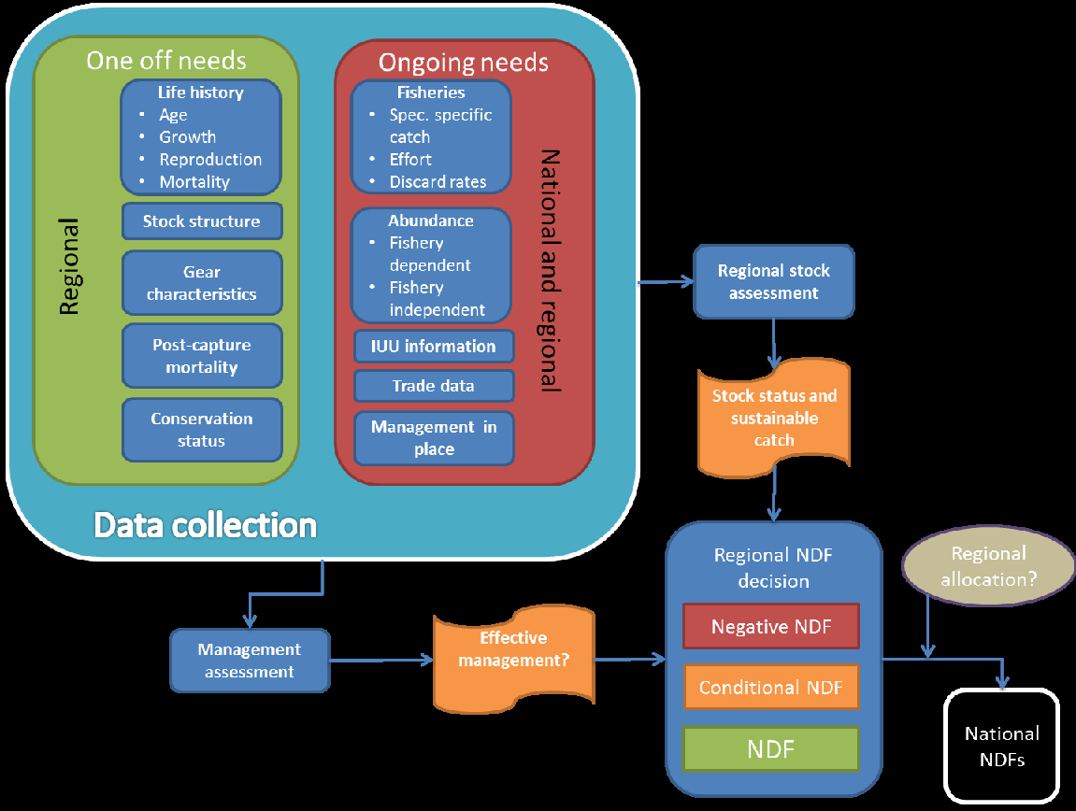

Figure 4. Model for the development and ongoing maintenance of multi-national NDFs.

It’s important to highlight that any regional NDF would have to be a voluntary agreement across Parties and that National SAs ultimately have the legal mandate with regard to assessments.

It was also raised that there are already NDFs that take account of the regional scale, primarily for migratory sharks - e.g. the New Zealand and US assessments for shortfin mako - and that it could be possible that these are used by less well-resourced Parties that harvest in the same waters.

Outside of individual Parties, a number of RFMOS have stock assessments that cover appropriate scales. For example, WCPFC has a stock assessment for shortfin mako shark in the Southwest Pacific which could be useful in making a NDF for the species.

- Marine species and case study directory
  - Marine invertebrates

    - Corals

Precious (Order Antipatharia and family Coralliidae) and stony corals (Orders Helioporacea, Milleporina, Scleractinia, Stolonifera, and Stylasterina) are listed in the CITES Appendices. Both Antipatharia (Black corals) and stony corals are listed in Appendix II and four species of Coralliidae (Corallium elatius, C.japonicum, C. konjoi and C. secundum) are listed in Appendix III by China.

      - Precious Corals

With regard to Antipatharia, two species in trade from Hawaii were used as a case study at the 2008 Cancun workshop.

In accordance with CoP Decision 17.191 on Precious corals, FAO produced a report in 2019, relating to the biology, fisheries and trade of these species. While it doesn’t explicitly reference NDFs, it could provide useful baseline information for Parties wishing to carry out an assessment for these species. The document was submitted to AC31 and an intersessional WG proposed a number of recommendations that were supported at SC74. These included the following which could be considered in the context of making NDFs for these species:

For the CITES-listed black corals, the Animals Committee recognizes the need for better information on their conservation and sustainable use, and the need for strengthening data-collection and reporting from most areas.

For species in Family Corallidae, the Animals Committee acknowledges that there have been advances and developments in fishery management and conservation arrangements in some regions, such as Japan's regulation in the Pacific, the adaptive management plan by the General Fisheries Commission for the Mediterranean (GFCM) for red corals (Corallium rubrum) in the Mediterranean Sea, the conservation measures by the South Pacific Regional Fisheries Management Organisation (SPRFM) and the North Pacific Fisheries Commission (NPFC), and others.

The Animals Committee:

encourages Parties to continue to strengthen their domestic management and conservation measures concerning all precious corals; and

reminds Parties which export CITES-listed black coral species to make non-detriment findings (NDFs) and encourages these Parties to provide copies of the NDFs to the Secretariat for publication on the CITES website.

notes the challenges of analysing trade in coral products since the current Harmonized System (HS) classification amalgamates them with other species due to the lack of specific custom codes;

notes that there are many potential impacts on many coral populations in the wild (including climate change, ocean acidification, and others) which may affect precious coral too, which should be taken into account to understand the coral diversity within the marine environment.

      - Stony corals

With regard to stony corals, two case studies from Australia and Indonesia were presented at the 2008 Cancun workshop.

Stony can take many forms in international trade, both live and dead, and there are significant issues in identifying to the species level. Resolution Conf. 11.10 (Rev. CoP15) on Trade in stony corals outlined this at a very high level, and recent documents at CoP19 and AC32 continue to examine these challenges – including proposing amendments to the Resolution. The aforementioned guidance document produced by the UK and Indonesia is a very useful tool in identifying corals to the species level. This also highlights the potential issues around the use of Source Code F and how this might be mis-used to trade species collected form the wild.

An issue that was raised in the context in trade of corals is the impact of climate change in the context of harvest and how this affects trade. For example, should mass bleaching events lead to a cessation of trade? Conversely, is reef health compromised by coral harvest and how does this effect the resilience of the reef and individual species to climate change? Parties may want to consider these when developing NDFs for stony corals.

    - Giant clam

One case study for the giant clam (Family Tridacnidae) was presented at the Cancun workshop in 2008.

    - Queen conch

This species has a high economic value, and cultural relevance, across its Caribbean range. It also has a complex life cycle which makes traditional stock assessments challenging. Queen conch has been listed in CITES since 1992 and two RSTs (1,2) have been carried out in that time. Several NDFs have been made available for the species – Honduras, St. Eustatius and Colombia - and a regional working group has produced a template for carrying out assessments. As stated in Section XX, a regional management plan was developed, this included a number of recommendations that are very relevant to the making of NDFs:

- Harmonized and simplified categories of queen conch meat conversion factors
- Improvement of catch and effort monitoring programmes
- A synchronized regional closed season
- NDF for export of queen conch meat and its by-products
- Licensing of all queen conch fishers, processors and exporters
- National level queen conch conservation and management plans
- Traceability of queen conch throughout the value chain

There is a wealth of information available for this species on a dedicated page on the CITES website.

It was highlighted that the most valuable Queen conch product is the pearl but this often gets overlooked as the scale of meat trade is much greater. At present, CITES permits and associated database reports only includes information on weights (kg), where numbers would be more useful in the context of sustainability of harvest and trade, and prevent underestimating volumes which is believed to be occurring.

At the time of writing the WG were informed that the FAO were in the process of developing simplified guidance and process for making NDFs – this is expected to be available at the workshop later in 2023.

    - Sea Cucumbers

Sea cucumbers are primarily traded dried as bêche-de-mer and they are an essential livelihood for many small-scale fishers in range states. But due to their large size and sessile life history, they are vulnerable to over-exploitation. Since 2019, there have been six species of sea cucumber (Class Holothuroidea) listed in CITES Appendix II (2019 - Holothuria fuscogilva, H. nobilis and H. whitmaei; 2022 - Thelenota ananas, T. anax and T. rubralineata); one species is listed in Appendix III (Isostichopus fuscus). Due to the relatively recent listing of these species, the available resources are limited, but a report was produced in 2020 which focussed on the management and trade of Holothuria fuscogilva, H. nobilis and H. whitmaei (teatfish). A range of issues are examined some of which could be useful in the context of developing a NDF:

- Fisheries management measures
- Characterisation of the supply chain
- Relevant RFBs
- Data sources
- Summaries of key teatfish harvest and trade countries
- Implementation challenges

It was highlighted in the context of NDFs that the Philippines and Yemen had banned trade, Papua New Guinea (PNG) had produced an assessment.

Australia has published a document relating to the NDF – a positive NDF for H. fuscogilva was produced for harvest in Queensland.

  - Aquatic vertebrates

    - Sturgeon

Three species of sturgeon (family Acipenseridae) are listed in Appendix I of CITES (Acipenser brevirostrum, A. oxyrhynchus and A. sturio) with the remaining species in Appendix II and Resolution Conf. 12.7 (Rev. CoP17) specifically focuses on ‘Conservation of and trade in sturgeons and paddlefish’.
The Resolution outlines the need for appropriate fisheries management, co-operation between range states, registration of facilities producing caviar and a universal labelling system for caviar. Illegal harvest and trade are of significant concern for the species due to the high value of caviar.

Sturgeon species were included in RST in response to Decision 11.95 and a number of recommendations were proposed as a result of this. Progress towards these was summarised at SC47.

    - European eel

One case study for European eel was presented at the 2008 Cancun workshop.

As stated previously, the European eel has a complex life history, which can make the production of NDFs challenging. This was the subject of a Master’s thesis produced in 2014 entitled: An assessment of the challenges faced in making a Non-Detriment Finding (NDF) for Anguilla anguilla. The thesis outlined a number of reasons why this is this case:

- It is considered to be panmictic i.e. from a single population.
- It has a complex life-cycle with multiple life stages.
- It has an extensive range crossing three continents and multiple regional bodies and/or management regimes.
- There are fundamental knowledge gaps in the biology and management of the species that hinder stock assessments, such as:
  - An estimate of spawning biomass
  - The scale of density dependant mortality
  - Sex ratios
  - The relationship between recruitment and spawning stock
  - The effectiveness of management interventions e.g., EU Council Regulation (EC) No 1100/2007
  - The effectiveness of re-stocking on the replenishment of the spawning stock
- There are multiple threats to the species that may impact the species cumulatively and/or synergistically and assessing the impact of exploitation and associated trade in isolation is very difficult.
- It is traded both live and processed in a number of different forms all of which can be reported in multiple formats.
- There is evidence of significant illegal fishing and trade which confound attempts to assess existing legal fisheries and trade.
- As wild stock has to be used to seed farms around the world (and often in non-range States), monitoring of the input and output of farmed eels is challenging.

These points should be considered by Parties producing a NDF for these species. For example, as stated above, the species is harvested for trade both as juveniles and larger eels, though the former tends to be for on-growing, and the latter for direct consumption.

Parties should thus consider whether NDFs for different life stages would be appropriate.

Historically, the demand for much of this harvest was from East Asia, but in 2010, the European Union’s (EU) Scientific Review Group (SRG):

…agreed that it was not possible to perform a "non-detriment finding" for the export of European eels, i.e. that it was not possible for the SRG to consider that the capture or collection of European eel specimens in the wild or their export will not have a harmful effect on the conservation status of the species or on the extent of the territory occupied by the relevant population of the species.

Consequently, a zero-import/export policy was set which remains in place at the time of writing. As a result, patterns of harvest and trade of the species, and anguillids more broadly, have shifted.

While the European eel is the only species in the genus Anguilla that has been listed in the CITES Appendices, in recent years it has been recognised that trade in the taxa as a whole is interlinked and as such there has been a broader examination of harvest and trade. . A key recommendation relating to NDF from (1, 2, 3) is that the development of a stock-wide NDF and/or the harmonisation of making national NDFs for this species could be useful.

These reports also highlight the significant scale of illegal trade in European eel and other anguillids, and the challenges relating to addressing this, particularly for glass eels where differentiating species is hugely challenging, and in a number of cases, only possible using molecular technologies.

At present six range States are commercially trading the European eel - Algeria, Egypt, Morocco, Tunisia, Turkey and the UK. The UK’s NDF has been presented previously in the document, but at present, no other NDFs for the species are publicly available. Algeria, Morocco and Tunisia are presently in a Review of Significant Trade (RST) for European eel and have provided a wealth of information relating to sustainable management of the species in support of their trade. As previously mentioned, ICES produced a report in relation to carrying out NDFs for the European eel.

    - Seahorses

All species of seahorses were listed in CITES Appendix II in 2002 and came into force in 2004.
Two Parties have shared their NDFs for seahorses, both in response to Notification 2020/015, Australia and the US, both for their small quantities of live exports.

- For Australia, exports of both captive bred and wild seahorses are only allowed from pre-approved operations with very detailed criteria for their approval. At the time of writing, one captive breeding program and two fisheries are approved for export of seahorses, managed by quotas on wild individuals.
- In the US, NDFs for the export of live seahorses from the state of Florida are based on three management measures: (i) recreational and commercial bag limits; (ii) large areas of quality habitat closed to commercial and recreational harvest; and (iii) a limited-entry fishery for the commercial take of these species. Export of one species, H. zosterae, is also regulated by a minimum size limit, appropriate to the species.

Project Seahorse has applied their NDF advice in two case studies focused on Thailand and India.

Seahorses were the focus of the first RST for fully marine fishes, with three rounds initiated in 2008, 2011 and 2014. A total of eight species were investigated, accounting for the vast majority of seahorse exports reported to CITES. From the 78 range States selected for review, the AC decided that four should be given recommendations for action, across five species. Such RST recommendations, issued at AC26 and AC27, provide useful guidance toward scientifically defensible NDFs.

The RST process brought to light three common issues that Parties encountered when making NDFs:

i) Protected areas were often assumed to provide automatic conservation benefits to seahorses, although the presence of seahorses in these protected areas were not confirmed prior to establishment and the benefits to seahorses were not analysed or presented.
ii) Party documentation in support of the RST revealed that sale of captive born (source code F) animals was often erroneously implied to be exempt from the NDF processes.
iii) Haphazard releases of captive bred seahorses were mistakenly cited as a tool for the conservation or management of wild populations.

Project Seahorse has developed an easy approach to making NDFs for seahorses, applicable to many taxa, using an approach that maps answers to five questions in overlapping layers. This easier approach is covered above, in Section 2.3.

The IUCN SSC SPS SG has provided Parties with the tools and information needed to inform NDF development and guide adaptive management for seahorses. These have been compiled online and include guidelines for species identification, monitoring seahorse populations (details in Section 2.6, above), country specific resources and information and NDF guidance, inter alia.

    - Sharks and rays

Sharks and rays are arguably the best resourced aquatic taxa with a specific guidance document, the eNDF platform, and many shared NDF case studies. At the time of writing, 41 NDFs or guidance for making NDFs are available for Elasmobranchii species, as well as many other resources. We have presented many of these elsewhere in the document, and the CITES database has further examples.

There are Parties that share resources on shark NDFs e.g., Australia and below we present a further national case study:

      - Mexico sharks NDFs

Since the entering into force of the Appendix II listings of sharks of commercial relevance in Mexico at CoP16 in Thailand in 2013, the Party has transited from a low data scenario to a higher level of data/lower level of risk when making NDFs.

The key steps that Mexico made to transit from lower to higher data situations were:

Population level – Data analysis (3a to 3b): An expert-lead intersectoral analysis of academia, fishery sector and CITES authorities coupled with local surveys by the Mexican fisheries authority (INAPESCA) to reconstruct the catch time series for each species.

Impact - Methodology to set harvest rate. (1a to 1b): Used the reconstructed catch time series to construct a Catch-MSY model for each species listed in CITES.

Impact – Harvest rate (2a to 2b): The Catch-MSY model yielded conservative reference points with confidence intervals. The exception to this was I. oxyrhinchus where a stock assessment was available and its status is not overfished and overfishing is not occurring. These reference points were used to inform ‘Sustainable Exportation Volumes’ (VES in its Spanish acronym).

Impact – Impact level (3a to 3b): With VES defined, international trade is within a sustainable margin

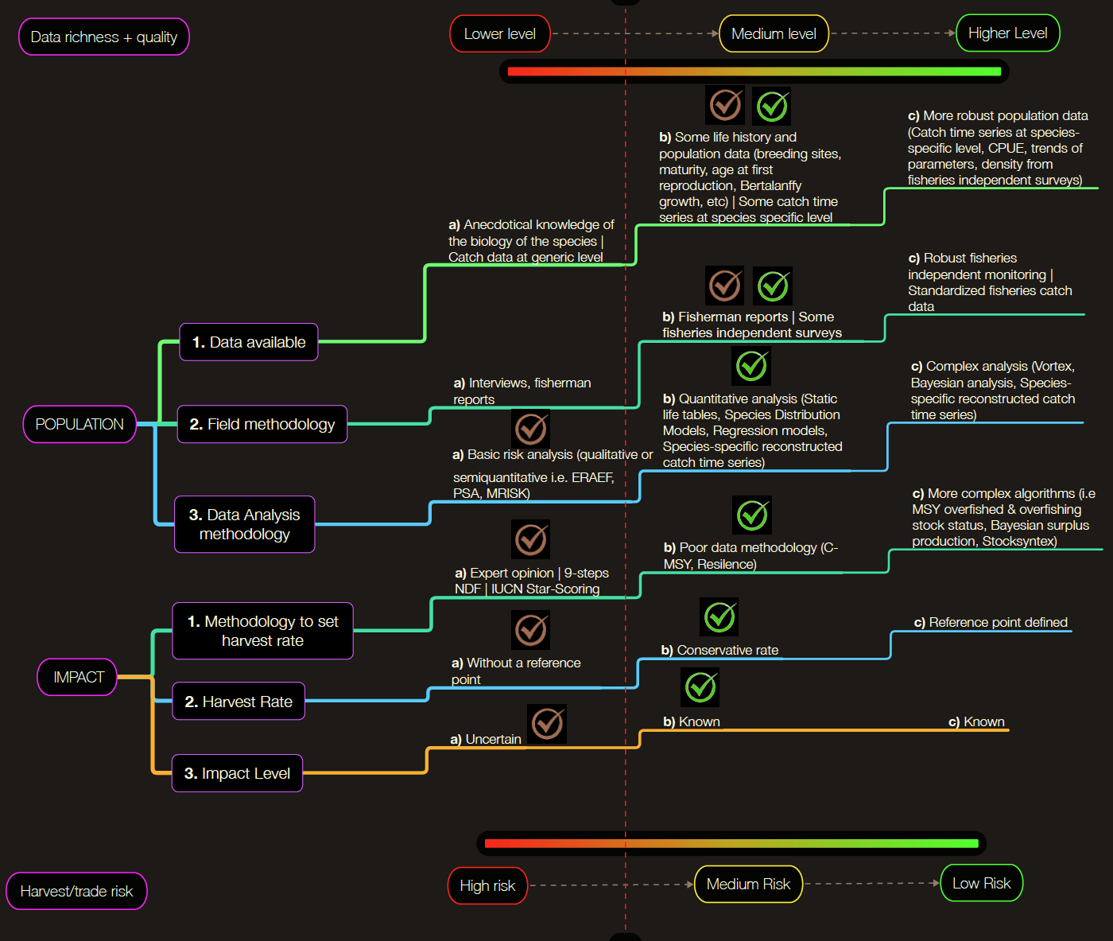
Figure X. NDF framework of data richness and trade risk for sharks. Ticks are signalling the level transition that Mexico has travelled from low data scenarios (orange ticks) to higher level scenarios (green ticks) since the CoP16.
      - Stock assessments

In particular for the blue shark, there have been a number of stock assessments made by RFMOs – Indian Ocean, North Pacific Ocean, Atlantic Ocean – that might prove a useful start point for carrying out NDFs for this species.

    - Cetaceans

Resolution Conf 11.04 (Rev. CoP12) on Conservation of cetaceans, trade in cetacean specimens and the relationship with the International Whaling Commission (IWC):

RECOMMENDS that the Parties agree not to issue any import or export permit, or certificate for introduction from the sea, under this Convention for primarily commercial purposes for any specimen of a species or stock protected from commercial whaling by the International Convention for the Regulation of Whaling;

As there is presently a moratorium on commercial capture of whales under the IWC, there are only a few circumstances under which permits should be issued e.g., movement of scientific samples. Trade in narwhal tusks derived from aboriginal harvesting presents a useful case study.

Certain dolphin species are still traded live for under purpose codes Q (circus or travelling exhibition) T (commercial) and Z (zoo). No NDFs for such trade have been shared on the CITES database, though a NDF for Tursipos aduncus from the Solomon Islands was used as a case study in Cancun in 2008. It was stated that, ‘Harvesting and Export Permits can only be held by persons or tribes of dolphin harvesting communities… A study carried out in the Solomon Islands in 2007 on removal of live dolphins for trade stated the following:

In order to ensure the persistence of Solomon Islands Tursiops aduncus in the long term… …no removal should be allowed outside the study area without further biological assessment. Future quotas should be species-specific and refer to the number of captures rather than the number of export because the last does not account for mortality during local captivity.

The Solomon Islands banned live dolphin expert in 2017 under a national regulation.

The Queen Conch has been renamed Aliger gigas but the CITES standard nomenclature at the time of writing remained Strombus gigas.
This does not include movement between EU Member States.

