MODULE 12: ONLINE TOOLS, CERTIFICATION SCHEMES, AND THEIR RELEVANCE TO NDFS

- What is in this module?

This Module includes information on the current status of online tools and certifications schemes, and discusses their use, relevance, and utility for aiding in the making of CITES NDFs. It is noted that, by their nature, the tools are constantly evolving and so the information contained within this module should be regularly updated.

- Online tools
To aid Scientific Authorities in making NDFs some online tools have been developed. These include:
- E-NDF for Elasmobranch Species (https://user.cites-endf.org/)
  - This tool has been based on the NDF guidance for Elasmobranch species (https://cites.org/sites/default/files/eng/prog/shark/docs/Shark%20NDF%20guidance%20incl%20Annexes.pdf). It combines guidance with electronic forms that are filled in as the user (or users, as more than one registered user can contribute to the same NDF) works through the steps to ultimately complete an e-NDF.
  - Drop down menus give standardised responses or text can be entered.
  - Some data on the relevant species is automatically pulled into the e-NDF from Sharkipedia (https://www.sharkipedia.org/) and the IUCN Red List (https://www.iucnredlist.org/en).
  - The sources of information entered are recorded by the user.
  - Pressures affecting the stock are matched with management measures (and their effectiveness) to assess whether these mitigate those pressures.
  - A summary of information entered is given with an automated recommendation of whether the trade is recommended or not. However, the User can also override this decision stating their reason. Additional management measures (which could be advise to the MA or conditions) are also automatically suggested which can be confirmed or overridden by the user.
  - the completed NDF can be published as a word document (for additional manual editing) or as a PDF ready for use.
  - The software can easily be adapted for other taxa (currently being done for sea-cucumbers).

- 9-Step Guidance for Perennial Plants and Timber species
  - A website containing guidance materials on the 9-Step Guidance documents for perennials and timber has been created (https://www.9steps-cites-ndf.org/).
  - Online training courses for each guidance are also available through the website (https://www.9steps-cites-ndf.org/online-courses
  - A decision tree has been created (https://www.9steps-cites-ndf.org/decision-trees), similar to the e-NDF for elasmobranch, which can be used in conjunction with the training, working through the example given throughout the course or it can be used for filling in any NDF giving a pdf report at the end. Unlike the e-NDF, recommendations for the conclusion or decision or condition/advice are not suggested.
  - These tools are being updated in line with the revised guidelines to be completed post the expert workshop in 2024.

- UNEP-WCMC online tool.
  - A tool is under development that aims to bring together relevant datasets to support NDFs.

- Certification Schemes and NDFs
Certification schemes exist to evaluate performance against a set of standards, which can be led by governments, third parties or companies (Furnell and Timoshyna, 2018). Some may certify that harvest or production is ecologically sustainable, such as the Marine Stewardship Council, Forest Stewardship Council and FairWild certification. Some look at specific species from a specific area (e.g., FairWild), whereas others may look at an area or harvesting operation more generally.
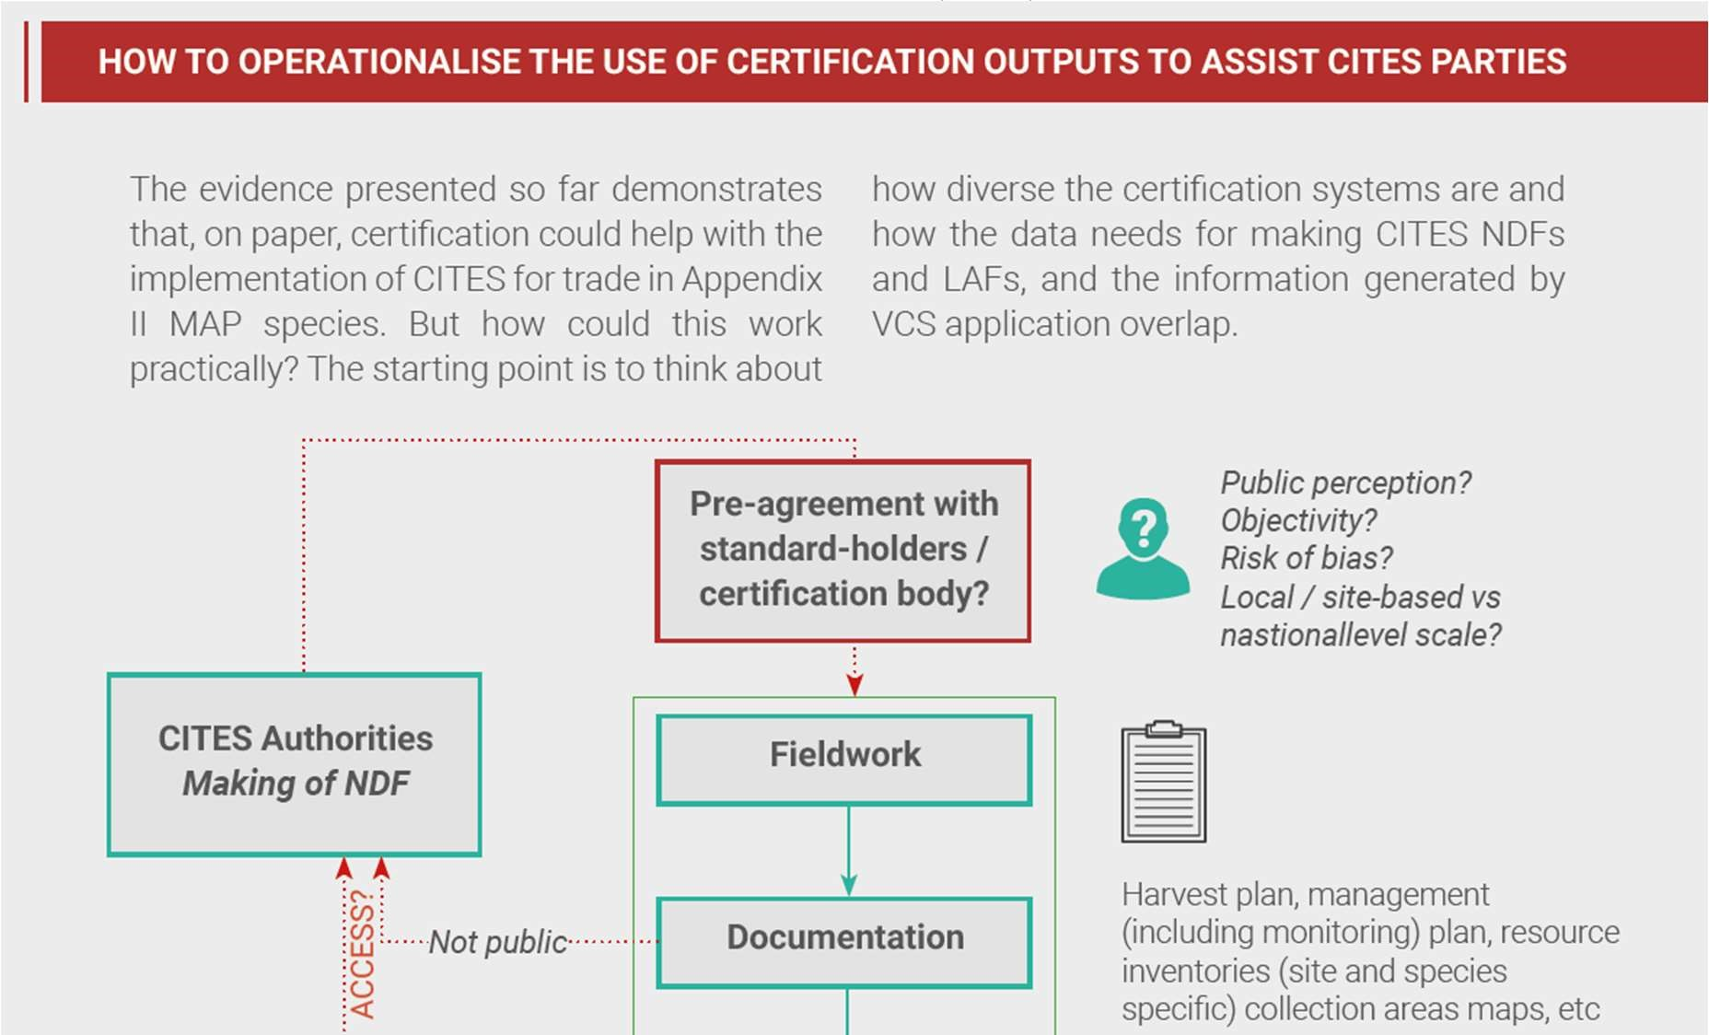
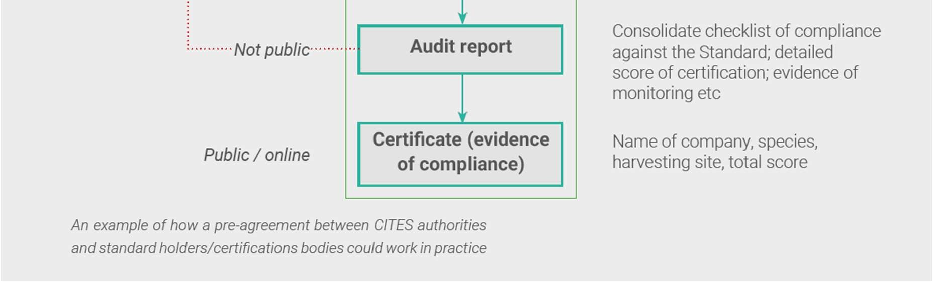
Germany and TRAFFIC reviewed the information required for various certification schemes to assess whether it might also provide any of the information needed by SAs to help with making NDFs (see Timoshyna, Furnell and Harter (2019), which many did. Often, Certification Schemes require independent audit or verification of information, in some cases including resource surveys, therefore certification documentation could in some cases provide significant information for the making of non-detriment findings by CITES Scientific Authorities (Broad and Natusch, 2022). Insert explanation of the relevance of Figure A. In the case of trees, independently evaluated forest certification schemes such Forest Stewardship Council (FSC) and the Programme for Endorsement of Forest Certification (PEFC) Certification of sustainable forest management (SFM) have become important components of national forest policy. Generally, certification schemes consider forest units rather than species but there may be ways to utilise processes and data available in formulating NDFs. Certification for timber requires formulation of a forest management plan for the area being certified which is a major source of information for an NDF. Additionally, chain of custody certification ensures verification of products sourced from the forest unit.

Figure 2: Example of how a pre-agreement between CITES authorities and standard holders/certification bodies could work in practice. Source: Timoshyna et al. (2019).
FSC certification covers a range of CITES timber species. Mahogany exported from Brazil is one example (see PC24 Inf. 12) and in Tanzania, an FSC group certification scheme has been developed for Dalbergia melanoxylon sourced from community-managed natural forest. Forest certification has developed relatively recently in Africa but is now well-established. The first experience with forest certification in Central Africa was in 1996 with an FSC attempt in Gabon. In 2004, companies turned first to legality certifications (OLB, LegalSource, TLV), and then again to FSC, whose first certificates were issued in 2005. In parallel, the idea of a pan-African certification was born in the early 2000s. The approach, called PAFC (Pan African Forest Certification) was first developed at the national level, and aimed to be recognized by PEFC, allowing the sale of PAFC-certified wood with the PEFC logo. The first operational and recognized national scheme was the PAFC Gabon in 2009, with a first certificate was issued in 2018. In 2019, the initiative to develop a regional Congo Basin PAFC scheme was launched, led by ATIBT and funded by the German cooperation (KFW). The Congo Basin PAFC scheme was recognized by the PEFC at the end of 2021. At the end of 2021, the Congo Basin had 5,392,066 ha of FSC and PAFC certified forest (representing 10% of exploitable forests), with a concession of approximately 600,000 ha being doubly certified. (Duhesme 2022). In Gabon all logging concessions must be certified by 2022. Any concessionaire not engaged in a certification process by that date could lose its logging rights.
Access to this information may require special arrangements between the SA and the certification providers; it cannot be assumed that information will be shared. Figure 2 gives an example of how this could work in practice. TRAFFIC has prepared a case study on Jatamansi (Nardostachys grandiflora (syn. Nardostachys jatamansi)) to demonstrate the synergies between information needed to make NDFs and that collected as part of the FairWild Standard certification process. ADD LINK IF THERE IS ONE.
FSC Principle 1: Compliance with Laws
FSC Principle 6: Environmental Values and Impacts
FSC Principle 7: Management Planning – a management plan is required for the FMU. The management plan should describe the natural resources that exist in the FMU and explain how the plan will meet the FSC certification requirements.
FSC Principle 8: Monitoring and Assessment
FSC Principle 9: High Conservation Values
FSC Principle 10: Implementation of Management Activities
PEFC ensures that national sustainable forest management requirements are always tailored to the needs of the specific forest ecosystems, the legal and administrative framework, the socio-cultural context and other locally relevant factors. all national sustainable forest management requirements must include the following:
- Maintenance, conservation and enhancement of ecosystem biodiversity
- Protection of ecologically important forest areas
- Prohibition of forest conversions
- Respect for the multiple functions of forests to society
- Respect for property and land tenure rights as well as customary and traditional rights
- Prohibition of genetically modified trees and most hazardous chemicals
- Exclusion of certification of plantations established by conversions, including conversions of ecologically important non-forest lands (e.g. peatlands)
- Climate positive practices such as reduction of GHG emissions in forest operations

Furnell, S. and Timoshyna, A. (2018) Potential of certification schemes to support Management and Scientific Authorities with the implementation of CITES Appendix II measures for medicinal and aromatic plant species. TRAFFIC, Cambridge, UK. Available as PC 24 Inf 12.
Timoshyna, A., Furnell, S. and Harter, D. (2019) CITES and voluntary certification for Wild Medicinal and Aromatic Plants. TRAFFIC Bulletin Vol 31 No 2. https://www.traffic.org/site/assets/files/12507/cites-wild-maps.pdf.
Broad, S. and Natusch, D. (2022) Exploring the use of registered marks of certification and other traceability mechanisms for products of CITES-listed species produced by indigenous peoples and local communities to enhance conservation and livelihood outcomes. Annex 2 of SC74 Doc. 21.2

