MODULE 1: PRINCIPLES AND CONCEPTS OF NON-DETRIMENT FINDINGS

- What is in this module?
This Module provides CITES Parties with an understanding of the principles of making non-detriment findings (NDFs). The Module looks specifically at what a non-detriment is, and how the issue of assessing a species’ role in its ecosystem can be understood and addressed. The Module then examines risk, uncertainty, and the use of conditions or precautionary measures on which a positive NDF might be dependent. It also considers the making of NDFs in circumstances of low risk, low data, or low capacity. Finally, it considers how all these issues might be addressed through adaptive management.
Many of the issues in this Module are inter-connected – not only within this section but across all the NDF guidance. Precaution, for example, is an approach to dealing with risk and uncertainty when significant gaps in knowledge exist. ‘Conditional NDFs’ are simply a means of incorporating precautionary measures in an NDF to mitigate identified risks. In practice, all can be integrated through adaptive management. Adaptive management is a structured, iterative approach to making the best decisions possible, despite risks, uncertainty and imperfect knowledge, while simultaneously accruing information, through monitoring, to inform, test and improve future management to achieve defined objectives which, in this case, include ensuring no detriment occurs to wild populations.
- What is a non-detriment finding?
The CITES Glossary defines a non-detriment finding (NDF) as:
“A conclusion by a Scientific Authority that the export of specimens of a particular species will not impact negatively on the survival of that species in the wild “
Although this could be interpreted in different ways, in simplest terms this can be taken to mean that harvest for trade is [biologically] sustainable”.
The Resolution on NDFs notes in its preambular paragraphs that “A non-detriment finding for an Appendix-I or -II species is the result of a science-based assessment that verifies whether a proposed export is detrimental to the survival of that species or not (paragraph 1. a) i)). It gives recommendations to consider a number of concepts and non-binding guiding principles Scientific Authorities should take into account when considering whether trade would be detrimental to the survival of a species. The Resolution notes in 1. a) v) that the data requirements for a determination that trade is not detrimental to the survival of the species should be proportionate to the vulnerability of the species concerned. CITES’ 2008-2020 and 2021-2030 Strategic Visions set objectives for Parties’ NDFs to be based on the best available scientific information.
A species is defined in the Convention text as meaning “any species, subspecies, or geographically separate population thereof” with Trade defined as “export, re-export, import and introduction from the sea”.

- Role of the species in its ecosystem
Article IV paragraph 3 of the Convention text states that, “A Scientific Authority in each Party shall monitor both the export permits granted by that State for specimens of species included in Appendix II and the actual exports of such specimens. Whenever a Scientific Authority determines that the export of specimens of any such species should be limited in order to maintain that species throughout its range at a level consistent with its role in the ecosystems in which it occurs and well above the level at which that species might become eligible for inclusion in Appendix I, the Scientific Authority shall advise the appropriate Management Authority of suitable measures to be taken to limit the grant of export permits for specimens of that species.”
  - Assessing a species’ role in the ecosystem
3.1.1. Theory
The term ‘role’ describes aspects of a species’ ecological niche and ecological ‘function’, which refers to how that species drives or regulates higher order ecological processes, such as pollination or influencing structure of ecological communities, which may differ in different ecosystems. Both should be considered when assessing the impact of harvesting on a species’ role in the ecosystem, but this requirement does not extend to ecosystem services or the benefits that are provided to humans by ecosystems. From this point on we will continue to use the term Role in Ecosystem to encompass both role and function. Box A and Table 1a provide a variety of examples of species’ roles in their ecosystems.
Although the consideration of Article IV.3 is separate from articles referring to non-detriment, the species’ role in the ecosystem is integrated into the generic NDF process as part of the impact evaluation. As implied in the text of the Convention cited above, the Scientific Authority should maintain an overview of the exports (permits and actual) to look overarchingly for indicators, or early warning signals, that the trade might become a risk in terms of threatening the role of a species in its ecosystems. However, it may be that looking at trade (or harvest) levels alone is not adequate to determine if it is having an impact on roles in ecosystems.
In many cases information on role in the ecosystem may be limited let alone the impact that harvest is having on the role, therefore any assessment is likely to be based on assumed impact rather than studies, which can be expensive and take considerable time. As part of their NDF for Puma concolor (Puma) Mexico studied the impact of Puma harvest on the ecosystem [functioning] for several years.
However, Res. Conf. 16.7 recommends that 1.a) iv) “the data requirements for a determination that trade is not detrimental to the survival of the species should be proportionate to the vulnerability of the species concerned”. This could also be taken to apply to the case of a species role in ecosystems. In higher risk situations [where higher numbers are being exported] or where risk is considered higher during the Risk Evaluation step of the NDF assessment, or where Scientific Authorities are concerned that harvest may impact the role of species in their ecosystems, further consideration could be made.
3.1.2. Practice
The Scientific Authority can base decisions on the impact that the harvesting of the species in question may have on its role and function within ecosystems by consideration of how the proposed harvest will affect population abundance, density or demographic structure. If such changes are considered likely, the Scientific Authority must determine whether these changes have the potential to result in non-trivial changes of the following types:
- a reduction in the abundance of another native species;
- an increase in the abundance of a non-native species or over-abundance of another species;
- a reduction in a demographic rate in any life stage of another native species (e.g., germination, seed production, nest success, natal dispersal, etc.) that has the potential to decrease its abundance or otherwise reduce its viability;
- a change in any ecosystem process or structural feature (see examples above);
- a change in the typical patterns of behaviour (e.g., social interactions, patterns of aggregation, movement) among individuals of the species being assessed or other species.
    - Geographical extent of consideration.
The Article refers to ecosystems, plural, and therefore determining whether role in ecosystems is maintained should take into account impacts that harvest [from the wild] will have not only on the ecosystem(s) from which that harvest took place but any other ecosystems that the offtake may influence. The life stage harvested should be considered in relation to the whole species life history where different life stages occur in different ecosystems with different roles in these. This is particularly important in relation to migratory species, or populations shared between two or more neighbouring countries, where the impact may extend to other jurisdictional areas occupied by the species, or populations of the species. For instance, harvest of glass eels from one country may have an impact on the availability of eels in subsequent life stages, and their availability as prey for other species, in another country (See Module 6 on Migratory species (particularly section 7 a)). Equally the impact of harvest in one part of a country may have an impact on the ecosystems in another part of the range within the same country.

Box A – Birds and their role in the ecosystem
Birds have the most diverse range of ecological functions of all vertebrates. A synthesis of the ecological functions in birds provide is included below. Ecological functions are categorised as representing one of three major linkages: genetic, resource, and process. Birds encompass all three. Habitat loss affects all bird functional groups, with large frugivores (seed dispersers) particularly vulnerable to exploitation.
Function | Description | Example
Genetic linkers | Responsible for the transfer of genetic material (i.e., by pollination or seed dispersal) | In the Philippines, the loss of seed dispersers, such as Palawan hornibills (Anthracoceros marchei), can result in most seeds being deposited under the parent tree and consumed by seed predators.
Resource linkers | Responsible for mineral and nutrient transport and deposit (i.e., through their guano resulting in crop fertilisation). | The elimination of Aleutian seabirds, such as tufted penguins Fratercula cirrhata, by introduced foxes can lead to reduced nutrient deposition, triggering a shift from grassland maritime tundra.
Trophic process linkers | Responsible for connecting habitats through their role as primary or secondary consumers across habitats (i.e., by insect control or scavenging) | Disappearance of scavenging Indian long-billed vultures (Gyps indicus) can cause increases in the number of rotting carcasses and of attending mammalian scavengers
Non-trophic process linkers | Responsible for facilitating essential processes in the physical environment (I.e., ecosystem engineers) | Reduced number of three-toed woodpeckers (Picoides tridactylus) in forest fragments can cause increases in spruce bark beetles (Dendroctonus and Ips species) and decreases in nesting holes used by other species.

Table 1a: Examples of roles in ecosystem
General category | Subcategory | Examples of ecological roles | Examples of impact when roles are no longer fulfilled
Direct interactions (incl. trophic functions and cascades) | Pollination | Bumblebees maintaining plant diversity by pollination | Loss of diversity of plants.
 | Nutrition | Trees provide a wide variety of fruits and leaves for birds and mammals e.g., Dalbergia spp. provide fruits for lemurs in Madagascar
 | Seed dispersal | Flying foxes or birds dispersing large seeds, cassowaries in rainforest | Removal of cassowaries has shown that some rainforest trees have reduced in abundance  A large number of plant species are strongly adapted to dispersal of seed by elephants ingesting them and depositing them elsewhere.
 | Herbivory | Herbivory by parrotfish and others preventing coral to macroalgal phase shift in reefs
 | Predation | Sea otter predation on urchins maintaining kelp forests; wolf predation on elk maintaining willow ecosystems  Monitor lizard predation on species. | Loss of monitor lizards from some landscape (e.g., Australia, due to toads) has increased abundance of megapode birds, which have altered forest-floor composition.
Indirect interactions (structural functions) | Habitat creation | Creation of landscape heterogeneity by African elephant.  Trees provide structural elements of ecosystems and individual trees act as ecosystems in their own right – providing water, food, substrate etc for fungi, insects, epiphytes | Tree damage by elephants provides crevices for lizard in broken limbs and can creates clearings that increase light penetration allowing plant species to flourish.
 | Ecosystem engineering | Wolves, elk, salmon rivers. | Wolves in Yellowstone Park and the impact of their re-introduction on the ecosystem functioning.  Elephants digging waterholes in dry months also benefits other species when water is scarce.
 | Nest supply provision | Pine trees providing cavities for nesting birds
Diffuse interactions (ecosystem-  level functions) | Nutrient cycling or redistribution | Nutrient input to terrestrial systems by breeding salmon populations and their predators  Guano production and habitat alteration by metallic starlings, other communal nesting birds  Fundamental role of plants in carbon cycle and nutrient cycling  Nitrogen fixing by leguminous spp. | Salmon spawning migrations of Pacific North America transport mass resource/nutrients across ecosystem boundaries delivering marine-derived nutrients to aquatic ecosystems and to the riparian zone through the activity of terrestrial salmon consumers such as bears, wolves, and scavenging birds having a significant influence on riparian forests.
 | Water cycling | Fundamental role of plants in water cycle; control of runoff
 | Maintenance of fire regime | Wiregrass maintaining longleaf pine savannas in the Atlantic Coastal Plain of US
Intraspecific interactions (within species processes) | Movement | Green-wave surfing and other seasonal movements by ungulates
 | Reproductive aggregations | Forming colonies, leks, spawning aggregations | Reduction in densities of adults reduces likelihood of reproduction/ reproductive success

- NDFs and Risk Assessment
  - What are risks and uncertainty?
Within a management system in which a species is being harvested and removed from a wild population, the possibility of the harvest being detrimental is linked to how the management copes with risk and uncertainty. Evaluating risks and uncertainty is, thus, a fundamental part of management and of making a non-detriment finding. The two terms (risk and uncertainty) are fundamentally different, although the terms are often used inter-changeably. The difference between the two is fundamental to implementing management procedures to ensure non-detriment.
    - Risks
Risks are known events that can occur, sometimes on known time or spatial scales, that can be anticipated with confidence, and management can have strategies in place to account for them. Extreme rain and flooding during an annual wet season is an example. Risks can be identified and measured, their potential outcomes or impacts are known, their probability can be predicted, and steps can be taken to mitigate them. For example, if a population continues to be subject to over-exploitation, there is a clear risk with identified probabilities that the population will decline, perhaps to local extinction, unless remedial measures (such as reducing the harvest) are taken; this risk can be tested through monitoring.
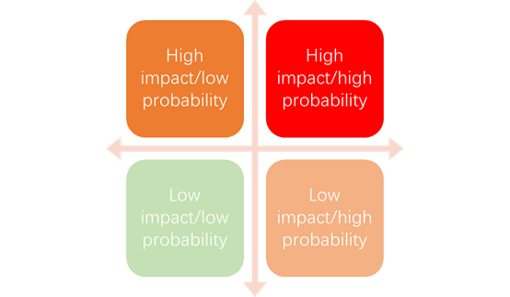
The relationship between the impact of any risk and the probability of that risk occurring can be expressed diagrammatically (see below), enabling the need for remedial or preventive action to be identified and prioritised, depending on whether the overall risk is assessed, or demonstrated through monitoring, as being high, low or intermediate.

Figure 1a. Schematic representation of relationship between the impact of any risk and the probability of it occurring; the degree of risk increases towards the top right-hand corner of the graph (source tbc).
    - Uncertainty
By contrast, in cases of uncertainty, we do not know what issues or events might arise, their probability of occurrence or severity of impact, nor what outcomes might result; they are typically unexpected or novel ‘wildcard’ events, such as a tsunami in which responses are only possible after they have occurred. A population might be affected by a novel disease (such as COVID19 in humans) for which survival rates, means of transmission, and the success of intervention measures are all initially unknown. However, over time, as information accumulates on the new disease, and treatments and remedial strategies for it are developed and tested, it becomes a known risk that can be quantified and assessed.
Uncertainty and risk are not limited to biological issues. Changes in socio-economic, legal and political factors (see later) can rapidly affect the demand for species in trade and affect the sustainability of harvests.
Uncertainty as a term is also used in other ways, for example to describe where limited information is available, to variability or unpredictability in data, with different types of uncertainty recognised. However, in this guidance, reference to uncertainty is restricted to the sense outlined above.
  - Why do risks and uncertainty matter?
In any NDF or management plan for a species, risk and uncertainty could affect any of the diverse and interacting social, economic, biological and other variables which have an impact upon whether non-detriment is achieved or not. Indeed, whilst the biological variables are arguably better known and more swayed to risks, the social, economic, legal and political variables are more swayed to uncertainties. It is thus an important step in developing any NDF to consider the risks to the species, their likelihood and impact, and any uncertainties as follows.
- Unless you assess the risks, you cannot put in place the measures to mitigate or manage them. The nature and severity of the risk determines how much investment in mitigation measures is made.
- If the risks around an NDF are assessed as low probability and low impact (Figure 1a), then you are unlikely to devote as many resources to mitigate them compared with a high impact and high probability risk.
- Addressing uncertainty is much more problematic, as they are typically novel, problem-solving events, that may have never occurred before, and depend on the capacity of management staff to act outside the normal boundaries of their management obligations. Such events can highlight areas where insufficient knowledge is available and, within an adaptive management framework, can lead to those gaps being addressed, so that better evidence-based decisions, as with known risks, can be applied in the future.

  - Types of risk and uncertainty
With respect to making NDFs, the various risks and uncertainties can be grouped under the following headings.
  - Intrinsic biology and vulnerability of a species
The biological attributes or life history traits of an organism determine to what extent it can sustain a level of wild-take or harvest. Understanding the basic biology of a species, and its vulnerability to harvest, allows you to assess the degree of risk. For example, slow-growing species with low fecundity are likely to be more susceptible to over-exploitation than species which grow and mature rapidly and produces numerous offspring. These different characteristics are often described by the concepts of ‘K-selected’ and ‘r-selected’ species which are summarised in Table 1b and Figure 1b.
Table 1b. Typical characteristics of K-selected and r-selected organisms
K-selected species | r-selected species
Late maturity | Early maturity
Long-lived | Short-lived
Greater parental investment in offspring | Lower parental investment in offspring
Usually greater competition | Less competition
Fewer offspring | More offspring
Larger offspring | Smaller offspring
Stable, more predictable environments | Fluctuating, less predictable and ephemeral environments
Selection for competitive ability in crowded environments | Selection for maximum population growth in uncrowded environments

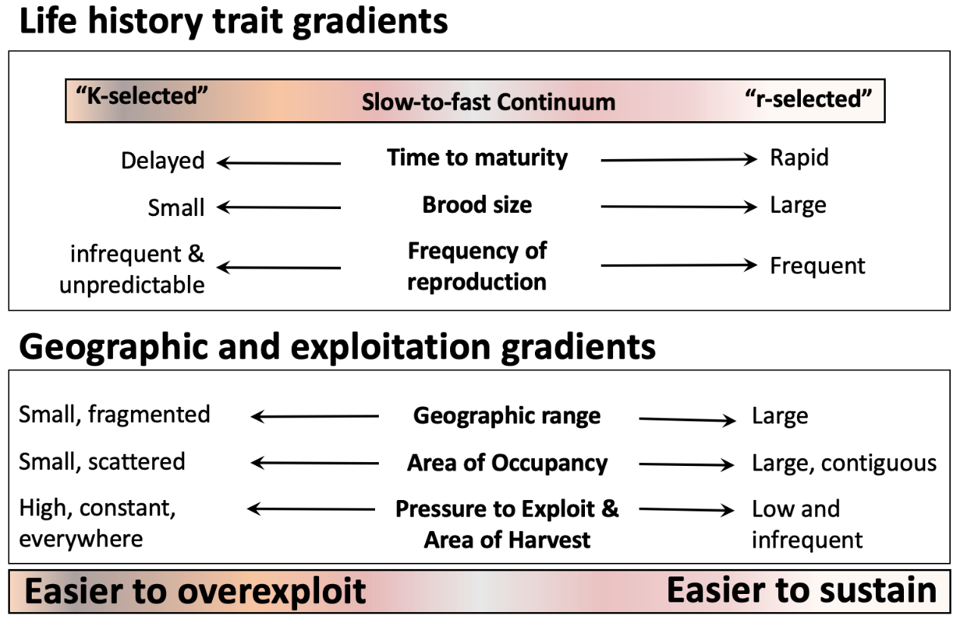
Figure 1b. Understanding life history traits, in concert with geographic distribution of populations and anthropogenic pressures, including wildlife trade, allow conservation scientists and managers to make robust predictions about the likelihood a population or species can withstand harvest for the international trade in wildlife. This framework of placing species along life history, geographic, and exploitation gradients is useful for both simplified and complex NDFs
However, not all organisms fit neatly into these general categories, many are intermediate, and some may, at different life stages, transition from one to the other. Importantly for management, K-selected species are far more likely to be affected by greater competition, internal regulation and density-dependent adjustments than r-selected species.
For example, mature individuals of crocodilians, marine turtles and some forest trees have many (but not all) of the characteristics of K-selected organisms. Despite being long-lived, they each produce large numbers of eggs or seeds which have limited parental care or investment and high mortality rates, and so have the characteristics of r-selected species. The harvest of mature individuals of such organisms, even if compensated for by density-dependent adjustments, may have a much greater biological impact and greater risks to long-term sustainability, than the harvest of eggs or tree seeds, even in large numbers. Risks and management responses to them must be judged accordingly (see Box B).
Other selected characteristics might also be used to identify species at greater intrinsic risk from harvesting. For example, Oldfield et al. (2012) found that minimum age at maturity and maximum size were the two criteria that best defined biological vulnerability to harvest in shark species.

Box B – Ostional, Costa Rica - harvest of eggs from olive ridley turtles (Lepidochelys olivacea)
This illustrative example, of a CITES Appendix I species, does not involve international trade (commercial international trade would not be permitted) and so an NDF is not required. However, the management of this egg harvest illustrates measures that might intrinsically vulnerable.
Olive ridley turtles are listed as vulnerable in the IUCN Red List. The adults are large and long-lived (typical of K-selected species) and are noted for their synchronised mass-nesting behaviour, known as arribadas. In these events, the eggs of earlier-nesting females are often inadvertently dug up and destroyed by later females. Taking advantage of this, laws permit the local community to harvest and sell for human consumption, eggs from nests laid in the first few days of an arribada (but not subsequently). The local community in return contributes to the policing of nesting beaches to prevent illegal take of eggs later in the arribada.
This management regime, which has been sustained for decades, has several obvious advantages. It provides the community with an important source of income and nutrition, through exploiting a life stage (eggs) that has the characteristics of an r-selected species. Eggs laid early in the arribada are unlikely to result in successful hatching and, so, eventual recruitment to the adult population may be minor. In turn, this harvest provides an incentive for the community to conserve the nesting beach and the returning adults. To work successfully, this requires local community ‘buy-in’, effective policing, and monitoring to ensure the offtake does not result in any negative impact on the adult population. There remain gaps in knowledge here – for example, it is challenging to distinguish the impact of egg harvest on trends in numbers of returning nesting females from other factors affecting the survival of adults away from the nesting beach (such as bycatch by fisheries etc).
Nevertheless, this management regime demonstrates an approach to mitigating risks arising from harvest and retains the scope for adaptive management if required. If an impact of harvest on adult numbers was demonstrated, harvests could be adjusted to respond to it. It is important to recognise that, despite the absence of complete knowledge, this harvest has been definitively sustained over time, and has generated stewardship and conservation benefits, and supports local people.

  - Extinction risk and level of harvest
The conservation status of a species, and the pressures or threats it faces, add to risks that might arise from harvesting being initiated, continued or curtailed.
It is relevant to know if a species is considered at risk of global, regional or national extinction, and if, for example, it has been included in one of the threatened categories (Critically Endangered, Endangered or Vulnerable) in an IUCN Red List category, or meets the criteria for being considered as Near Threatened, Least Concern or Data Deficient.
Even if not formally considered at risk of extinction, a species might be affected by several drivers of biodiversity loss, such as habitat loss or invasive alien species, that might lead to a decline in its population size, area of occupancy or other measures of population viability. Exploitation for international or domestic trade could potentially increase the probability of harvests being detrimental. These other drivers of biodiversity loss need to be identified and considered when making an NDF - even if they cannot be addressed directly.
However, simply because a species is assessed as threatened, does not mean that sustainable harvests cannot take place, but it does mean that additional safeguards, based on as assessment of known risks, might be required.
The extent and degree of harvest or offtake (both legal and illegal), and whether driven by domestic or international demand, also affects risk. Occasional harvesting of just a few individuals, from a large and robust population, is low risk (see Figures 1a and 1b). A more intensive harvest, as a proportion of the population, especially from smaller or more vulnerable populations, clearly increases the risk of population decline. Risks might be increased or decreased by the life stage being targeted, by the timing of harvest relative to critical or vulnerable periods in the species’ life history, or by other factors. Box C provides somewhat more detail how IUCN assess the conservation status of species.
  - Geographic extent of harvest
Anthropogenic pressures on species, including hunting pressure, are not evenly distributed. There may be hotspots of hunting in small areas, or hunting may occur everywhere the species may be found. Even coarse information about the area over which exploitation for trade occurs goes a long way to understanding if the trade is detrimental. For example, a species may be distributed over a large area, but the majority of individuals entering the trade come only a small fraction of its distribution. Multiple populations of species are interconnected through dispersal, which drives immigration and emigration that in turn, exert a strong influence population size. A population that has suffered a decline can be bolstered through immigrants from a population that is thriving. This pattern is akin to what ecologists refer to as source-sink phenomena where “source populations” provide immigrants to “population sinks”, sustaining them or speeding their recovery. As such, it is important to know if there are large areas where species are not hunted, which serve as insurance against widespread over-exploitation. Importantly, knowledge of geographic distribution, hunting pressures, and area where hunting occurs can be re-estimated over time with updated measures incorporated into adaptive management plans. Information about the interactions between distribution of the species and distribution of hunting areas is even more important to consider for complex NDFs.

BOX C: Sustainability, threat status and the IUCN Red List
Estimation of sustainable harvest should take into account the population data and harvest pressure resulting from legal and illegal trade relative to the vulnerability of the species (intrinsic and extrinsic factors that increase the risk of extinction of the species).
Vulnerability of the species – taking into account distribution, population size and trends, ecology and threats which contribute to the conservation status as documented for example by The IUCN Red List of Threatened Species.
The IUCN Red List system for categorising extinction risk has eight categories: Extinct; Extinct in the Wild; Critically Endangered (CR), Endangered (E); Vulnerable (VU); Near Threatened (NT); Least Concern (LC); Data Deficient (DD) and Not Evaluated (NE). The three threatened categories are CR, E and V. In a species assessment, the species is evaluated against five criteria which relate to: A) population reduction; B) geographic range; C) small population size and decline; D) very small or restricted population; and E) quantitative analysis. Each criterion has quantitative thresholds and is qualified by several sub-criteria.
Criterion A relates to species with significantly declining populations. The population decline may be in the past, ongoing or projected into the future. “The term ‘population’ is used in a specific sense in the Red List Criteria that is different to its common biological usage. Population is here defined as the total number of individuals of the taxon. For functional reasons, primarily owing to differences between life forms, population size is measured as numbers of mature individuals only.
To qualify for Criterion A, the threshold for population decline to meet the lowest category of threat i.e. VU, is 50% over a defined period in the past where the decline has ceased and 30% for ongoing or projected decline. The basis for the recording the decline must be specified with a range of options including actual or potential levels of exploitation. The thresholds for population decline for CR and EN are higher.
Detailed population data is rarely available for use in IUCN Red List assessments. For example, a recent study of assessments for over 4,000 timber species indicated that Criterion A was used for 32% of timber tree assessments - more than double the rate for all threatened tree species (currently 13.8%). However, even internationally traded species lacked population and trade information to guide assessments under Criterion A. In some cases, such data were not publicly available. Although these species were assessed as threatened due to declining population, their assessments lacked quantitative information on inventory, production and trade data and often population decline estimates were supported by “surrogate” information on habitat loss and other threats (Barstow et al, in press).
  - Governance, policy, and management
The type and effectiveness of any governance regime and/or regulation of any harvest, whether by statutory or other means, clearly affects the degree of risk (also see Box D).
Harvests might be unmanaged or unregulated, might be subject to traditional or indigenous management, or might be subject to a range of legal or other controls from national, regional or local government.
However, the simple existence of legal or other control measures only provides assurance if measures are properly applied, if they are complied with or enforced, and if the measures will genuinely lead to effective outcomes. Control measures might be based on poor or inadequate evidence and their effectiveness at achieving desired outcomes might not be monitored.
Tenure and rights over harvests also need to be considered in risk assessments. The types of tenure that might affect the risks relating to the sustainability of harvests include:
- open access – for example, fisheries in areas beyond national jurisdiction might have no controls over who enters the harvest, what is taken and how it is taken, even though such controls might often apply to States that are Parties to relevant multilateral bodies;
- de facto open access – these conditions might arise where the land has formal tenure but there are no controls or regulation of harvest (or these are not applied or enforced);
- communal tenure – harvests are controlled or regulated by indigenous peoples or through other community-ownership models;
- privately-owned;
- State-owned or controlled;
- co-managed between indigenous peoples, local communities, non-government organisations and/or private individuals and a government body or bodies;
- combinations of any or all of the above.
Many Parties have federal or other forms of devolved sub-national governance. Such sub-national governments and agencies might take differing approaches to management of a species within the same country. Species’ populations might also be shared with neighbouring countries or, for migratory species, with ones that are more distant. While Scientific Authorities are ultimately responsible for making a decision on NDFs, the range of other bodies and types of tenure that might be involved in managing the wild resource, potentially affects risk and uncertainty and, ultimately, the complexity of management decision making.
Box D. Assessing risks from ineffective management – ‘M-risk’ & intrinsic vulnerability.
A novel approach, focusing on shark fisheries as an example, aims to rapidly assess a species’ risk to over-exploitation from ineffective management (referred to as ‘M-risk’). Combined with assessments of intrinsic vulnerability to harvest (see above), this approach can be used by managers to identify species or populations at greatest risk from inadequate regulatory or management controls. It identifies potential gaps in management that, if necessary, can be overcome by additional management actions, a simple step within an adaptive management program.
In this case study, Sherman et al. (2022) showed that the management of shark fisheries both in areas within national jurisdiction and in areas beyond it (the ‘high seas’), is inherently complex, often with overlapping governance regimes including Regional Fisheries Management Organisations. Their analysis evaluated whether the management of individual species was sufficient for their relative sensitivity by combining a management-risk score for each species with their intrinsic vulnerability to determine a final M-Risk score.
However, such an M-risk analysis need not necessarily be complex – it can be applied to analysing gaps in governance or effective management at a national level where different sub-national governments or agencies manage a species within their own separate jurisdictions.

- The Precautionary Approach

  - What is it?
Precaution is a means of responding to, or mitigating risks and uncertainty, especially when knowledge on those risks is limited. Where such data are limited, or of low quality, a precautionary approach might be needed until gaps in information can be filled, and the extent of risk judged with more confidence.
The precautionary principle (or approach) originated in German law and has, since the 1990s, been incorporated in most multi-lateral environmental agreements and many domestic statutes. The approach has been subject to significant debate and has generated a substantive amount of literature – but it is interpreted differently in different legal systems. Regardless, whether the principle or approach is referred to or not, the intention is always to avoid environmental harm arising from risk and uncertainty.
The general spirit of the precautionary approach is referenced in the preamble to the Convention on Biological Diversity (CBD):
Noting also that where there is a threat of significant reduction or loss of biological diversity, lack of full scientific certainty should not be used as a reason for postponing measures to avoid or minimize such a threat.
  - How is the precautionary approach expressed in the context of CITES?
There is no explicit reference to the precautionary approach in the text of the CITES Convention, yet it is implicit in Articles II, III and IV. Reference to precaution does appear in some Conference Resolutions, notably in Annex 4 (precautionary measures) of Res. Conf. 9.24 (Rev. CoP17) on Criteria for the Amendment of Appendices I and II:
When considering proposals to amend Appendix I or II, the Parties shall, by virtue of the precautionary approach and in case of uncertainty either as regards the status of a species or the impact of trade on the conservation of a species, act in the best interest of the conservation of the species concerned and adopt measures that are proportionate to the anticipated risks to the species.
A more indirect reference is contained in Res. Conf. 16.7 (rev. CoP17) on Non-detriment Findings with reference to data requirements (and thus the degree of confidence in an NDF):
the data requirements for a determination that trade is not detrimental to the survival of the species should be proportionate to the vulnerability of the species concerned.
  - Why does it matter?
Taking an appropriate and proportionate precautionary approach when making NDFs can reduce the risk to a species through harvest for international trade. Yet a precautionary approach can enable a positive NDF finding, despite information gaps on identified risks or uncertainty.
In both the above Resolutions, the Parties have accepted that precautionary measures should be both proportionate to the risks to the species and be in the best interests of the species; that is the sense that will be applied in this guidance.
  - How could the precautionary approach be applied to the making of NDFs?
Taking a precautionary approach does not mean that if any risks are identified, a positive NDF cannot be made or that trade or harvests need to be halted. Instead, in the presence of risk and uncertainty, decisions should be made that maximise the probability of a positive outcome for the species (that is, to act in the best interest of the species). It should also be noted that halting trade or harvests is not necessarily a risk-free or least-risk option – in the presence of high and continued demand, trade might shift to being illegal and become harder to regulate or control.
By considering the risks, their probability and their likely impact, Scientific Authorities can adapt their precautionary measures (see below) in proportion to the risk. ‘High probability-high impact’ situations (Figure 1c) require greater and stricter precautionary measures than ‘low-probability-low impact’ situations, where no specific measures other than appropriate monitoring are needed.
A similar approach can be taken with respect to the quantity and quality of evidence available to inform decision making – where such data are limited or of low quality, a more precautionary approach might be needed until gaps in information can be filled, especially in situations judged to be higher risk.
The degree to which precaution may be needed can be expressed graphically in response to various risks (Figure 1c).
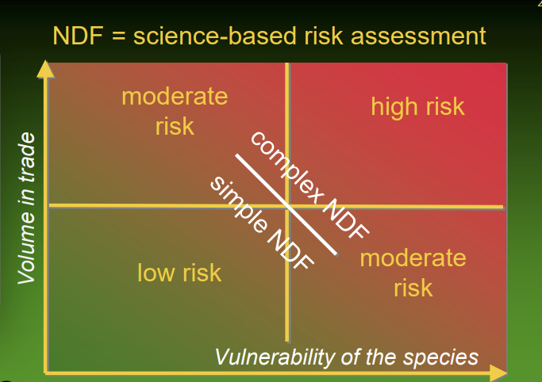 | 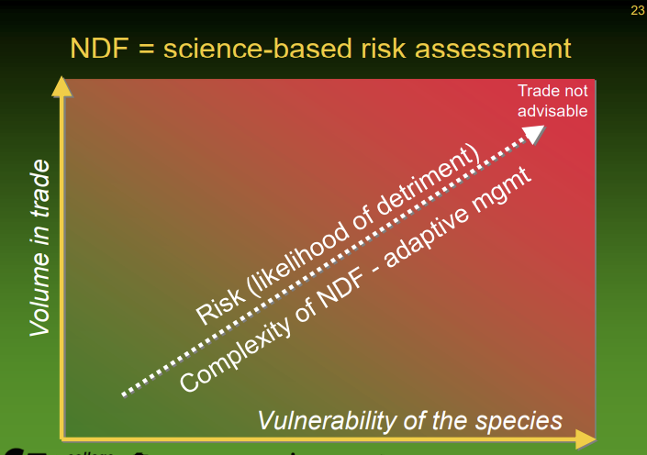
Figure 1c. The relationship between the vulnerability of the species and the volume of specimens derived from it in trade; the risk, and so the need for greater precaution, increases towards the top right of the diagram. (Morgan, 2008).
- Conditional NDFs and measures to mitigate risk and uncertainty

  - Conditional NDFs
The term ‘conditional NDF’ is often used when a positive non-detriment finding has been made subject to certain (precautionary) conditions being established by the exporting Scientific Authority and/or by those responsible for managing the harvest. These conditions are intended to mitigate defined risks and to increase the probability that a harvest is sustainable.
This approach can be taken to make positive NDFs, allowing some trade, even where information or data are limited or of poor quality (see later); the conditions provide a safeguard against over-exploitation. Most NDF’s now include conditions of one form or another – it has become the “norm”. The types of conditional measures applied are outlined below.
Safeguards and measures to reduce risks and uncertainties
There are many examples of the conditions or safeguards that can be applied to increase the probability that non-detriment is achieved in any harvest for international trade. The examples in the following section might be used in isolation or in combination with others but they are not exhaustive.
How can the risk of over-exploitation be mitigated?
A range of conditions can be applied to limit or restrict harvest as shown by the following examples.
- Quotas – limiting the number of individuals or the weight or volume of specimens that can be harvested or exported to ensure harvests remain within sustainable limits. Such quotas are frequently used in CITES and other management regimes; further guidance is provided in Res. Conf. 14.7 (rev. CoP15). Quotas should ideally be developed following analyses of risk and precaution in the NDF, they are not an alternative to undertaking an NDF. Quotas might also be imposed externally, for example through the Review of Significant Trade, as temporary precautionary measures whilst a fuller NDF is in preparation.
- Size, age or weight limits – these might be maximum or minimum limits noting that weight, size and age are not necessarily independent variables. For example, a minimum size limit might be used to ensure that individuals of an r-selected species are able to reproduce before they are harvested. By contrast, a maximum size limit might be used to protect mature individual specimens of K-selected species from harvest and to focus harvest on earlier, less vulnerable life stages. For some species, both minimum and maximum size (or other) limits might be combined to protect important or vulnerable life-stages and to focus harvest and trade on the most resilient part of the population (perhaps one which includes many individuals which are unlikely to survive to maturity). For trees, conditions commonly involve a minimal breast height diameter to ensure specimen are only harvested after having reaching maturity, at which they are assumed to have reproduced.
- Other limits on biological parameters - in some cases, harvests might only be targeted on one sex, for example harvesting only males in the trophy hunting of large cats or rhinos. This approach protects breeding females and, when combined with an age limit for example, focuses harvests only on males which are already likely to have successfully fathered young.
- Spatial or temporal closures – portions of a population might be protected from harvest by closing certain areas to harvest so these can act as refugia which might contribute to recruitment in nearby harvested areas. Closures can also be temporal, using close seasons, for example, to protect breeding or spawning sites at critical periods.
- Limitations on effort and methods – harvest effort can be limited by reducing the number of people permitted to take part in a harvest, by restricting the times individuals are allowed to harvest and by restricting the methods by which specimens are taken (e.g., mesh sizes on nets). Limitations of harvesting methods may aim to ensure that specimens survive the harvest or populations can recover. Common examples in CITES include a limit of harvest of Prunus africana bark to two quarters of any specimen’s trunk, or a condition to place a subset of Jatamansi (Nardostachys grandiflora) rhizomes back into harvested soil to support vegetative replenishment of the population.
- Setting ‘trigger’ points or ‘safeguard’ thresholds – setting pre-determined limits which, if passed, trigger management interventions. These trigger points are typically based on biomass or population (or metapopulation) size but might also be linked to breeding success, productivity, survival rates or population trends. For example, a threshold, trigger or reference point might be set such that if the population drops to less than, say, 60% of an agreed baseline that management interventions will be introduced to curtail or suspend harvests. Alternatively, harvesting might only be permitted if the population exceeds a defined threshold.
- Monitoring or data gathering only – this approach in isolation does not restrict harvesting but requires only that suitable monitoring or other data gathering is in place to establish trends in key parameters; ultimately, this might indicate the need for some of the measures outlined above to be applied or confirm that a harvest is low risk and low impact, and so no additional measures are needed. Monitoring is an essential part of adaptive management regardless of whether any other measures above are applied.
These conditions can be used singly or in combination. They are not mutually exclusive, they each have their own strengths and weaknesses (Table 1c), and their use needs to be linked to defined objectives for the harvest or population. Through monitoring and other means, their effectiveness needs to be tested objectively, to ensure they achieve their goal and that the assumptions upon which they were based are sound (see Section 9.0 on Adaptive Management).
In addition to their use for achieving non-detriment, some of the measures above might also be used for social, economic or other reasons, for example to avoid harvesting specimens of low economic value. Box E provides an example of making condition NDFs for Panax quinquefolius (American Ginseng).
Table 1c. Common measures used to provide safeguards against over-exploitation when making NDFs, with indications of their strengths and weaknesses.
NDF condition | Strengths | Weaknesses
Quotas | Simple, easily understood and used by many CITES Parties.  A visible and an effective way of informing others of the controls in place.  Can be monitored through trade data (for export quotas)  Relatively straightforward to implement.  Eliminates the need for an NDF for each individual shipment.  Can be coordinated at international / regional level for shared or migratory species.  Where (precautionary) quotas are set, due to lack of knowledge, they can act as an incentive to harvesters to improve knowledge, increase confidence and thus lead, potentially, to increased quotas. | Need appropriate procedures to ensure quotas are not exceeded – either in harvests or exports.  Export quotas do not necessarily regulate harvests or specimens derived from bycatch – the full offtake of specimens needs to be considered in NDFs.  Setting a quota is not an alternative to an NDF but arises from it.
Limits on size, age or weight or other biological parameters | Effective if species biology and impacts of harvesting sufficiently well known. | Need appropriate regulation to implement and measures to ensure compliance  Need to be sufficiently practical to apply in the field.  Might influence the demographics of a population
Closures – spatial or temporal | Effective if species biology and impacts of harvesting sufficiently well known. | Need appropriate regulation to implement and measures to ensure compliance.  Need community / industry buy-in and support if they are to work effectively.
Limiting effort +/or methods | Effective if species biology and impacts of harvesting sufficiently well known. | Need appropriate regulation to implement and measures to ensure compliance.
Trigger points / thresholds | The use of harvest-dependent data is more informative of population change as such data will not then be affected or biased by any management restrictions on harvest. | If reference points set without sufficient precaution, populations might have declined considerably before any interventions are made.  Monitoring is essential and needs to be of sufficient sensitivity and frequency to detect if threshold crossed in time for interventions.  Depends on having baseline data of sufficient quality to set thresholds with confidence.
Monitoring or data gathering only | Suitable for low risk NDFs where additional controls might be disproportionate.  Additional information generated can be used to improve risk assessments and reduce any uncertainties.  Monitoring can be combined with setting trigger or threshold points, as part of an adaptive management strategy, to determine when action might be required. | Parameters to be monitored or additional data to be gathered need to be set with care.  Monitoring needs to be of sufficient sensitivity and frequency to pick up trends.
Compensatory measures | Requires non-harvest related measures (in situ or ex situ) to be in place to boost populations (and so compensate for harvest losses).  Creates incentives for local communities to invest in species conservation in return for increased harvest opportunities. | No guarantee of success of compensatory measures.  Needs to be done at sufficient scale to make a difference.

BOX E. American ginseng – United States of America – using conditions in NDFs
American ginseng Panax quinquefolius is a long-lived, slow-growing herbaceous perennial plant whose roots are harvested predominantly for export to east Asia where it is used for medicinal purposes; the combination of its life history traits and high market demand put it at potential risk of over-harvest.
Harvests are managed by 19 individual States but conditions for international trade are determined by the Scientific Authority in the Federal government. Conditions applied to harvests include prohibitions or regulation of harvesting on State and Federal controlled lands, to provide refugia from harvest, and the use of close seasons to provide opportunities for seed production by plants. Harvested roots are certified by State authorities. Finally, as a further safeguard, the Scientific Authority only permits international trade in roots which are five or more years old, which is intended to provide a greater opportunity for plants to contribute to recruitment before being harvested.
Ginseng is also produced from artificial propagation and from 'forest farming’, but wild-harvested plants are more sought after and command higher prices.
The United States thus applies a range of conditions to harvest and to trade, to reduce the risks of ginseng being detrimentally affected by harvests.

- Making NDFs under conditions of low data availability and quality
The information on which an NDF is based, and the confidence users have in it, also affects how an NDF evaluation is made. While the quantity and quality of data on which to base NDFs always varies, gaps in knowledge are inevitable. In practice, full knowledge is never achievable in the management of any species.
Just as conditional NDFs are routine, so it is also the case that most NDFs are made under conditions of limited or low-quality data. Most Scientific Authorities are thus looking to improve the information available to them to increase their confidence when making findings of non-detriment.
Variability in the quality and availability of available data can be significant but may not constitute a risk in its own right. However, the absence of data or existence of only poor-quality data, does mean that the ability to identify and quantify risks is reduced with lower confidence.
The quality of available data will also vary and thus the degree of confidence in it, including whether information and conclusions have been subject to peer review. IPBES, for example, uses the ‘four box model’ (Figure 1d) for the communication of confidence in its findings. While this model is used by IPBES for its formal multilateral scientific assessments, and so the ‘level of agreement’ and ‘degree of certainty’ axes can be judged by appointed experts, this model or similar approaches can still be used independently by Scientific Authorities to assign levels of confidence to conclusions drawn from the data available to them. For example, where there are several peer-reviewed studies that provide evidence that are broadly in agreement with each other, a Scientific Authority might conclude the results fit in the ‘well established’ box and they can apply them with confidence. However, where data on a topic are more limited, come from different sources (say from a combination of grey literature and local & traditional knowledge), and are not entirely in alignment or are contradictory, a Scientific Authority might conclude the results fit more readily into one of the three other boxes. As a result, the topic might be considered as a gap in knowledge that the Scientific Authority might want to fill. Ultimately, the outcome of some approaches to harvest management might only be resolved by testing them in the field, under an adaptive management approach, if available evidence is inconclusive. In some cases, other knowledge systems can help to fill-in gaps in data availability (see Module 3 on Traditional Knowledge).
Figure 1d. The IPBES ‘four-box model’ for the qualitative communication of confidence. Confidence increases towards the top-right corner as suggested by the increased strength of shading. ‘Well established’ can be further sub-divided into ‘very well established’ and ‘virtually certain’. Source: IPBES (2018).
  - Measures to improve data availability and quality
While recognising that complete knowledge can never be achieved, a Scientific Authority should aim to identify key areas of concern where knowledge gaps exist, seek to address them, and so increase confidence in their NDF.
When addressing gaps in knowledge within adaptive management programmes, it is vital to differentiate between critical ‘need to know’ versus desirable or biologically intriguing ‘nice to know’ parameters. This focuses attention on the issues of greatest risk to achieving non-detriment. It is also useful to recall the statement in Res. Conf. 16.7 that ‘data requirements …. should be proportionate to the vulnerability of the species concerned’. Making complex NDFs, with exhaustive amounts of data, are not required if there is a low probability that trade could be detrimental.
Gaps in knowledge can be highlighted in any recommendations a Scientific Authority makes to a Management Authority and can form part of any conditions for new information included in an NDF.
How can I address critical gaps in knowledge
Table 1d suggests different approaches to acquiring additional information about important factors where data are limited or of low quality; the list is not exhaustive. The benefits and limitations of each approach are summarised. These approaches and sources of information can be combined and integrated into an adaptive management approach.
Despite risks associated with some approaches, such as relying on harvest-dependent data derived directly from stakeholders directly engaged in the supply chain, the benefits of acquiring additional information from those who share a common interest in the resource, are significant and will strengthen NDF development and implementation. Using harvest-dependent data can provide critically important indices of sustainability in a cost-effective way, and are fundamental to many adaptive management programs, particularly in fisheries. Using harvest-dependent data can also incentivise data improvement if harvesters know that the data are used, for example, to set quotas where such improved knowledge might lead to larger quotas.

Table 1d: Different approaches to acquiring additional data for NDFs and the limitations and benefits of each.
Approach | Source | Types of data provided | Benefits | Limitations
Harvest-dependent data | Trade supply chain – harvesters / middlemen / exporters | Provision of harvest-dependent data, for example, on numbers, size of specimens taken, locations of harvesting areas, catch per unit effort or equivalents. | A potential (and often over-looked) source of valuable and low-cost data.  Important source where few other data are available.  Information provision can be made a condition of export or other permits.  Can use low-tech methods (logbooks) or novel means (smartphone apps) to gather data, often in ‘real time’  Harvest data can be compared with export data to provide an indication of domestic markets.  Harvesters and traders have an intimate knowledge of the species & can provide historical background.  Involvement of the trade in data provision increases their engagement and involvement with the management of the species | Traders might have a conflict of interest and be unwilling to provide information if they perceive this might act against their interests.  Likely to be biases in data collection including if harvests are subject to other restrictions.  Data might be falsified to suggest compliance with other requirements.  Spot checks might be required on the accuracy of data being provided or the use of observers might be considered (thus increasing resource needs).  Needs a compliance mechanism.
Harvest-independent data | Commissioned studies from consultants, academic & NGO sectors | Broad range of information from populations parameters, impacts of harvests to socio-economic studies. | The work is targeted and focused on meeting the needs of the NDF. | Costs are likely to be high, as for all harvest independent data, and resources might not be available, especially where repeated surveys for monitoring are needed
Harvest-independent data | Universities, academics, NGOs | Broad range of information from populations parameters, impacts of harvests to socio-economic studies. | The work is likely to be of good to high scientific quality.  Universities are often looking for research ideas that their students can explore.  Increasing the policy relevance of their work can, in some cases, increase the likelihood of receiving external funding.  The academic and NGO sectors are likely to have research interests in some of the species being traded and so be a source of data. | The interests and focus of the academic / NGO research might differ significantly from that required for the NDF.  Research focused on less charismatic species and on harvests and sustainable use might attract less interest.  Researchers & NGOs might also have their biases and conflicts of interest, and some might be engaged in lobbying
Harvest-independent data | Citizen science | Information of distribution of species and trends in populations [others?] | Work is likely to be low cost and to give a significant return on initial investment.  Can be high quality if projects designed and communicated well – many non-professionals are experts.  Can use novel technology (smartphone apps) to make information available rapidly | Data has to be focused on species and parameters that can be readily and accurately recorded by citizen scientists.  Biases are likely and analysis might be challenging – a potential trade-off between ease of collection and greater difficulty of analysis.  Some errors of identification are likely
Local and traditional knowledge | Indigenous peoples & local communities (IPLCs) | Where IPLCs are involved in the trade, seeking the sharing of their relevant local and traditional knowledge can provide an additional perspective on species management.  Any information collected must be provided with the free, prior and informed consent of the owners of relevant knowledge | Valuable and low-cost data.  Important source where few other data are available.  Includes insights based on evidence acquired through direct and long-term experiences and extensive and multigenerational observations (often over centuries or millennia), lessons and skills.  Can be an integral part of any co-management agreements.  Increases engagement and involvement of IPLCs in management | IPLCs might have a conflict of interest and be unwilling to provide information if they perceive this might act against their interests.  Data may be collected or presented in a format that is not easily compatible with Western scientific models.
Novel techniques | Can be used by multiple sources | Use of smartphone apps to capture information, or computer-driven ‘data mining’ from the internet, perhaps using artificial intelligence | Can provide rapid, readily available ‘real time’ data.  Can be used to gather harvest dependent data.  Have the potential to be low-cost tools. | Initial development costs might be high even if running costs are low.  Require specialist expertise & knowledge in their development.  Experience and skills / knowledge of users of apps might vary; data quality might be low.

- Making NDFs under conditions of limited capacity
The capacity, in human or other resources, to undertake NDFs is often limited. Scientific Authorities might be limited by a) few personnel, b) inadequate training in management science, c) inadequate financial resources, d) inadequate access to IT equipment and/or sources of information, or e) an insufficient range of skills to undertake NDF assessments. Individually or in combination, such realities reduce the ability of SAs to undertake confident, evidence-based NDFs.
Issues of limited resources and capacity affect most SAs. Whilst the Scientific Authority is responsible for final decisions on NDFs, making use of the best available information, they do not need to themselves undertake all the additional tasks of further surveys, evidence provision and analysis. Rather, Scientific Authorities could seek to use and influence the use of resources available to others to meet shared needs and goals relating to the species and/or the NDF. A Scientific Authority can apply directly for funding but must decide if such bids are a sensible use of their limited resources. Engaging with other institutions, such as universities and research bodies, which have separate means of accessing funds, could contribute to the gathering of information required. That the research has direct policy relevance can aid in securing grant funding generally. Industry and those involved in the trade often have vested interests in the outcome of an NDF and may be willing to provide resources to support relevant studies. It is important to avoid conflicts of interest that might arise with any external funders.
Some kinds of research might be easier to find external funding for than others. There are obvious biases towards projects focusing on charismatic species and to research on population trends and/or threats. Outside the fisheries and forestry sectors, studies of the impacts of harvest regimes on wild populations are harder to attract either students and/or funders, despite their critical importance to management and NDFs.
Citizen science can be a cost-effective way of acquiring relevant information, especially if combined with the use of novel technologies such as smartphone apps. As with direct engagement with the trade sector (section 5.2), having more direct involvement from the public in providing data for NDFs broadens the ‘ownership’ of the issue and the evidence base, building trust and collaboration. However, the ease of acquisition of data derived from citizen science has to be offset against potential greater costs of analysis and management (Annex 2).
Examples of how issues of low capacity, in its various forms, might be overcome are summarised in Table 1e with the limitations and benefits of each approach.

Table 1e. Examples of means which Scientific Authorities might use to address limitations in capacity.
Limit on capacity | Potential solution | Benefits | Limitations
Personnel | Use external ‘manpower’ through use of citizen science, university students, to undertake surveys or research | A very effective way of gathering significant amounts of data at low cost | Requires some investment from Scientific Authority of time and effort to ensure suitable data being gathered and information needs are communicated
 |  | Might open doors to other avenues of funding | Types of surveys that might be undertaken are limited.
 |  |  | The skills of the public or their ability to participate might be limited.
Technical skills | Engage external consultants or expert bodies (e.g. IUCN, WCMC etc) | Provides targeted expertise and can be tailored to meet Scientific Authority needs | External input usually dependent on external funding
 |  |  | Input and support is usually time-limited (tied to funding)
Technical skills | ‘Twinning’ with another or multiple Scientific Authorities for skills transfer (including south-south cooperation) | Works to the mutual benefit of both Scientific Authorities | Has cost and time implications
 |  | Skills can be shared with those experiencing similar problems / issues | Some issues might still require external support (e.g., for funding)
Finances | Charge permit fees or other form of conservation levy | Income can be proportionate to the volume (& value) of trade | Funds generated might ‘disappear’ into a central finance ministry or treasury
 |  | Income can be used to employ additional staff | Might cause resentment & non-compliance if charges set too high
 |  | Traders directly contribute to species management
Finances | Seek funding / donations from those directly engaged in the trade - whether exporters or importers (or NGOs) | Traders are dependent on positive NDFs – contributing to them could be a sound investment | Funding might come with ‘strings attached’.
 |  | Can be used by business / NGOs to demonstrate their sustainability & ethical credentials | Funding directly from business interests or NGOs might be seen as biasing the independence of the NDF process.  Need to avoid real or perceived conflicts of interest
Finances | Seek grant funding from independent donors (e.g., GEF) | Significant sums available | Funding typically for short periods (3 yrs)
 |  | Focused on defined priorities & needs | Significant investment required in bid preparation
 |  |  | Training in bid writing often needed
 |  |  | Need to adjust bid to donor, not Scientific Authority, priorities
 |  |  | Need evidence of good governance & financial management

- Adaptive management

  - What is adaptive management?
There are several definitions for adaptive management and an extensive literature. It can broadly be described as ‘learning by doing’ – a structured, iterative approach to making the best decisions possible, despite risks, uncertainty and imperfect knowledge, whilst simultaneously accruing critical new information to inform, test and improve future management and achieve defined objectives.
Some example definitions include the following:
- A structured process that allows for taking action under uncertain conditions based on the best available science, closely monitoring and evaluating outcomes, and re-evaluating and adjusting decisions as more information is learned.
- Adaptive management is a procedure for implementing management while learning about which management actions are most effective at achieving specified objectives.
- Adaptive management provides a framework which allows resource managers to deal with complex ecological systems in which there are continual changes, hence the available information at any particular point in time is incomplete. The strength of adaptive management is that it establishes an experimental or scientific approach to resource management.
  - Why is adaptive management useful for making NDFs?
Adaptive management is a tool that enables all the issues discussed above regarding risks, uncertainty and precaution, to be considered and addressed together through one structured process.
Many Scientific Authorities are comprised of individuals with ecological backgrounds. It is natural then to see adaptive management as a useful or essential tool to manage wildlife populations, whether for trade or not. However, a participatory, adaptive management approach can also be applied to the process of making an NDF, especially where many State and non-state actors are involved with multiple and potentially diverging governance regimes. Such an adaptive approach, with suitable stakeholder engagement and regular reviews of progress, can enable all to work towards common goals (in this case achieving non-detriment) even if their contributions differ.
Indeed, adaptive management must be set in the context of the relevant social-ecological system. Scientific Authorities are rarely or not necessarily those directly responsible for managing a species and its harvest, instead they use various policy instruments or ‘levers’ (whether enforcement, quota-setting, or closures) to which harvesters or managers then respond. Adaptive management doesn't assume that pulling specific levers leads to certain conservation outcome, instead it sets out to learn about the system through intervention.
Importantly, adaptive management does not seek to postpone decisions (such as whether an NDF is possible or not) or management actions (such as whether harvests can be permitted or not), until full knowledge is achieved. Rather, it uses the best available information to make and test assumptions about how a population might respond to management and then captures empirical data to inform, improve and modify such assumptions. NDFs are fundamentally theoretical models that aim to predict whether a harvest will be detrimental which can then be tested by applying an adaptive management approach to a harvest program. This not only tests the predictive accuracy of NDFs but might reveal insights into variables simply not known before. Adaptive management can thus progressively increase knowledge and reduce risks. Precaution can clearly be built into initial assumptions in cases where risks are assessed to be greater and, to further reduce risks, experimental approaches can be trialled in limited parts of the harvest area.
  - Adaptive management and prescriptive management
An alternative to adaptive management is prescriptive management. In a CITES context, ensuring that trade is not detrimental to the survival of the species depends upon management of populations being harvested for international trade. The degree to which management can achieve non-detriment, given the many interacting variables involved (biological, social, economic, legal and political), depends on the knowledge base underpinning management, and where the management approach lies in the continuum between being highly prescriptive to highly adaptive.
At the extremes, adaptive management accepts populations are themselves dynamic and the way they respond to harvest is largely unpredictable until such harvesting takes place and the impacts are monitored. Knowledge of the biology of the species is important, but not as important as understanding the response of a population to harvest. As new insights are gained, the management program is adapted to account for them. It accepts imperfect knowledge, risk and uncertainty.
Prescriptive management, by contrast, tends to assume that if enough knowledge is available, risks of over-exploitation can be accounted for and a commitment to set management protocols can be justified, without extensive knowledge on the way populations respond to harvest.
The two extremes differ in the types of knowledge needed, the investment in knowledge (that may or may not prove relevant), the delays before experience from harvests can be gained, the degree to which detriment to populations can ultimately be established by practice rather than theoretical prediction, and the commitment to either retain or change management protocols, as experience with risk and uncertainty is gained.
In practice, there is rarely enough knowledge available for most CITES species to enable prescriptive management approaches and some form of adaptive management is likely to be most useful in increasing the probability of achieving non-detriment.
  - How do I implement adaptive management?
In all approaches to adaptive management, the intention is to achieve the desired objectives whilst accounting for known or suspected risks and learning, through monitoring the impact of management actions, about the significance of each risk (and perhaps new risks not previously considered). A feedback loop (Figure 1e), based on monitoring, is integral to the dynamic approach implemented.
It is important to stress that not all NDFs will require a full adaptive management approach as described below and in Annex 1. The approach can be scaled up, or down, to respond to the degree of risk and complexity of the harvest regime. Where limited trade is taking place from a large population and it is judged to be low risk, adaptive management can be limited to an initial review, the setting of any relevant control measures or conditions and limited but targeted monitoring and periodic reviews.
The adaptive management process normally involves a series of discrete steps (see Annex 1 for more detail); whilst there are many variations in the approach to adaptive management, the following represent the three essential elements.
- Review & plan. Assess the current conditions, review available information, and assess risks. Determine goals and objectives for the management and design a management plan to achieve these, including the use of any precautionary conditions or safeguard measures. Decide on indicators, monitoring methodology and data management needs, to measure progress towards the objectives. At the conclusion of this phase, it should be possible to decide if, and how, non-detriment can be achieved.
- Implement & monitor. Implement the agreed management plan ensuring sufficient governance is in place. Assess the impact and success of the management plan using the agreed indicators, monitoring methods and timing agreed at the outset.
- Evaluate & adjust. Use the results of the monitoring process and other feedback to learn from implementation to date. Review, revise and adjust the plan (and the NDF finding), and/or its use of conditions and safeguards, as needed to respond to changing conditions and to progress towards objectives with more confidence. The ability to respond rapidly to changing circumstances is an essential element of adaptive management.
The frequency at which the adaptive management programme is evaluated and adjusted will vary depending on the circumstances. Management actions might need to be reviewed often, perhaps annually, with regular if less frequent reviews (say every 3-5 years) of the entire programme. Over time, as confidence in the programme increases, the time-period between reviews might be extended for the evaluation of some elements of the programme. Box F presents an example of adaptive species management in practice.
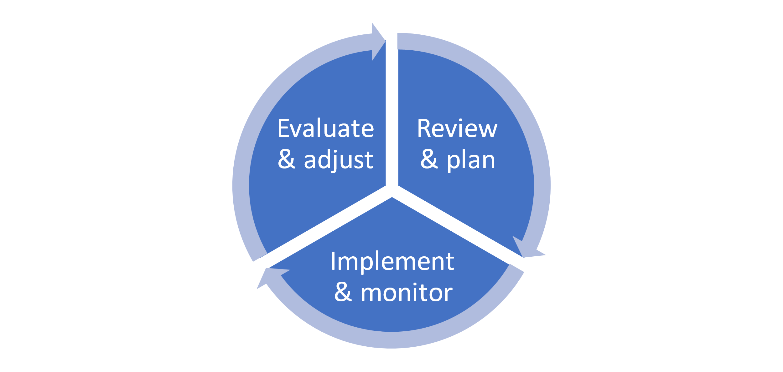
Figure 1e. Figurative representation of the adaptive management cycle

BOX F - Changes in adaptive management approach to management of Crocodylus porosus in Australia’s Northern Territory
The biomass of saltwater crocodiles in the NT at the time of their first protection (1971), was estimated to be reduced by 99% relative to when intense harvesting started (1945-46), with adult population abundance 1-2% of former abundance. Through legal protection and regulated management regimes, the population has since recovered. During recovery, management has had to adapt to a range of changing circumstances (outlined below) not only relating to the status of the population, but to changing public perceptions, international obligations and economic value.
Adaptation 1. (1945-46) From minimal to maximal unregulated harvest to meet international demand for skins. In the absence of any regulation, this was not an adaptation as such, simply a change in the pressures on the population.
Adaptation 2. (1971). From unregulated harvest of a severely depleted population to total protection of a remnant population with no idea of whether it could recover.
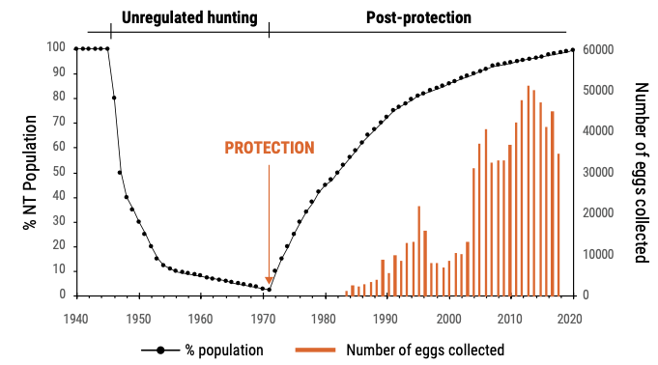
Adaptation 3. (1979-80). With the increasing population, the introduction of management actions to reduce the probability of attacks on people through public education programmes, problem crocodile removal program and the first crocodile farm (for tourism, stocked with problem animals and production anticipated as being from captive breeding in the future).
Adaptation 4. (1983-84) With further recovery, the introduction of a ranching program through which landowners (indigenous and non-indigenous) could sell the eggs from their lands to the three farms established by then.
Adaptation 5. (1985-87) Formulation of formal NT management program, approved by the Commonwealth, in order to comply with the requirements of CITES, noting that the population had been transferred from Appendix I to Appendix II (1985) pursuant to the ranching resolution (then Resolution Conf. 3.15), which required annual reporting of biological and commercial viability, and the commitment to continuing population monitoring.
Adaptation 6. (1994-5). With further recovery, and with the transfer to Appendix II being changed from the ranching resolution to the then Bern Criteria (Resolution Conf. 1.2), management and monitoring obligations were scaled back. The farming industry (still based largely on ranching) increased, strengthening the view that crocodiles were a valuable commercial asset to the NT community.
Since 1995, the ranching programme and measures to reduce human-wildlife conflict have continued. No effort to maximise the sustainable offtake of the wild population, by adding a significant wild harvest to the ranching program, has yet been made, and it is thus under-utilised in terms of maximising sustainable offtake.
  - What are the limitations of adaptive management?
Steps 2 & 3 above, to monitor, evaluate and adjust, are critical if adaptive management is to be successful. However, the IPBES (2022) Thematic Assessment on Sustainable Use concluded that: ‘scientific monitoring is limited or lacking for many extractive and non-extractive practices (well established) and is identified as a critical knowledge gap for sustainable use’ and ‘the lack of ongoing monitoring of population dynamics may make the most adaptive of regulations insufficient to prevent species decline (well established)’.
In other words, it is not possible to ‘learn by doing’ to inform future management decisions if the relevant information is not being generated by appropriate monitoring (and subsequently analysed). However, monitoring is often expensive and its long-term nature means it can be difficult to fund given the frequent preference by donors and governments to fund short-term projects. This emphasises the need to use low cost means of obtaining information, such as harvest-dependent data, suggested in section 5.2 and Annex 2, including using local and traditional knowledge, which can be sustained over time.
A critical point here is that considerable thought needs to be given to monitoring at the start of the planning process, including what is going to monitored, why it is being monitored, the methods by which this will be achieved, how the data will be stored and analysed, what indicators will be generated, and how it all will be funded. There is no point monitoring some parameters if they are not relevant to management and won’t inform any adjustments required to both harvests and management measures. The resources need also to be in place to ensure that indicators derived from monitoring are given appropriate review and management measures are adjusted, if necessary, as a result. An information document to CoP17 (Cop17 Inf. 65), although focused on marine fish and invertebrates, provides a good overview of approaches to, and key principles for, monitoring for adaptive management.
When a program is started, and the predicted effects of harvest on a wild population have not been tested, the research component is typically elevated, the geographic spread of monitoring may be wide, the monitoring may be frequent and the types of monitoring implemented may be diverse. If the results demonstrate sustainability unequivocally, and the same basic harvest is implemented annually, the commitment to ongoing research can be scaled back, and more cost-effective monitoring approaches and indices can be used as a check that nothing unexpected has happened.

Resolution Conf Res. Conf. 16.7 (Rev. CoP17) on Non-detriment Findings https://cites.org/sites/default/files/documents/COP/19/resolution/E-Res-16-07-R17.pdf
Milner-Gulland & Shea. 2017. Embracing uncertainty in applied ecology. Journal of Applied Ecology 54, 2063-2068. Available here.
Oldfield, T.E.E., Outhwaite, W., Goodman, G. and Sant, G. 2012. Assessing the intrinsic vulnerability of harvested sharks. 26th Meeting of the CITES Animals Committee. AC26 Inf. 9.
IUCN Standards and Petitions Committee. 2022. Guidelines for Using the IUCN Red List Categories and Criteria. Version 15.1. Prepared by the Standards and Petitions Committee. Downloadable from: https://www.iucnredlist.org/documents/RedListGuidelines.pdf.
Morgan D. 2008. CITES non-detriment findings in context. International workshop on CITES non-detriment findings. Cancun, Mexico. Available here – see slides 21-23.
See: de Bie, Addison & Cook (2017) Integrating decision triggers into conservation management practice. Journal Applied Ecology 55, 494-502 Available here.
IPBES (2018): IPBES Guide on the production of assessments. Secretariat of the Intergovernmental Science-Policy Platform on Biodiversity and Ecosystem Services, Bonn, Germany. 44 pages. Available here.
IPBES (2018): IPBES Guide on the production of assessments. Secretariat of the Intergovernmental Science-Policy Platform on Biodiversity and Ecosystem Services, Bonn, Germany. 44 pages. Available here.
Dobson et al. 2020. Making messy data work for conservation. One Earth 2, 455-465. Available here.
California Department of Fish and Wildlife, 2009
New South Wales Department of Planning & Environment https://www.environment.nsw.gov.au/research-and-publications/our-science-and-research/our-work/adaptive-management#:~:text=Adaptive%20management%20is%20a%20procedure,effective%20at%20achieving%20specified%20objectives.
Bond, I., Davis, A., Nott, C., Nott, K. & G. Stuart-Hill (2006) Community-based Natural Resource Management Manual. WWF, Southern African Regional Office. Harare, Zimbabwe. Available here.
Modified from: Rogers, P. and Macfarlan, A. (2020). What is adaptive management and how does it work? Monitoring and Evaluation for Adaptive Management Working Paper Series, Number 2, September. Available here.
IPBES (2022). Summary for Policymakers of the Thematic Assessment Report on the Sustainable Use of Wild Species of the Intergovernmental Science-Policy Platform on Biodiversity and Ecosystem Services. Fromentin, J.M., Emery, M.R., Donaldson, J., Danner, M.C., Hallosserie, A., Kieling, D., Balachander, G., Barron, E.S., Chaudhary, R.P., Gasalla, M., Halmy, M., Hicks, C., Park, M.S., Parlee, B., Rice, J., Ticktin, T., and Tittensor, D. (eds.). IPBES secretariat, Bonn, Germany. https://doi.org/10.5281/zenodo.6425599
Note the additional guidance available on: Incorporating local, traditional and indigenous knowledge into NDFs and participatory species monitoring and management (available here INSERT LINK)
FAO & IUCN. 2016. Simple is good: moving toward pragmatic and effective monitoring to support CITES implementation for marine fishes and invertebrates on appendix II. CoP17 Inf.65. Available here.

