PC13 Doc. 25.1
CONVENTION ON INTERNATIONAL TRADE IN ENDANGERED SPECIES
OF WILD FAUNA AND FLORA
____________
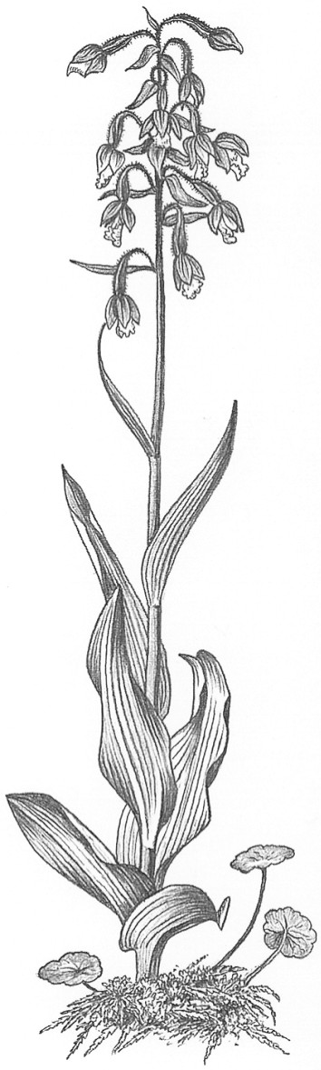
Thirteenth meeting of the Plants Committee
Geneva (Switzerland), 12-15 August 2003
Production systems involving CITES-listed species and
their impact on wild populations – source code designations
Plant production system
1. This document has been prepared by the Secretariat.
2. The Plants Committee has noted concern that CITES definitions of production systems are not being used appropriately (see document PC11 Doc. 9.1a, Harvesting techniques of Galanthus in Georgia, which discusses how to define the production system for Galanthus bulbs). Further discussion on this topic was tabled at the 12th meeting of the Plants Committee (Leiden, May 2002) when document PC12 Doc. 23.1 on CITES plant production systems was discussed. Documents PC11 Doc. 9.2 on Decision 11.155, discussing how to characterize sylviculture production systems and PC12 Doc. 20.3 on Relationship between in situ conservation and ex situ production of plants also address this issue.
3. In document PC12 Doc. 23.1 it was noted that there is a wide range of production systems in use, but that creating many new source codes would not necessarily be helpful. Rather, it was argued that definitions of plant production systems should be used to clarify existing codes given in Resolution Conf. 12.3 on Permits and certificates, and that additional codes should be kept to a minimum. It was also noted that source codes should not replace non-detriment findings, but could complement them. One Party suggested developing a checklist of production systems and evaluating the conservation benefits of the various systems.
4. The Secretariat contracted the IUCN/SSC Wildlife Trade Programme to work further on this issue. It is expected that a summary of its main findings and recommendations will be made available by the time of the meeting. In that case, the Secretariat would propose that the Plants Committee considers establishing a small technical working group to review the information presented in this summary document, and to progress with classifying different production methods for CITES-listed plant species in trade. This group should be tasked with preparing a document for consideration at the 14th meeting of the Plants Committee.

