AC18 Doc. 12.1

CONVENTION ON INTERNATIONAL TRADE IN ENDANGERED SPECIES
OF WILD FAUNA AND FLORA

___________________
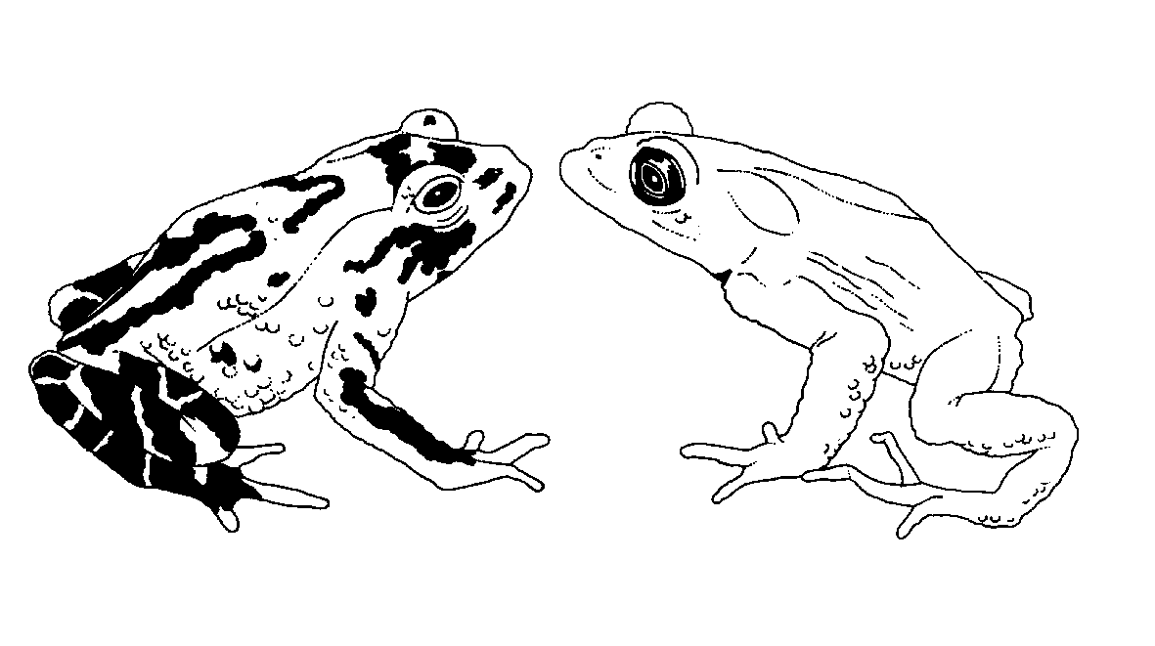

Eighteenth meeting of the Animals Committee
San José (Costa Rica), 8-12 April 2002

Implementation of Decision 11.99

REPORT OF THE WORKING GROUP

This document has been prepared by the Chairman of the working group on trade in hard corals of the Animals Committee on the request of the Secretariat.
Introduction
1. This report summarises the action taken by the working group on trade in hard corals pertaining to Decision 11.99, directed to the Animals Committee, which states: “The Animals Committee shall provide advice to the Secretariat, for dissemination to the Parties, on which genera of corals it is practical to recognize to species level and which genera may be acceptably identified to genus level for the purposes of implementing Resolution Conf 9.4 and Conf. 10.2 (Rev.).”
2. The working group provides recommendations to the Animals Committee and outlines the rationale for these recommendations. Other tasks in our terms of reference will be addressed during the 18th meeting of the Animals Committee.
Identifying coral taxa to species or genus level
3. Building on earlier work at AC16 in relation to Decision 11.99, the group continued their work to produce a list of taxa that may be identified to genus level only and a list of genera which must be identified to species level. The group recognised that this issue was central to much of the other work identified in their terms of reference (attached). In particular, determining whether a taxon is identified to species or genus level has significant implications for:
a) making non-detriment findings;
b) recording levels of trade in various species;
c) the level of detail required in identification guides;
d) monitoring of levels of harvests in the wild; and
e) whether some species should be retained on the Appendices or not.
4. It may also set a precedent in CITES that others may wish to exploit. Equally, the group noted the genuine difficulties of identifying corals (live and dead corals as defined in Resolution Conf. 11.10) in trade. These difficulties include the plastic growth forms of corals, considerable variation within and between species from different areas and when growing in different environmental conditions, and the need to identify their skeletons microscopically for a definitive identification (not readily visible in live specimens). These features may make it impractical or impossible to identify some corals below the level of genus. Even within a single colony, there can be marked variations in skeletal structure and form. In addition some species are only reliably separated with dead specimens or in other cases with live specimens. Closely related species groups are often capable of hybridisation, whilst individual species from distant regions may no longer be capable of inter-breeding. There is also a minimum of 600 reef-building coral species world-wide that may potentially be in trade, many of which are very similar in appearance. Taxonomic problems are widespread. It should also be noted that many of the corals added to the Appendices in 1990 were listed for so-called ‘look-alike’ reasons.
5. However, identifying some corals to generic level only, has risks and benefits. We assessed these as follows:
Risks of identifying some taxa to genus level only
6. Non-detriment findings (Article IV.2.a) are more difficult to make at the genus level and the role of a species within an ecosystem (Article IV.3) may not be consistent for all species within a genus.
7. Less abundant or more vulnerable species in a genus may be exploited at unsustainable levels but this will not necessarily be recognised through analysis of trade data.
8. Shifting patterns of trade within a genus will not be apparent. Identification to genus only might be used to avoid restrictions or stricter measures imposed by some importing countries.
9. Species level data can be aggregated to report at the genus level but genus level data cannot be broken down to species level data.
10. Despite the practical difficulties in identifying many corals to species level, traders often know the species in trade very well and can identify them with certainty.
Benefits of identifying some taxa to genus level only
11. The group has already noted the significant practical difficulties of accurately identifying some corals to species level; it may be preferable to have accurate identification at genus level rather than poor or inaccurate data at species level.
12. The difficulties of identification to species level may lead to shipments being seized if an importing country makes a different identification of a specimen(s) than that on the export permit (even though it is generally simpler for an exporting country to make an accurate identification because they have comparative material to hand).
13. Greater confidence in trade data from importing and exporting Parties.
14. Non-detriment findings can still be made to a degree but with a reduced level of confidence in the result (NB for some genera, monitoring data may also only be collected at the generic level rather than the species level?)
15. There may be redundancy of species within a genus in the role they play within the ecosystem.
16. The analysis above suggests that it is still preferable to identify corals in trade to the specific level wherever possible. However, there will be circumstances in which such identification is not possible and identification to the genus level should be acceptable (as provided for in Resolution Conf. 11.17). However, it is also clear that even in the ‘difficult’ genera, traders are exporting a relatively small number of species and are confident of their species identification. It is clear that such specimens should continue to be identified to species level and allowing identification to genus level only must not be used simply for the sake of expediency.
Recommendations
17. Following our deliberations, the coral working group makes the following recommendations. The list upon which these are based, with explanatory comments, is provided in the Annex. The Committee is asked to note that a small number of genera (identified in the Annex) may need to be re-considered following recent comment.
18. We recommend that where feasible, corals should be identified to species level (as recommended in Resolution Conf. 11.17).
19. Specimens of the following genera MUST be identified on CITES permits to species level:
a) All mono-specific genera (sensu Cairns et al., 1999)
b) Blastomussa* Cladocora, Colpophyllia, Dichocoenia, Diploria, Euphyllia (live)*, Galaxea, Halomitra, Heteropsammia, Hydnophora*, Merulina, Mycedium, Oulophyllia, Pachyseris*, Physogyra (live), Plerogyra (live), Podabacia, Polyphyllia, Seriatopora*, Sandalolitha.
c) All other species in genera not formally assessed by the coral working group.
20. Whilst we recommend genera marked with * be identified to species level, some difficulties may still arise for the identification of some species within these genera. Indeed, specific guidance in identification to species level for these (and other) genera may be required to be produced for Parties, enforcement officials, traders and other stakeholders. It should also be noted that identification is likely to be more accurate in exporting countries than at importing ports of entry. Some species within these genera might still require significant caution before making a positive identification. The group also noted that corals are often inspected in less than ideal conditions, when they are in transit for example, and the coral polyps may be contracted. Additional caution is required in these circumstances and guidance to Customs officials on how best to handle specimens to enable accurate identification is desirable.
21. Specimens of the following genera MAY be identified on CITES permits to genus level only:
Acanthastrea, Acropora, Agaricia, Anacrapora, Alveopora, Astreopora, Balanophyllia, Barabattoia, Caulastrea, Coscinaraea, Ctenactis, Cyphastrea, Dendrophyllia, Distichopora, Echinophyllia, Echinopora, Euphyllia (dead), Favia, Favites, Fungia, Goniastrea, Goniopora, Leptastrea, Leptoseris, Lithophyllon, Lobophyllia, Madracis, Millepora, Montastrea, Montipora, Mussissmillia, Mycetophyllia, Oculina, Oxypora, Pavona, Pectinia, Physogyra (dead), Platygyra, Plerogyra (dead), Pocillopora, Porites, Psammocora, Scolymia, Siderastrea, Solenastrea, Stylaster, Stylocoeniella, Stylophora, Symphyllia, Tubastrea, Turbinaria.
22. It is expected that Parties will only use identification to genus level on permits when it is genuinely not possible to identify a specimen to species level. As noted above, it is frequently the case that only a few species are exported from, or occur in a country, even if there are many species in the genus overall. In such cases, every effort should be made to identify specimens to species level.
References
Cairns, Hoeksema & van der Land, 1999. List of extant stony corals. Atoll Research Bulletin No. 459. Smithsonian Institution, Washington.
Annex
(English only / / )
Working group on trade in hard corals & coral mariculture
Coral taxa identifiable to species or genus level - summary of recommendations

Taxa  (taxa in bold indicate that consensus yet to be achieved) | Number spp in genus  (from Cairns et al 1999) | Comments | Working group recommendation
Mono-specific genera
Acrhelia horrescens | 1 | plus additional undescribed spp? | S
Anomastrea irregularis | 1 | Caribbean | S
Asteosmilia connata | 1 |  | S
Australogyra zelli | 1 |  | S
Australomussa rowleyensis | 1 |  | S
Boninastrea boninensis | 1 |  | S
Catalaphyllia jardinei | 1 |  | S
Coeloseris mayeri | 1 |  | S
Ctenella chagius | 1 |  | S
Cynarina lacrymalis | 1 |  | S
Dendrogyra cylindricus | 1 | Caribbean | S
Diploastrea heliopora | 1 |  | S
Duncanopsammia axifuga | 1 |  | S
Erythrastea flabellata | 1 |  | S
Eusmilia fastigiata | 1 | Caribbean | S
Gardineroseris planulata | 1 |  | S
Gyrosmilia interrupta | 1 |  | S
Heliofungia actiniformis | 1 |  | S
Heliopora coerulea | 1 |  | S
Helioseris cucullata | 1 | Caribbean | S
Herpolitha limax | 1 |  | S
Horastrea indica | 1 |  | S
Indophyllia macassarensis | 1 |  | S
Isophyllastrea rigida | 1 | Caribbean | S
Isophyllia sinuosa | 1 | Caribbean | S
Leptoria phrygia | 1 |  | S
Manicinia areolata | 1 |  | S
Meandrina meandrites | 1 | Caribbean | S
Montigyra kenti | 1 |  | S
Moseleya latistellata | 1 |  | S
Mussa angulosa | 1 |  | S
Nemenzophyllia turbida | 1 | Genus recognised by Cairns | S
Oulastrea crispata | 1 |  | S
Palauastrea ramosa | 1 |  | S
Paraclavarina triangularis | 1 |  | S
Parasimplastrea simplicitexta | 1 |  | S
Physophyllia ayleni | 1 |  | S
Plesiastrea versipora | 1 |  | S
Pseudosiderastrea tayami | 1 |  | S
Scapophyllia cylindrica | 1 |  | S
Schizoculina fissipara | 1 |  | S
Simplastrea vesicularis | 1 |  | S
Stephanocoenia intersepta | 1 | Caribbean | S
Stylarea punctata | 1 |  | S
Trachyphyllia geoffroyi | 1 | Includes Wellsophyllia radiata | S
Tubipora musica | 1 |  | S
Zoopilus echinatus | 1 |  | S
Other taxa to species level
Blastomussa | 2 | Some difficulties may be encountered when trying to distinguish between these species | S
Cantharellus | 3 | species id proposed by Hoeksema & supported by Belgium - await other group comments | S
Cladocora | 4 |  | S
Colpophyllia | 3 |  | S
Dichocoenia | 2 | Caribbean | S
Diploria | 3 | Caribbean | S
Euphyllia (live) | 9 | NB difficulties may be encountered when trying to distinguish between E. glabrescens and E. divisa. AKKII note id difficulties when tentacles retracted | S
Galaxea | 4 | Hoeksema suggests id to genus | S
Halomitra | 2 |  | S
Heterocyathus | 3 | species id proposed by Hoeksema & supported by Belgium - await other group comments | S
Heteropsammia | 2 |  | S
Hydnophora | 6 | v difficult to id in field - but 2 spp exported usually easy. AKKII note id difficulties in juveniles | S
Merulina | 3 |  | S
Mycedium | 2 |  | S
Oulophyllia | 2 |  | S
Pachyseris | 4 | AKKII note difficulties of distinguishing between species | S
Physogyra (live) | 2 |  | S
Plerogyra (live) | 4 |  | S
Podabacia | 2 | Okay to spp level but may need both species together for comparison | S
Polyphyllia | 2 |  | S
Sandalolitha | 2 |  | S
Seriatopora | 2 | Some difficulties may be encountered when trying to distinguish between these species | S
Taxa where identification to genus is acceptable (but which should be identified to species where feasible)
Acanthastrea | 10 |  | G
Acropora | 127 |  | G
Agaricia | 7 |  | G
Alveopora | 12 |  | G
Anacrapora | 5 |  | G
Astreopora | 11 |  | G
Balanophyllia | 56 |  | G
Barabattoia | 3 | retain ID at genus level - size main distinction, small sized specimens a problem. | G
Caulastrea | 4 | retain ID at genus level - 2 spp regularly in trade -spp distinguished on size? and angle of branching, problems at importing end?  Hoeksema & Belgium suggest changing to species id for this genus. | G
Coscinaraea | 9 |  | G
Ctenactis | 3 |  | G
Cyphastrea | 7 |  | G
Dendrophyllia | 21 |  | G
Distichopora | 23 | Only 2 reef-dwelling species - easy to distinguish. Others deep water. | G
Echinophyllia | 8 |  | G
Echinopora | 9 |  | G
Euphyllia (dead) | 9 |  | G
Favia | 18 |  | G
Favites | 9 |  | G
Fungia | 25 | Includes Cycloseris & Diaseris | G
Goniastrea | 8 |  | G
Goniopora | 20 |  | G
Leptastrea | 6 |  | G
Leptoseris | 14 |  | G
Lithophyllon | 2 | Easy to sp level - Hoeksema | G
Lobophyllia | 7 |  | G
Madracis | 15 |  | G
Millepora | 17 |  | G
Montastrea | 9 |  | G
Montipora | 56 |  | G
Mussissmillia | 3 |  | G
Mycetophyllia | 5 |  | G
Oculina | 9 |  | G
Oxypora | 3 |  | G
Pavona | 17 |  | G
Pectinia | 5 |  | G
Physogyra (dead) | 2 |  | G
Platygyra | 9 |  | G
Plerogyra (dead) | 4 |  | G
Pocillopora | 7 |  | G
Porites | 41 |  | G
Psammocora | 11 |  | G
Scolymia | 5 |  | G
Siderastrea | 4 |  | G
Solenastrea | 2 | Caribbean - sp level suggested by Hoeksema & Belgium | G
Stylaster | 75 | Most single common reef dwelling sp in PH & ID has no accurate id. - Hoeksema | G
Stylocoeniella | 3 | retain id at genus level - small differences between the species, rarely in trade - recommendation supported by Hoeksema | G
Stylophora | 5 |  | G
Symphyllia | 7 |  | G
Tubastrea | 6 |  | G
Turbinaria | 12 |  | G

