AC17 Doc. 15.1

CONVENTION ON INTERNATIONAL TRADE IN ENDANGERED SPECIES
OF WILD FAUNA AND FLORA

____________
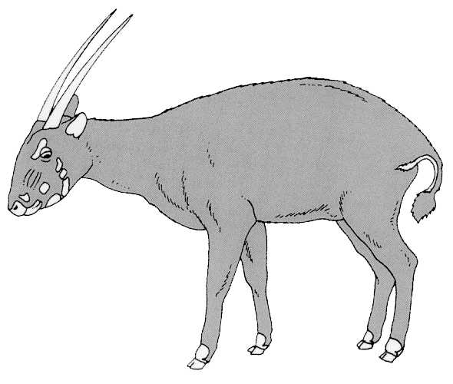
Seventeenth meeting of the Animals Committee
Hanoi (Viet Nam), 30 July-3 August 2001

Universal labelling of caviar

report of the working group
This report has been prepared by the Chairman of the working group on the universal labelling of caviar.

Background

- Pursuant to Resolution Conf. 11.13 (Universal Labelling System for the Identification of Caviar) a working group was established at the 16th meeting of the Animals Committee (AC16) comprised of the Regional Representative for Oceania (Chairman), China, France, the Islamic Republic of Iran, the Russian Federation, the United States of America, International Caviar Importers Association, IWMC-World Conservation Trust, Tsar Nicoulai Caviar and TRAFFIC Europe.

- Though the establishment of a universal labelling system is technically difficult and many of the issues are outside the normal scope of expertise of the Animals Committee, good progress was made at AC16 and subsequently. Work on implementing the Resolution is not complete though.

Implementing Resolution Conf. 11.13

- In response to a recommendation of the working group, the CITES Secretariat requested information from caviar exporting countries on their lot identification systems, including the type and nature of the labels affixed to different containers, the “uniqueness” of the information on the labels and the inclusion of label information in the relevant export permits. The purpose of this was to provide examples of existing acceptable systems to be circulated in a Notification to the Parties on the universal labelling of caviar. The response to that request was initially limited, and some Parties may have been awaiting further guidance from the CITES Secretariat on the specifics of a system that would meet the requirements of Resolution Conf. 11.13. However, good information has been obtained from a few Parties that can probably serve as a model for others.

- TRAFFIC Europe offered to assist with the drafting of a Notification to the Parties covering the requirements as interpreted by the working group and identified a number of issues that needed to be outlined. These included:

a) The potential, as suggested in the working group report, that an exporting plant may be classified as a processing plant, which could compromise tracking a shipment back to its source, and
b) The recommendation to the Parties to establish, where legally possible, a system of registration or licensing or both of importers and exporters of caviar, and the possibility of asking Parties to provide a list of registration numbers and names of registered exporting companies.
- Of particular concern was the potential for confusion over the phrase “more than 249 grams” in paragraph a) of the Resolution. This paragraph was meant to indicate the need to classify any container of 250 grams or more as a primary container needing full labelling. Because this is in the text of the Resolution it is not simply a matter of interpretation, though the Notification to the Parties may be able to clarify the intent.

- Further work is required by the working group to assist in drafting the Notification to the Parties, and to start drafting amendments to the existing Resolution Conf. 11.13 (or to initiate the drafting of a new resolution) to clarify further labelling requirements, including the requirement to label any container with 250 grams or more of caviar, and to cover the labelling of caviar that is re-exported.

