PC13 Doc. 14.2 (Rev. 1)
CONVENTION ON INTERNATIONAL TRADE IN ENDANGERED SPECIES
OF WILD FAUNA AND FLORA
____________
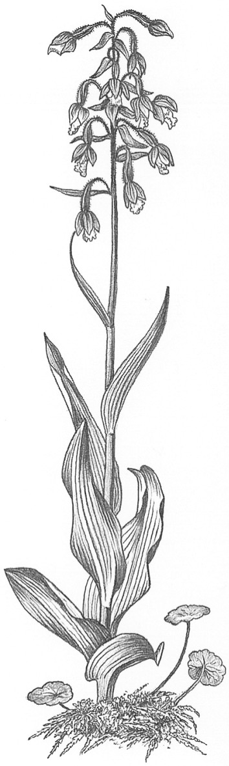
Thirteenth meeting of the Plants Committee
Geneva (Switzerland), 12-15 August 2003
Review of heavily traded non-CITES species
Evaluation of tree species (Decision 12.10)
1. This document has been prepared by the Scientific Authority of the Netherlands.

Background
2. In 1998, the Management Authority of the Netherlands published the Contribution to an evaluation of tree species using the new CITES Listing Criteria, a comprehensive study reviewing the conservation and trade status of tree species, and the potential role of CITES. At the 11th meeting of the Plants Committee (PC11, Langkawi, September 2001), all participating Parties and observers were asked to send up-to-date or complementary information to the regional representatives of Europe. Unfortunately, at PC12 (Leiden, May 2002) little additional information was reported to have been received. The Plants Committee recommended at the same meeting that the development of proposals to amend the Appendices be based on this evaluation of tree species in trade, and the Netherlands was asked to take the lead in this.
3. At its 12th meeting (Santiago, November 2002), the Conference of the Parties confirmed this task through the Actions directed to the Plants Committee (Annex 2 to the CITES Decisions, Action Point 2.1.4) and through Decision 12.10:
The Plants Committee shall, during the period between the 12th and 13th meetings of the Conference of the Parties, develop proposals to amend the Appendices on the basis of the Contribution to an evaluation of tree species using the new CITES Listing Criteria, published by the Management Authority of the Netherlands in 1998.

Activities since PC12
4. After the 12th meeting of the Plants Committee, during 2003, the Director of the Botanical Garden of the Leiden University, Dr Ir. J. de Koning, consulted with experts of the Scientific Authorities of several Parties and NGO’s with an interest in this issue. A small explorative meeting of botanists, CITES experts and NGO’s was convened in Cambridge in April 2003. The aim of the meeting was to find a constructive and practical approach to contribute to the conservation of tree species.
5. The discussions led to the following conclusions:
a) The eventual preparation of proposals requires an integrated and basal approach towards the conservation of tree species.
b) A variety of stakeholders should participate in a transparent communication process to explore options for the best conservation policy for tree species.
c) Problems in conservation and possible solutions, the tools needed and actions required would probably most effectively be identified on a regional basis. Potential tools should be feasible and effective, and could be either local, national, regional or global, and involve either a non-CITES approach or a CITES approach.
d) There is a clear need to raise awareness of the benefits and the various applications of CITES regulations, in particular for Appendix II and III.
e) Improvement of the implementation of CITES for species already listed should have a high priority.
f) As a first step, regional workshops are to be organized to address items a)-e), in Africa, Asia, Central and South America and the Caribbean, Europe, and North America.
6. The Director of the Botanical Garden of Leiden University has taken the initiative to start instigating these regional workshops, and UNEP-WCMC and Fauna and Flora International have been requested to assist in the process. Current actions include the preparation of a budget, fund raising, preparation of logistics and documents, and the identification of stakeholders.
7. The Leiden Botanical Garden will coordinate actions and keep participating persons and institutions, as well as the Plants Committee informed.

