PC12 Doc. 12.1.2
CONVENTION ON INTERNATIONAL TRADE IN ENDANGERED SPECIES
OF WILD FAUNA AND FLORA
____________
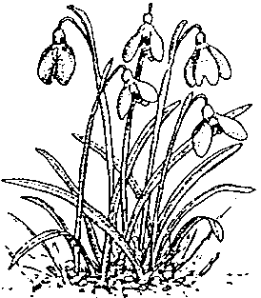
Twelfth meeting of the Plants Committee
Leiden (The Netherlands), 13-17 May 2002

Medicinal plants

Implementation of Decision 11.165 on trade in traditional medicines

List of species traded for medicinal purposes
1. The Annex to this document has been prepared by the Secretariat on the basis of the list of CITES species used fro medicinal purposes, as contained in an Annex to Medicinal Plants Significant Trade Study; CITES project S-109 (Uwe Schippmann, 2001).
2. No attempt has been made to add non-listed species, because there number would vastly exceed the CITES-listed ones, and it would be very time consuming. Such a list would probably also be incomplete. A list of animal species (CITES and non-CITES was prepared, but is still largely incomplete as it.
3. The Secretariat notes that the existence of records of the use of a species for medicinal purposes does not necessarily imply that specimens of those species are traded internationally. In order to compile the list called for in Decision 11.165, paragraph c), a lot of time and money is needed, and the Secretariat is seeking the opinion of the Plants Committee on whether such an investment effort, and the resulting list, will be useful for the purposes of CITES.

PC12 Doc. 12.1.2
Annex



