PC11 Doc. 8.1
CONVENTION ON INTERNATIONAL TRADE IN ENDANGERED SPECIES
OF WILD FAUNA AND FLORA
____________
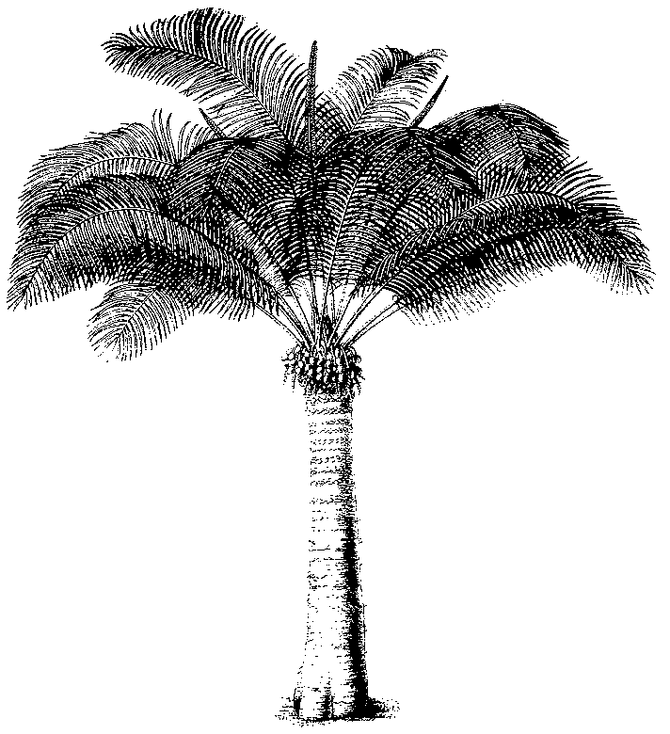
Eleventh meeting of the Plants Committee
Langkawi (Malaysia), 3-7 September 2001
Follow-up of CoP11 Decisions
harpagophytum spp.
1. This document has been prepared by the Secretariat.
2. At its 10th meeting the Plants Committee agreed that the work to implement Decision 11.111 would be coordinated by the regional representative for Africa, Mr John Donaldson. Mr John Donaldson is doing this in close coordination with the management Authority of Namibia.
3. In consultation with the Chairman of the Plants Committee, the United States of America agreed to allocate USD 5,000 of the funds for Plants Committee projects to this task.
4. The Secretariat has established a Memorandum of Agreement with the National Botanical Institute of South Africa (for an amount of USD 2,750) for staff assistance to John Donaldson to collect information, as required in the Decision, and to prepare documentation for the regional devil’s claw conference (see below) and the final report to be presented at CoP12.
5. The Namibian devil’s claw working group is preparing a regional devil’s claw conference, to improve regional cooperation between the stakeholders involved in these species at various levels and to address current issues, problems and weaknesses including:
- Information exchange on various issues
- Resource management
- The quality of devil’s claw supplied on the international market
- Prices, market stability and marketing
- Benefit-sharing opportunities
- Value addition
- Access to genetic material and other bio-diversity related issues
- Negotiating from a position of strength rather than on an individual basis
6. The estimated cost for this meeting is USD 27,400 for which the organizers are seeking external funding. The remaining USD 2,250 of the funds from the United States will be allocated to the conference costs.

