PC11 Doc. 5.5
CONVENTION ON INTERNATIONAL TRADE IN ENDANGERED SPECIES
OF WILD FAUNA AND FLORA
____________
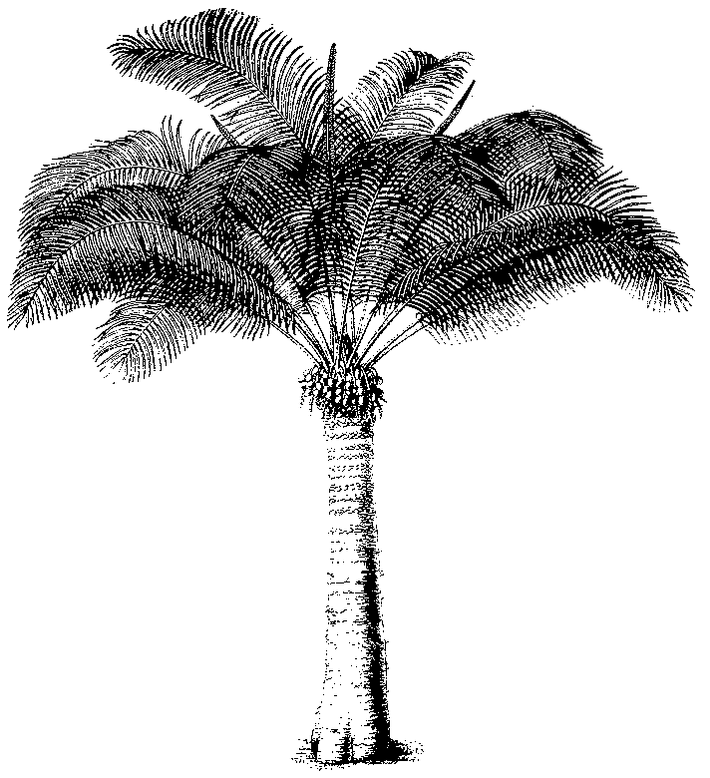
Eleventh meeting of the Plants Committee
Langkawi (Malaysia), 3-7 September 2001
Regional reports and reports on regional meetings
north america

A) General Information
- Name of the Member (author of the Report): Bertrand von Arx (Canada)
- Name of alternate Representative: Patricia Dávila (Mexico)
- Number of Parties in the Region: 3 (Canada, Mexico, United States of America)
- Number of Scientific Authorities responding to communications: 2 / 2
- Names of other institutions or NGO’s contacted for CITES work during the period.
- American Orchid Society (AOS),
CFS (Canadian Forest Service),
IUCN/SSC Carnivorous Plants SG,
IUCN/SSC North American Orchid SG
SSC Plant Conservation Committee
etc.

B) List of Items

Introduction
As usual in this region work has been performed mostly at a national level. Good communication between the Scientific Authorities in the region allows proper implementation of the regional issues without actual meetings. In this perspective, it is particularly enjoyable to notice that in Mexico the relationship between the Scientific Authority (Conabio in coordination with Dra. Patricia Dávila and Dr. Rodrigo Medellín) and the Management Authority (INE-Semarnat) has matured and become much stronger. Work is being conducted in close collaboration on many different CITES issues and a positive attitude is noticeable on both sides when looking for solutions for an adequate implementation of the Convention with the best possible compromises necessary for conservation of wildlife in Mexico.
Parties also started to gear up for the coming COP by preparing the Calendar of the various consultation processes and by looking more closely at taxa for possible proposals. The US published a first public notice in their Federal register (http://www.access.gpo.gov/su_docs/aces/fr-cont.html) on possible species proposals for which they are requesting information from the public. In Canada, the consultation process will start in December 2001.
FOLLOW-UP ON AGENDA ITEMS SINCE LAST PLANTS COMMITTEE
- Regional Directory Several changes occurred since last update. In Mexico major changes in staffing at both MA and SA level occurred. In Canada, your humble servant was appointed as CITES scientific Authority and International Coordinator on March 1, 2001 at The Canadian Wildlife service (CWS) Headquarters in Ottawa/Hull.
- CITES Carnivorous Plant Checklist The final draft was circulated at Kew for another final, FINAL round for comments. It will (hopefully) be ready for distribution as you read this report!.
- Guaiacum sanctum project - PC10 determined that the study presented by the students of the University of Maryland should be continued. At the request of Mexico the students were asked to continue their work. The Secretariat provided funds donated by the Netherlands and the United States of America. The students worked closely with Mexico to carry out their study. Results will be available for discussion at PC11.
- Timber identification manual - The U.S. Department of Agriculture/Animal and Plant Health Inspection Service and the U.S. Forest Service have provided funding to an effort led by Environment Canada to develop identification materials for tropical woods to be used by enforcement officers. The final document will be available soon. An interactive version on the Web should also be ready soon.
Regional Meetings
One regional meeting was held in April 2001 as part of the North American Trilateral Committee for Wildlife & Ecosystem Conservation and Management (aka Trilateral Meeting) in which a “CITES Table” plays the role of a regional meeting. The presence of other “tables” such as migratory birds and Wetlands, Shared species, Biodiversity Information inter alia allow efficient interaction with other scientist when needed. All three Scientific Authorities as well as Management Authorities attended this meeting.

Work by Parties
Several documents - which will be presented at this meeting - show the work accomplished in each Party to improve the implementation of CITES on plant related matters or to comply with Decision of the last COP. A summary of important activities is provided below for each Party.

United States of America
- Cactus delisting proposal - The U.S. Scientific Authority analysed the potential implications of a proposal drafted by Switzerland to delist several morphologically distinct species of cacti. The results were shared within the region and with Switzerland.
- Orchidaceae Review - PC10 established a Working Group to determine how to proceed with the review of the Orchidaceae. The U.S. Scientific Authority (Mr. Roddy Gabel) is conducting this project for the North American Region in collaboration with the American Orchid Society. Results will be discussed at PC11.
- Medicinal Plant Annotations Working Group - PC10 established this Working Group to address specific recommendations identified in document PC10.8.4. The U.S. Scientific Authority coordinated input from Working Group members and will present a document on this subject for discussion at PC11.
- Taxus wallichiana review - PC10 requested the United States and China to conduct a review of the conservation status of this species. The United States has focused on this and related Asian species in the genus due to taxonomic uncertainties yet to be resolved by the Nomenclature Committee. The results will be presented for discussion at PC11.
- Request for information - On June 12, 2001, the U.S. Scientific Authority officially requested information and recommendations from the pubic on species to consider for changes to the CITES Appendices at the next COP. Comments must be received before August 13, 2001. A summary of the plant species specifically identified in this notice will be presented at PC11. Many species that range into Canada and/or Mexico are included.
- European Regional Meeting - At the invitation of the European Regional Representative, the United States (Ms. Julie Lyke) attended the IV European Regional Meeting on CITES Plant Issues held in Turkey in April 2001. This occasion offered an opportunity to share information with European Parties and the Secretariat and enhanced our understanding of the bulb trade from Turkey.

Mexico
Among many other projects, in-depth work on the status of Mexican cacti – especially with extensive field trips - has been conducted during this term and will continue in the future. The projects are in many cases aimed at issues directly related to the work of the Plants Committee (delisting of Opuntioids; Review of App. I Cacti). In other cases, financial constrains dictate the scope of a research as it is the case with the review of some native populations of cacti where the first group of taxa chosen are located at a reasonable distance from Mexico City. Further investigations will cover more distant regions.
Also the project on Guaiacum conducted field work in Mexico and the results will be presented during the meeting.
A major event for the near future will be the National Congress of the Botanical Society of Mexico of which the alternate Representative is the Chairman. The Congress will be held from October 14-19, 2001 for further information check the Website at www.socbot.org.mx.
Canada
- A great deal of efforts were put into taking over the new Scientific Authority Office. A great attention has been given to the Network of other Scientific Authorities in Canada such as the Provinces and Territories, the Department of Fisheries and Ocean; the Canadian Forest Service, as well as Enforcement agencies. Education and training was provided through a PowerPoint presentation – based on the one available on the CITES website. It features a core of general information on CITES and more specifically on the implementation in Canada and a special section was added to show specific issues or requirements depending on the interlocutors.
- A working group was also created to update the information available on the Internet about CITES in Canada. A new Website will be designed during the summer and should be available for this Fall at www.cites.ec.gc.ca. One of the major features will be the consultation process for the next CoP and the availability for permit applications online (later all the permitting process shall be online).
- Work is also ongoing on the checklist of the Canadian native species listed in CITES. This list does include both plants and animals. On the plant side only 4 families are represented with 100+ taxa. However, two families Ranunculaceae (Hydrastis canadensis) and Araliaceae (Panax quinquefolius) – both medicinal plants - have only one representative each. Cactaceae (approx.5 sp. All App. II) and even more so Orchidaceae (78-100+ sp. depending on taxonomy; all App. II) share the bigger amount of taxa. Assessment of the threat level is available, but data on trade of most of those is still missing.
- The representative has also participated in the second Criteria Working Group held in Sigüenza, Spain, May 2001 and in the 45th Standing Committee in Paris, June 2001.

