PC11 Doc. 3.1
CONVENTION ON INTERNATIONAL TRADE IN ENDANGERED SPECIES
OF WILD FAUNA AND FLORA
____________
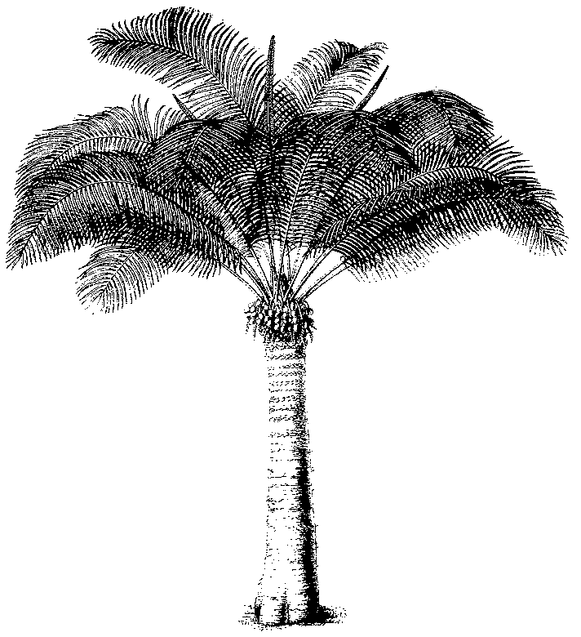
Eleventh meeting of the Plants Committee
Langkawi (Malaysia), 3-7 September 2001
Provisional agenda
Open Session of the Plants Committee
Agenda item | Document No. | Language
1. Opening of the meeting | No document
2. Adoption of the Rules of Procedure | PC11 Doc. 2 | E, F, S
3. Adoption of the Agenda and the Working programme | No document
3.1 Agenda | PC11 Doc. 3.1 | E, F, S
3.2 Working programme | PC11 Doc. 3.2 | E, F, S
4. Admission of observers | PC11 Doc. 4 | E, F, S
5. Regional reports and reports on regional meetings
5.1 Africa | PC11 Doc. 5.1
5.2 Asia | PC11 Doc. 5.2a | E
5.3 Central and South America and the Caribbean | PC11 Doc. 5.3
5.4 Europe | PC11 Doc. 5.4 | E
5.5 North America | PC11 Doc. 5.5 | E, F, S
5.6 Oceania | PC11 Doc. 5.6
6. Regional Directories [Resolution Conf. 11.1, Annex 2, paragraph e)]
6.1 Africa
6.2 Asia
6.3 Central and South America and the Caribbean
6.4 Europe
6.5 North America
6.6 Oceania
7. Review of Resolution Conf. 9.24
7.1 Meeting with the Chairmen in Geneva | No document
7.2 Second meeting of the Criteria Working Group | No document
7.3 Report of the Standing Committee meeting (plants issues) | PC11 Doc. 7.3 | E, F, S
8. Follow-up of CoP11 Decisions
8.1 Harpagophytum spp. | PC11 Doc. 8.1 | E, F, S
8.2 Guaiacum sanctum | PC11 Doc. 8.2 | E, F, S
8.3 Aquilaria spp. | PC11 Doc. 8.3 | E, F, S
8.4 Mahogany Working Group | No document
9. Technical proposals for the 12th meeting of the Conference of the Parties
9.1 Harvesting techniques of Galanthus in Georgia | PC11 Doc. 9.1a  PC11 Doc. 9.1b | E, F, S  E, F, S
9.2 Decision 11.155 | PC11 Doc. 9.2 | E, F, S
9.3 Standard exemptions for Appendix-II plant species | PC11 Doc. 9.3 | E, F, S
9.4 Definitions of the technical terms used in the annotations | PC11 Doc. 9.4 | E, F, S
9.5 Exemptions for flasked seedlings | PC11 Doc. 9.5 | E, F, S
9.6 Exchange of scientific herbarium specimens of certain plant taxa listed in Appendix II | PC11 Doc. 9.6 | E, F, S
10. Species proposals for the 12th meeting of the Conference of the Parties
10.1 Delisting of leaf-bearing cacti (Pereskioid and Opuntioid Cactaceae)
10.1.1 Draft proposal by Switzerland | PC11 Doc. 10.1.1 | E, F, S
10.1.2 Comments from Mexico on Document PC11 Doc. 10.1.1 | PC11 Doc. 10.1.2 | E, F, S
11. Significant trade in plants
11.1 Problems and inconsistencies in Resolution Conf. 8.9 (Rev.) and Decision 11.117 | PC11 Doc. 11.1 | E, F, S
11.2 Implementation of Resolution Conf. 8.9 (Rev.) (cf. decision 11.117)
11.2.1 Trade in plants from Madagascar | PC11 Doc. 11.2.1 | E, F, S
11.2.2 Cycads | PC11 Doc. 11.2.2 | E, F, S
11.2.3 Selection of taxa for review | PC11 Doc. 11.2.3 | E, F, S
12. Medicinal plants
12.1 Trade in Prunus africana | No document
12.2 Possible future activities | No document
13. Review of the Appendices
13.1 Review of Orchidaceae spp. | PC11 Doc. 13.1 | E, F, S
13.2 Appendix–I Cactaceae | PC11 Doc. 13.2 | E, S
13.3 Tree species (Decision 11.116) | PC11 Doc. 13.3 | E, F, S
14. Checklists and nomenclature
14.1 Progress report | PC11 Doc. 14.1 | E, F, S
14.2 Issues referred to the Nomenclature Committee | PC11 Doc. 14.2 | E, F, S
14.3 Masdevallia | No document
14.4 Bulbophyllum | No document
14.5 Nomenclature of Cedrela odorata | PC11 Doc. 14.5 | E, F, S
15. Strategic planning
16. Identification materials for plants
16.1 Progress report | PC11 Doc. 16.1 | E, F, S
17. Guidelines for transport of live plants | PC11 Doc. 17 | E, F, S
18. Tree species evaluation: progress report by the Netherlands | PC11 Doc. 18 | E, F, S
19. Issues resulting from PC10, not included elsewhere in the Agenda | No document
20. Training initiatives
20.1 Standard slide package: progress report | No document
21. Trade in Mexican cacti
21.1 Trade in seeds of Cactaceae included in Appendix II | PC11 Doc. 21.1 | E, F, S
21.2 Cacti sales through Internet | PC11 Doc. 21.2 | E, F, S
22. Review of the genus Taxus | PC11 Doc. 22 | E, F, S
23. Time and venue of the 12th Plants Committee meeting
24. Any other business
24.1 Relationship between ex-situ breeding operations and in-situ conservation programmes (Decision 11.102) | PC11 Doc. 24.1 | E, F, S
24.2 Report on the Global Strategy for Plants (CBD) | No document
24.3 Annotation to Cistanche deserticola | PC11 Doc. 24.3 | E, F, S
24.4 Illegal trade in Paphiopedilum spp. | PC11 Doc. 24.4 | E, F, S
24.5 Implementation issues related to Appendix-III timber species | PC11 Doc. 24.5 | E, F, S

Information documents
Document title | Document  No. | Language
Implementation of Resolution Conf. 8.9 (Rev.)  The significant trade review process | PC11 Inf. 1 | E, F, S
Implementation of Resolution Conf. 8.9 (Rev.)  An introduction to the significant trade review process | PC11 Inf. 2 | E, F, S
Control of captive breeding, ranching and wild harvest production systems for Appendix-II species | PC11 Inf. 3 | E, F, S
Information on plant species for which amendment proposals were rejected or withdrawn | PC11 Inf. 4 | E
Extract federal register (United States of America) | PC11 Inf. 5 | E
Example from WISIA Database | PC11 Inf. 6 | E
Enquête sur les annotations des plantes médicinales inscrites à l’Annexe II | PC11 Inf. 7 | F
Illegal trade in Paphiopedilum spp. (Agenda item 24.4)  Some recently described taxa in the genus Paphiopedilum | PC11 Inf. 8 | E
Gestion de Prunus africana (Pygeum) au Cameroun | PC11 Inf. 9 | F
Development of harvesting quotas for Prunus africana | PC11 Inf. 10 | E
Report by TRAFFIC Oceania on Aquilaria | PC11 Inf. 11 | E
Report of the Animals Committee working group on Alien species | PC11 Inf. 12 | E
Report of the Animals Committee working group on Resolution Conf. 8.9 (Rev.), (Agenda item 11.1) | PC11 Inf. 13 | E

