AC17 Doc. 10.1

CONVENTION ON INTERNATIONAL TRADE IN ENDANGERED SPECIES
OF WILD FAUNA AND FLORA

____________
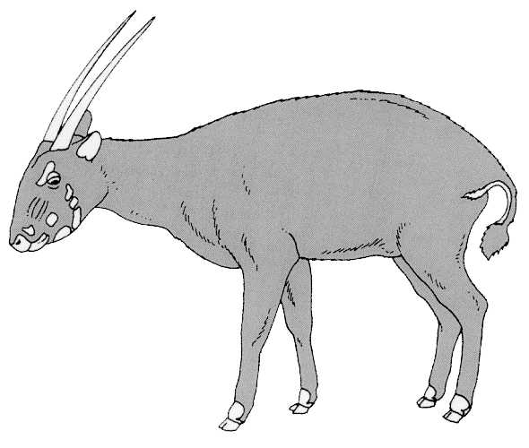
Seventeenth meeting of the Animals Committee
Hanoi (Viet Nam), 30 July-3 August 2001

Implementation of Resolution Conf. 10.21 on transport of live animals

REPORT OF THE WORKING GROUP
This document has been prepared by the Chairman of the Transport Working Group (TWG) of the Animals Committee.

Introduction
1. The TWG has been requested by the Chairman of the Animals Committee to formulate its Terms of Reference on the basis of Resolution Conf. 10.21. At the 16th meeting of the Animals Committee in December 2000, the Committee had adopted the terms that were proposed by the TWG. This report takes account of the achievements under these Terms of Reference.
Establishment of a format for the presentation of data on mortality and injury or damage to health in transport
2. The establishment of a common format for presenting relevant data was one of the important objectives of Resolution Conf. 10.21. The TWG has dealt with this subject since it was reconstituted. As a result of discussions within the TWG, the Secretariat prepared and circulated Notification to the Parties No. 1999/48. Since the questionnaire on transport mortality and injury has been notified to the Parties, the TWG has strongly supported the implementation of Notification to the Parties No. 1999/48 and the ongoing process of data collecting. Unfortunately only a few Parties regularly collect mortality data and participate in the process. An analysis of the process, of the response to and the acceptance and suitability of the questionnaire, and of the results will be prepared for the next meeting of the Animals Committee.
Collaboration with IATA
3. One additional important area of work for the TWG is the collaboration with the International Air Transport Association (IATA). The Wildlife Conservation Society prepared an amendment to the IATA Live Animals Regulations. This proposed amendment was discussed by the TWG, and a draft document was submitted to the IATA Board. The draft was tabled in March 2001 and accepted with some minor language changes. Over the last three years, the TWG has thus submitted two significant amendments to the IATA Live Animals Regulations, which were adopted in both instances. Furthermore, the responsible IATA board expressed a strong interest to the Chairman of the TWG in further collaboration between IATA and the TWG of the Animals Committee.
Evaluation of “CITES Guidelines for Transport and Preparation for Shipments of Live Wild Animals and Plants”
4. In 1979, the second meeting of the Conference of the Parties adopted the Guidelines for Transport and Preparation for Shipment of Live Wild Animals and Plants, published as a UNIPUB edition in 1980 (ISBN 0-89059-013-3). The Guidelines have not been reviewed or amended ever since. The TWG started to evaluate these CITES Transport Guidelines, and is planning to make recommendations to the next meeting of the Animals Committee on how best to proceed.
5. The CITES Transport Guidelines refer not only to animals but also to the transportation of live plant specimens. The Chairman of the TWG contacted the Chairman of the Plants Committee and drew her attention to this document. The Plants Committee is currently assessing whether there is a general need for transport guidelines for live plants, and will in due course advise the Secretariat accordingly.

