AC17 Doc. 5.6

CONVENTION ON INTERNATIONAL TRADE IN ENDANGERED SPECIES
OF WILD FAUNA AND FLORA

____________
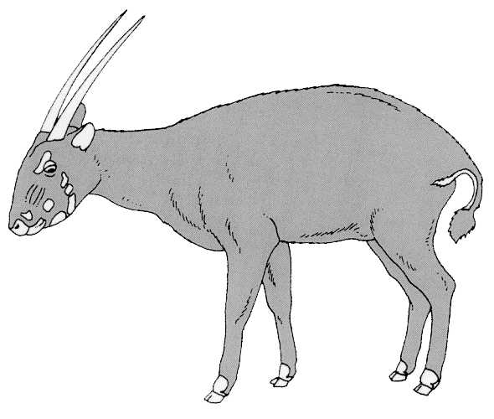

Seventeenth meeting of the Animals Committee
Hanoi (Viet Nam), 30 July-3 August 2001

Regional Reports

OCEANIA
This document (for the period December 2000 – May 2001) has been prepared by Dr Rod Hay and Dr Dick Watling in their capacity as Regional Representatives for Oceania.
General Information
1. Member: Dr Rod Hay (New Zealand).
2. Alternate: Dr Dick Watling (Fiji).
3. Both Dr Hay and Dr Watling were elected to their positions at CoP12 in Gigiri. R. Hay had been alternate Oceanian representative since CoP9 (1994).
4. Number of Parties in Oceania: 5 (Australia, Fiji, New Zealand, Papua New Guinea, Vanuatu).
5. Number of Parties in the region not members of CITES: 11 (note that this does not include the territories of France, United Kingdom and United States of America)
6. Number of Parties responding to communications in 2001: 2
7. Names of other institutions, NGOs contacted: IUCN Species Survival Commission Invasive Species Specialist Group (ISSG); South Pacific Regional Environment Programme (SPREP); New Zealand delegates to the Convention on Biological Diversity SBSTTA; Birdlife International.
8. Note that the five-month period between AC16 and the deadline for reports for AC17 limits the opportunity for activity.
List of items
9. Follow-up to agenda items since AC16: Following AC16, R. Hay participated by correspondence in the continuing work of the Criteria Working Group (CWG). Unfortunately, other commitments at the last moment rendered it impossible for him to attend the second meeting of CWG in Spain convened to address definitions for the revised listing criteria.
10. Oceania participated in some of the discussions of the working group at AC15 and offered to review Anas aucklandica as part of the review of the appendices. This review hadn’t been prepared for AC16 and still has not been completed, though the New Zealand representative is committed to the task and has commissioned the work.
11. R. Hay was a member of the Syngnathid working group and helped facilitate the request to experts in New Zealand for information on use and trade of seahorses (Notification No. 2001/034).
12. At AC16 R. Hay chaired the Working Group on the universal labelling system for the identification of caviar. Subsequently he endorsed TRAFFIC Europe’s offer to facilitate work leading up to AC17. Progress on this issue will be reported separately.
Communication with other Parties in the region
13. Following AC16, R. Hay circulated his own report and the draft official report of the meeting to Parties in the region.
14. On receipt of the Draft Agenda for AC17 in late April, R. Hay circulated the material to the Scientific and Management Authorities in the region, requesting items for the regional report and comments on the agenda. At the time of writing, no responses had been received; the report will be updated verbally where appropriate at AC17
15. There has been communication with Australia on the subject of sharks and discussions are continuing on the need to raise shark conservation issues at AC18 following work on the issue at COFI.
Other regional activities
16. R. Hay attended the ISSG Conference on Eradication of Island Invasives and an associated meeting of the ISSG in February 2001 in Auckland, New Zealand. He gained the agreement of ISSG in collaborating on a review of trade in CITES listed species which are actual and potential invasives.
17. R. Hay also had discussions with a SPREP representative, Dr Greg Sherley, about the future of species protection initiatives in the SPREP region once Dr Sherley’s position with SPREP expires. Subsequently, SPREP has secured funding to continue a bird conservation and invasive species initiative. This provides an enhanced opportunity for advancing CITES in Oceania.
18. In April 2001, Birdlife International held its inaugural Partnership Meeting for Oceania at Miranda, New Zealand. The Action Plan developed at that meeting reinforced the need for regional initiatives for capacity building and information sharing. This may also have implications for strengthening CITES in the region.
Forthcoming listing proposals
19. There are no concrete proposals currently but consultation is beginning on at least two. In the light of the taxonomic revision of Cyanoramphus parakeets, New Zealand is prepared to submit appropriate proposals, subject to agreement with other range States (Australia, France).
20. New Zealand is also developing a draft proposal for listing a range of gecko species, protected in New Zealand but subject to possible illegal trade.
Difficulties of implementation in the region
21. No regional meetings have been held, nor are they likely to be held unless opportunities arise in conjunction with other gatherings. Discussions continue on the possibility of using SPREP meetings to advance a number of CITES-related issues.
22. Communication has been difficult, in some cases, because of lack of fax and email contact. For example, neither the Papua New Guinea Management Authority nor Scientific Authorities have email contact, and fax communication with them using the listed numbers has been unsuccessful. Postal communication is used but the short deadlines often render feedback from this contact impractical.
23. For the smaller Parties of the region, CITES usually constitutes one of a large range of activities for the responsible authority. This inevitably limits the quantity of engagement on from the Parties on any but the most relevant and critical issues.
24. As with other regions, the identification of corals remains a difficult issue for border control authorities.

