PC13 Doc. 17
(English only/Únicamente en inglés/Seulement en anglais)
CONVENTION ON INTERNATIONAL TRADE IN ENDANGERED SPECIES
OF WILD FAUNA AND FLORA
____________
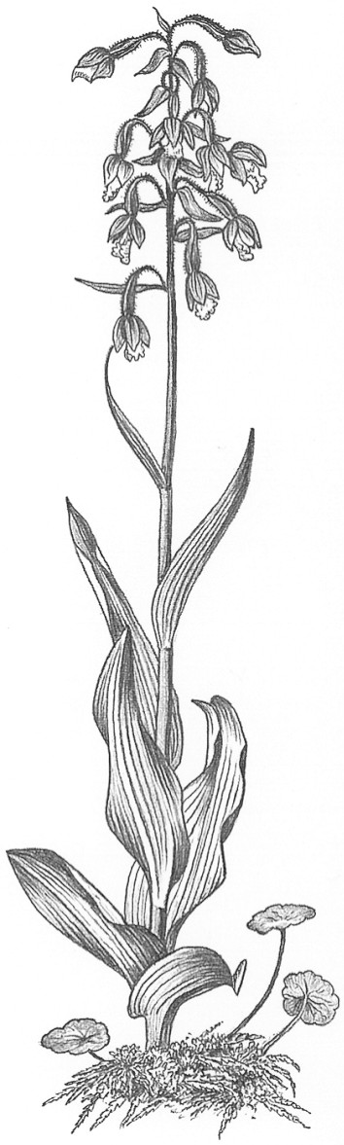
Thirteenth meeting of the Plants Committee
Geneva (Switzerland), 12-15 August 2003
ID Manual: progress report
1. In accordance with Resolution Conf. 11.19, paragraph g) the Secretariat herewith provides a report on the progress made with the production of the Identification Manual.
2. A list of the sheets that have been distributed since 1 December 2002, and of those being printed edited, formatted, translated, or prepared, is included in the Annex.
3. The source of the sheets is indicated under the original language in which they were provided.
4. The Secretariat has created a database on the ID Manual and is currently in the process of converting all the published sheets into electronic format, for updating and inclusion on its website.

PC13 Doc. 17
Annex
Identification Manual sheets sent to the Parties since 1 December 2002
Fauna

English
Accipitridae: 1 species

French
Mammalia
Cercopithecidae: general remarks: 2 pages
Procyonidae: general remarks (2 pages) plus 1 species
Equidae: general remarks (2 pages) plus 2 species
Tayasuidae: 3 species
Aves
Accipitridae: 26 species
Fringillidae: 5 species
Megapodidae: 1 species
Musophagidae: 1 species
Psittacidae: 3 species
Reptilia
Ambystomatidae: general remarks: 2 pgs
Cordylidae: 21 species
Phelsuma spp: 34 species
Parts and derivatives
Testudinata/Carving material: 4 pgs

Flora

English
The genera of Cycads, How to identify them; 18 pages (Prepared by the Management Authority of Switzerland)
Succulents: Identification Key: 1 page (Prepared under contract with the Secretariat, funded by the Management Authority of the Nederland)
Identification of Cactaceae based on morphological characteristics, 33 pgs (Prepared under contract with the Secretariat, funded by the Management Authority of the Nederland)
Medicinal and aromatic plants: 16 pages introduction plus 19 species or other taxa sheets (submitted by the Scientific Authority of Germany)
Timber: 7 species or higher taxa
Agavaceae: 4 species; Fouquieriaceae: 3 species; Portulacaceae: 2 species; Crassulaceae: 2 species (submitted by the Management Authority of United States of America)

Identification Manual sheets requiring editing and/or formatting
Fauna

English and French
Psittacidae / Psittacinae: 19 species with colours photos (submitted by the Management Authority of Switzerland)
Psittacidae / Loriinae: 5 species
Chamaeleonidae: about 120 sheets with colours photos (submitted by the Management Authority of Germany)
Bataguridae: 9 species

French
Accipitridae: 33 species
Cracidae: general notes 3 pgs, plus 12 species
Caudata: general remarques: 5 pgs
Musophagidae: 7 species
Ranidae: 2 species
Hirudinidae: 1 species
Papilionidae: 9 species
Anatidae: 1 species

Spanish
Psittacidae: 20 species
Viverridae /Fur: general notes 2pgs

Flora

Spanish
Identification of Cycads based on leaf characteristics (20 pages, including colour illustrations) in Spanish (provided by the Management Authority of Switzerland)

In preparation
Fauna

English
Rhincodontidae: 1 species (1 sheet on species and 1 sheet on carving and other material)
Dasypodidae: 1 species
French
Caudata: general notes 5pgs
Boidae: 35 species
Ambystomatidae: 6 species
Ranidae: 2 species
Cryptobranchidae: 2 species

Spanish
Theraphosidae: general notes 4 pgs, plus 8 species

Flora

Spanish
Timber identification: Introduction (24 pages) plus 15 species (provided by the Scientific Authority of Spain.)

